CSS GENDER STUDIES
T1QA
The Question Answers
Topic 1 · Gender Studies and the Social Construction of Gender — every past question answered as a model
WHAT THIS DOCUMENT GIVES YOU
◆ All sixteen CSS questions on Topic 1 (2016–2026) and the 2024 short note, answered in full
◆ An answer map for every answer — each branch a numbered heading
◆ The command words and limbs of every question decoded
◆ Model answers of 1,000–1,300 words with evidence inside every heading
◆ Why each answer scores — what the examiner rewards
Federal Public Service Commission · CSS Competitive Examination · Optional paper, 100 marks
Written for CE-2027 onwards · Record: CE-2016 to CE-2026 · Facts current to September 2026

Contents
HOW TO BUILD THE CONTENTS
The contents list below fills itself in. When Word asks "This document contains fields that may refer to other files. Update the fields?", click Yes.
If it does not ask: right-click the grey contents area → Update Field → Update entire table → OK. On a Mac, Control-click the same area. Or press Ctrl + A, then F9 (Windows), to update every field at once. Repeat after any edit, before you export to PDF.

Right-click here and choose Update Field to build the contents.

How to Use These Answers

What is in this document
Table 1 · The questions answered for Topic 1, in the order they were set.
No. | Question | Year · Q | Family
1 | Write a note on the status of women's studies in Pakistan and give your views on the autonomy/integration debate in Women's Studies. | CSS 2016 · Q2 | Status of Gender / Women's Studies in Pakistan; The autonomy versus integration debate
2 | What are the theories of social construction of gender? | CSS 2016 · Q6 | Social construction of gender — theories; deconstructing 'gender'
3 | Define and discuss the discipline of Gender Studies and also differentiate between Women's Studies and Gender Studies. | CSS 2017 · Q2 | Gender Studies as a discipline — meaning, need, scope; Women's Studies versus Gender Studies
4 | Write a comprehensive note on the autonomy versus integration debate in Gender Studies. | CSS 2017 · Q7 | The autonomy versus integration debate
5 | What are the fundamental differences between Gender Studies and Women's Studies? Substantiate your argument(s) with examples. Highlight the … | CSS 2018 · Q2 | Women's Studies versus Gender Studies; Status of Gender / Women's Studies in Pakistan
6 | Write a comprehensive essay on the 'sex versus gender debate' in feminist philosophy and social sciences, reflecting the nature versus nurtu… | CSS 2018 · Q3 | Sex versus gender; is sex socially constructed; nature versus nurture
7 | How do you differentiate the discipline of Gender Studies from that of Women's Studies? Historically trace the need for the establishment of… | CSS 2019 · Q2 | Gender Studies as a discipline — meaning, need, scope; Women's Studies versus Gender Studies; Status of Gender / Women's Studies in Pakistan
8 | Gender has multiple meanings. How do you deconstruct the word 'GENDER'? | CSS 2020 · Q2 | Social construction of gender — theories; deconstructing 'gender'; Sex versus gender; is sex socially constructed; nature versus nurture
9 | 'Language is gendered.' What does this imply? Explain with examples. | CSS 2020 · Q4 | Gendered language
10 | Discuss in detail how the autonomy and integration debate in Gender Studies has made an important contribution to the development of the fie… | CSS 2021 · Q2 | The autonomy versus integration debate
11 | Masculinity and femininity are deeply engraved realities since the distant past in human history. Discuss various theoretical debates on the… | CSS 2021 · Q3 | Masculinities, femininities and gender roles; Sex versus gender; is sex socially constructed; nature versus nurture
12 | Discuss in detail the multidisciplinary nature of Gender Studies. | CSS 2022 · Q2 | The multidisciplinary nature of Gender Studies
13 | Write a note on the status of Gender Studies in Pakistan. Give your views on the autonomy versus integration debate in Gender Studies. | CSS 2023 · Q2 | Status of Gender / Women's Studies in Pakistan; The autonomy versus integration debate
14 | Differentiate between Gender Studies and Women's Studies. Discuss in detail the multidisciplinary nature of Gender Studies. | CSS 2023 · Q3 | Women's Studies versus Gender Studies; The multidisciplinary nature of Gender Studies
15 | Define the terms masculinity and femininity. In your opinion, where do traditional gender roles come from? | CSS 2023 · Q4 | Masculinities, femininities and gender roles
16 | Is 'sex' also a social construct? | CSS 2024 · Q8(a) | Sex versus gender; is sex socially constructed; nature versus nurture
17 | Critically examine the theoretical arguments of social constructionism and queer theory regarding the categories of sex and gender. How do t… | CSS 2026 · Q2 | Queer theory and transgender rights; Social construction of gender — theories; deconstructing 'gender'

How every answer is built
1. The question, exactly as set, with its year and number.
2. The answer map — a mind map whose centre states what the question asks, part by part. Every branch is one numbered heading of the answer, and every point on it is a short phrase that makes complete sense on its own — so the map alone tells the examiner the whole argument. Draw a quick version in the margin of your answer book before you write.
3. Decoding the question — the command words and what each part demands.
4. The model answer — 1,000 to 1,300 words, the length a strong candidate can write in about thirty minutes. It is built in two levels: main headings 1, 2, 3… taken from the question's own words, and sub-headings i), ii), iii)… under them. The introduction always has a simple definition, the background, the Pakistani context and the argument. Each sub-heading answers one point in a short paragraph with the key words in bold. Every answer has at least one figure besides the answer map (a comparison, flow, cycle, tree, spectrum or grid), often a table as well, a Pakistan angle, a counter-argument and a balanced conclusion.
5. Why this answer scores — what the examiner rewards in it.
EXAMINER'S EYE · REPEATS AND NEAR REPEATS
Topic 1 repeats itself more than any other topic. Several answers below cover the same ground (the status of the field in Pakistan; autonomy versus integration; Women's versus Gender Studies) — but each is built for its own question's limbs. Notice how the same knowledge is re-organised under different headings. That skill — re-cutting what you know to fit the exact question — is what this document teaches.

Answer 1 · The Status of Women's Studies in Pakistan and the Autonomy/Integration Debate (CSS 2016)
AT A GLANCE · CSS 2016 · Q2 · 20 MARKS
Write a note on the status of women's studies in Pakistan and give your views on the autonomy/integration debate in Women's Studies.

The answer map
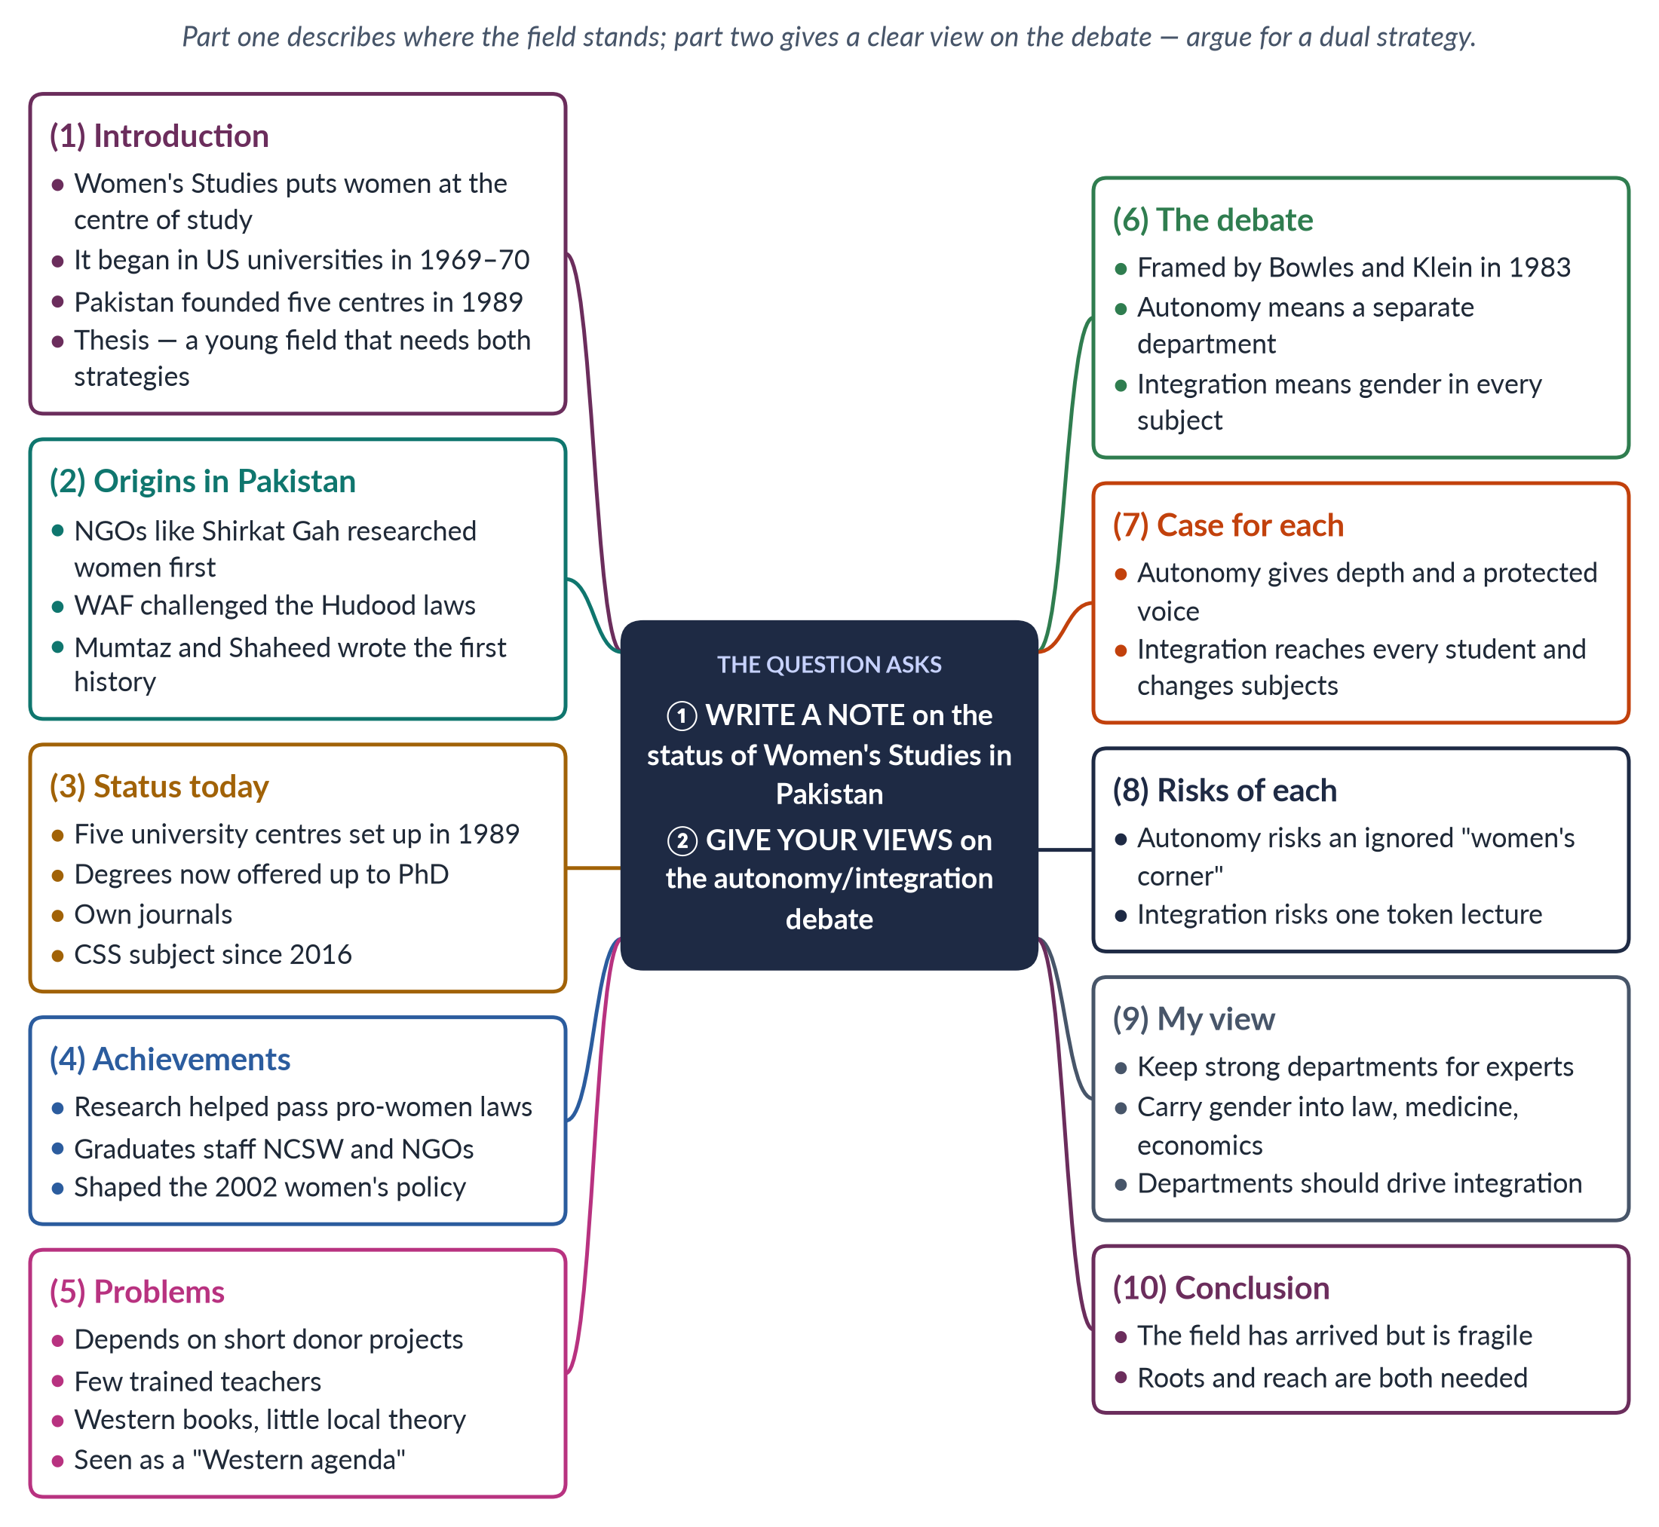
Figure 1 · The answer map: every branch is one numbered heading of the model answer below.

Decoding the question
The question has two parts. "Write a note on the status" asks for a clear, organised picture of where the field stands today: its history, institutions, achievements and problems. "Give your views" asks for your own position on the autonomy/integration debate, supported by evidence. The best answers link the two parts: the problems you find in part one should explain the view you take in part two.

The model answer

1. Introduction

i) Definition
Women's Studies is the academic field that puts women at the centre of study. It studies women's lives, work, history and experience, and aims to improve them.

ii) Where it began
It began in American universities in 1969–70 — a course at Cornell and the first programme at San Diego State — as "the academic arm of the women's movement".

iii) Pakistan and the question
In Pakistan, the field entered the universities in 1989. Three decades later it is recognised and productive, but still fragile. Its future depends on combining a separate academic base with gender in every discipline — the "dual strategy".

2. Origins of Women's Studies in Pakistan

i) Research by women's organisations
Research on women began outside the universities. Shirkat Gah (1975) and the Aurat Foundation (1986) studied women's legal rights, work and political participation.

ii) The Women's Action Forum
The Women's Action Forum (1981) was formed to resist the Hudood Ordinances of 1979 — laws on sexual offences that harmed women. Its members produced legal and social analysis that became the base of later scholarship.

iii) The first history
Khawar Mumtaz and Farida Shaheed wrote Women of Pakistan: Two Steps Forward, One Step Back? (1987), the country's first standard history of the women's movement. The universities followed the activists.

3. The status of the field today

i) The centres of 1989
The federal Ministry of Women's Development set up Women's Studies centres at Quaid-i-Azam University (Islamabad) and the Universities of Karachi, the Punjab (Lahore), Peshawar and Balochistan (Quetta). Some later became centres of excellence.

ii) Degrees and departments
Most centres have renamed themselves "Gender Studies", showing a shift from studying women alone to studying relations between women and men. Many universities now offer BS, MPhil and PhD degrees, and gender courses appear in sociology and social work.

iii) Journals and recognition
Journals such as the Pakistan Journal of Gender Studies publish local research. From CE-2016, Gender Studies became a CSS optional subject — a sign that the field has arrived.

4. Achievements

i) Research that became law
Research on honour crimes, harassment and violence at home gave evidence for the laws on workplace harassment (2010) and honour killing (2016).

ii) Trained people
Graduates staff the National Commission on the Status of Women (2000), provincial commissions, women's protection centres and NGOs.

iii) Policy
Researchers helped shape the National Policy for Development and Empowerment of Women (2002).

iv) New words for hidden problems
The field gave the public words for problems once kept inside the home — harassment, domestic violence, care work. Once a harm has a name, it can be reported, measured and brought before a court.

5. Problems
Table 2 · The field's problems and their effects.
Problem | Effect
Depends on donor projects | Centres shrink when a project ends; outsiders set the agenda
Few trained teachers | Few PhDs; many teachers borrowed from other subjects
Western books, mostly in English | Little local theory; limited reach beyond elite students
Weak data | Small studies; little long-term research on Pakistani families
Social resistance | Seen as a "Western" or "anti-family" agenda
Ghettoisation | Mostly women students and staff; little influence on others

Two problems matter most. Funding shapes everything: when a donor project ends, research teams scatter. Resistance is just as serious: because the field questions family roles, it is easily painted as foreign.

6. The autonomy/integration debate

i) Origin
The debate was set out by Gloria Bowles and Renate Duelli Klein in Theories of Women's Studies (1983), a book on the FPSC reading list. The question was simple: where should the new knowledge live?

ii) Autonomy — defined
Autonomy means keeping Women's Studies as a separate department, with its own teachers, courses, degrees and budget. Example: a Department of Gender Studies awarding its own PhDs.

iii) Integration — defined
Integration (or mainstreaming) means adding women and gender to every existing subject. Example: a law degree that teaches women's inheritance rights, or a medical degree that teaches maternal health properly.

7. The case for each

i) The case for autonomy
- Depth: students can study gender for a whole degree, not one lecture.
- New theory: new ideas need a place where they are the main business.
- Protection: gender topics inside other departments disappear when a friendly teacher leaves.
- A critical voice: an independent unit can criticise male bias elsewhere.

ii) The case for integration
- Reach: every future doctor, lawyer and civil servant meets gender.
- Real change: the subjects themselves are corrected, not only a separate corner.
- Cost: cheaper for poor universities.
- Men involved: gender stops being "women's business".

8. The risks of each
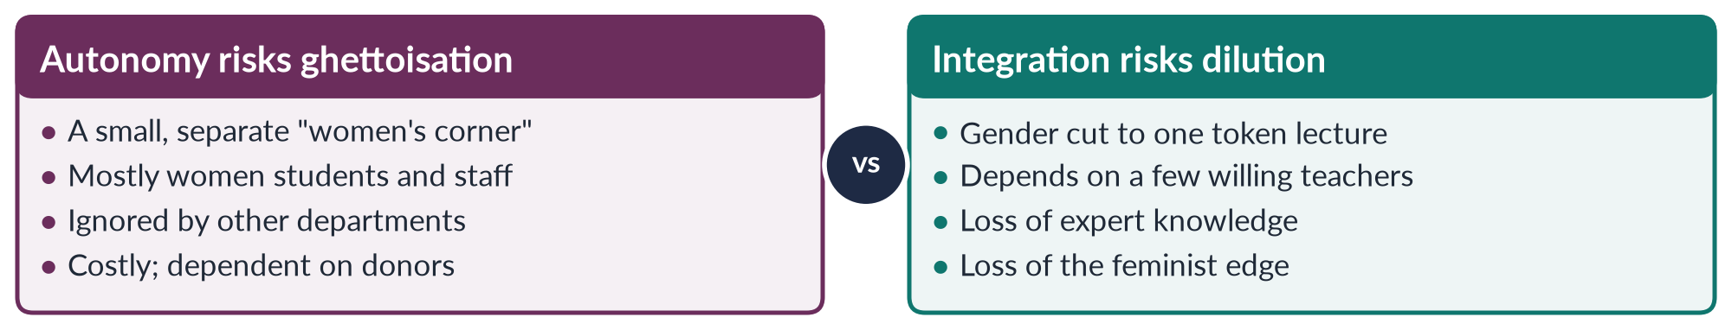
Figure 2 · The risk of each strategy.
In short: autonomy without integration stays in a corner; integration without autonomy has no experts to lead it. Pakistan today shows the first risk clearly: its departments are strong on paper but isolated in practice.

9. My view: a dual strategy for Pakistan

i) Why autonomy is still needed
The field is young and short of trained teachers. Pakistan needs strong departments to train specialists and produce local research.

ii) Why integration is essential
The greatest impact lies outside the department: maternal health in medical colleges, family and criminal law in law schools, unpaid work in economics, gender-aware textbooks in teacher training, and gender analysis in civil-service academies.

iii) How the two should work together
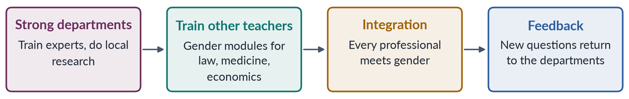
Figure 3 · The dual strategy: departments drive integration.

iv) An answer to critics
Some fear that integration will be only a token lecture. That is why the departments must lead it, with trained teachers and approved content. Local integration also answers the "Western agenda" charge: gender taught inside a Pakistani law or medical course is plainly about Pakistan's own problems.

10. Conclusion
Women's Studies in Pakistan has moved in three decades from activist research to university degrees and real influence on law. Yet it still depends on donors, lacks teachers and sits in a corner of the university. The debate is therefore practical, not academic. The answer is both: well-funded departments that make gender part of every discipline — as the Beijing Platform (1995) did for governments with its "twin track" of special measures plus gender mainstreaming.

Why this answer scores
- Both parts are answered under headings taken from the question ("status"; "views").
- The introduction gives a simple definition, the origin, the Pakistani context and a thesis.
- Each sub-heading answers one point in a short paragraph, with key words in bold.
- The debate is broken down properly: origin → definitions with examples → case for each → risks → view.
- A table and two figures (comparison and flow) make the answer easy to mark at a glance.
- The view is clear and practical, and it grows out of the problems found in part one.

Answer 2 · The Theories of Social Construction of Gender (CSS 2016)
AT A GLANCE · CSS 2016 · Q6 · 20 MARKS
What are the theories of social construction of gender?

The answer map
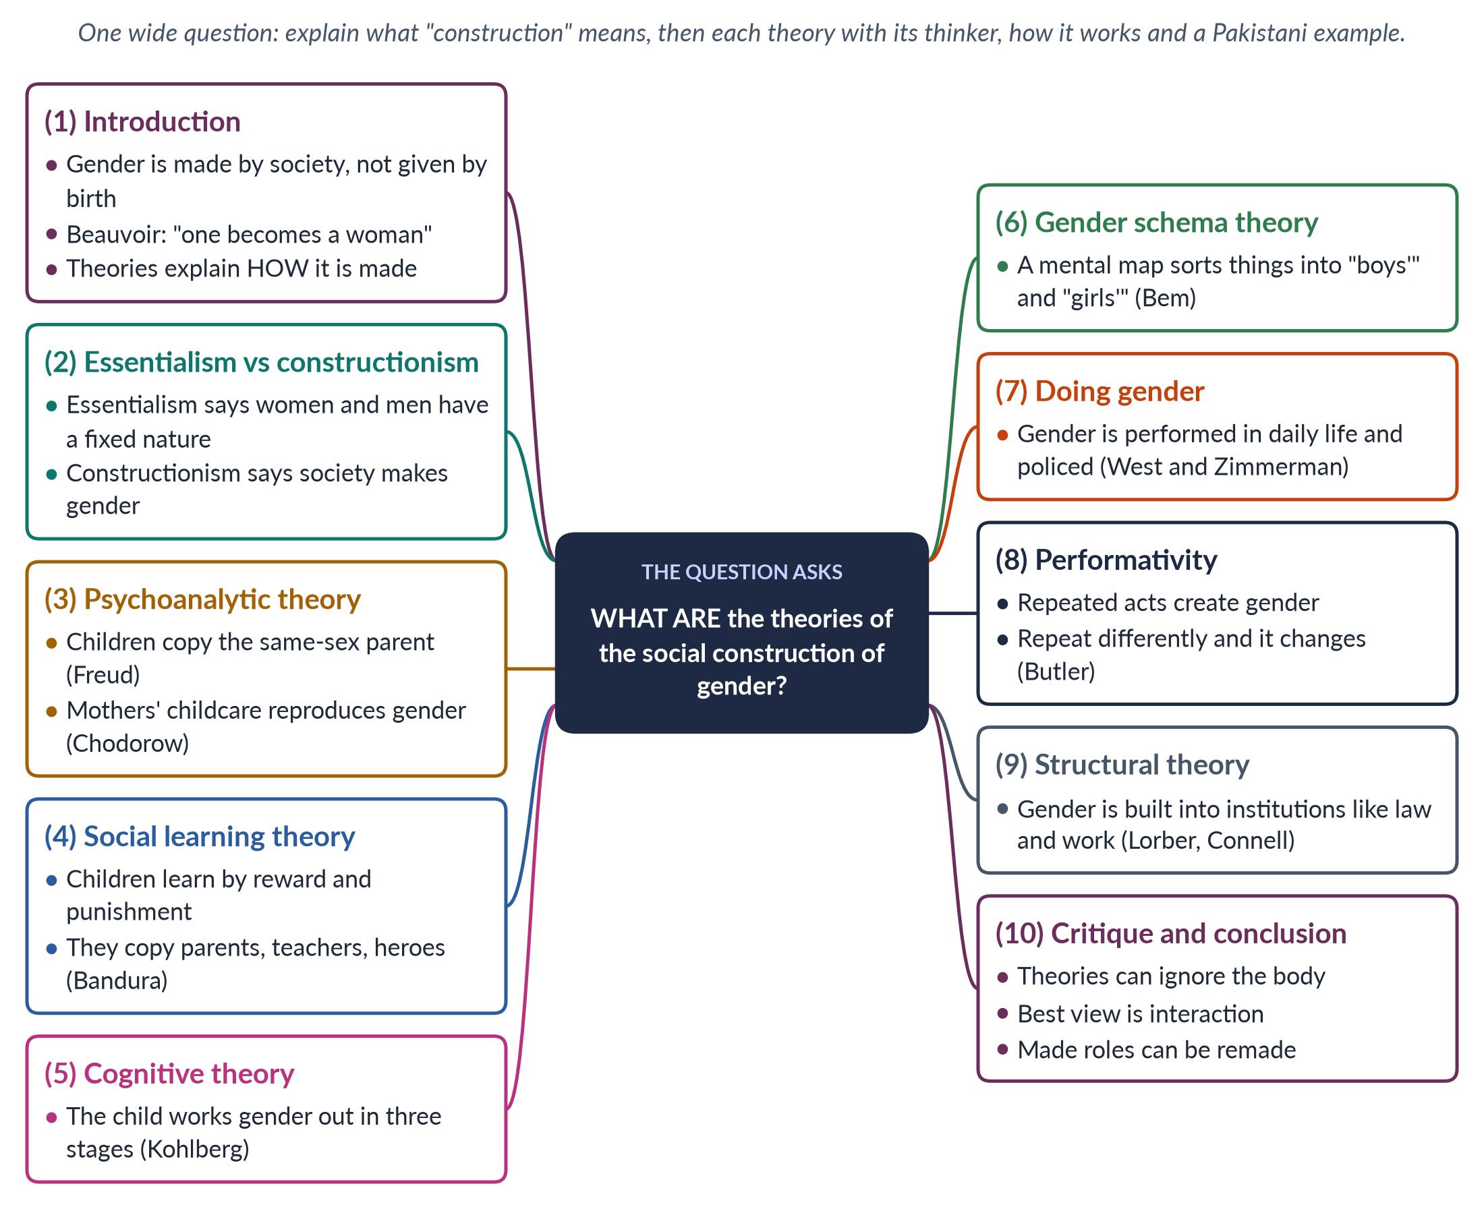
Figure 4 · The answer map: every branch is one numbered heading of the model answer below.

Decoding the question
"What are" asks you to name and explain the main theories. The examiner wants each theory attributed to its thinker, explained by how it works (the mechanism), and illustrated with an example. A short critique and a clear conclusion turn a list into an analysis.

The model answer

1. Introduction

i) Definition
Sex means the body differences between females and males. Gender means the roles, behaviour and power that society attaches to them. Social construction means that something which looks natural is really made by society.

ii) The central claim
Simone de Beauvoir put it in one sentence in 1949: "One is not born, but rather becomes, a woman." Girls and boys are made into women and men.

iii) What the theories do
The theories below explain how this happens — through the mind, through learning, through daily life and through social structures.

2. Essentialism versus constructionism

i) Essentialism
Essentialism says women and men have a fixed, natural essence that explains their roles. For centuries it justified women's exclusion — Aristotle saw the female as an "incomplete male".

ii) Constructionism
Constructionism says gender is made by upbringing, language, institutions and law. Ann Oakley (1972) summed it up: sex is biological; gender is cultural.

3. Psychoanalytic theory

i) Freud
Sigmund Freud argued that children form their gender identity by identifying with the parent of the same sex after early family conflicts.

ii) Chodorow
Nancy Chodorow (The Reproduction of Mothering, 1978) made this a social theory. Because mothers do almost all early childcare, girls learn to care for others, while boys become "men" by separating from their mothers and hiding feelings. Mothering reproduces gender in every generation. Pakistan: where fathers are distant and mothers raise children alone, this pattern is strong.

iii) Chodorow's remedy
If fathers shared early childcare, boys would learn to care and girls to be independent, and the cycle would weaken. Her theory therefore has a policy message: shared parenting changes gender.

4. Social learning theory

i) How it works
Children learn gender like any other behaviour — through reward and punishment and by copying models (parents, teachers, film heroes). Albert Bandura and Walter Mischel (1966) developed this theory.

ii) Example
A boy praised for being "brave like a man" and told "boys don't cry", and a girl praised for being shy and helpful, are being taught their gender.

iii) Strength and limit
The theory explains why roles differ between families and cultures — children copy what they see. Its limit is that it treats children as passive receivers, which the next theory corrects.

5. Cognitive-developmental theory

i) Kohlberg's three stages
Lawrence Kohlberg (1966) said children actively work out gender:
1. Gender identity (age 2–3): "I am a girl."
2. Gender stability (age 4–5): "I will be a woman."
3. Gender constancy (age 6–7): "I stay a girl whatever I wear."

ii) What follows
Once children know their gender, they look for behaviour that fits it — they teach themselves.

6. Gender schema theory
Sandra Bem (1981) said children build a gender schema — a mental map that sorts toys, colours, jobs and feelings into "for boys" and "for girls". They then filter everything through it, remembering what fits and ignoring what does not. Societies that stress gender everywhere create strong schemas. Example: a child who has only seen male doctors may "forget" meeting a woman doctor, or remember her as a nurse. Bem argued that a less gendered upbringing would produce more androgynous — and more flexible — adults.

7. "Doing gender"

i) Gender in daily life
Erving Goffman (1979) showed how gender is displayed in posture and dress. Candace West and Don Zimmerman ("Doing Gender", 1987) argued that gender is something we do in every interaction, and are judged if we do it "wrong".

ii) Example
How men and women are expected to sit, speak to elders, laugh in public or travel alone in Pakistan are everyday ways of "doing" gender, checked by comment and gossip.

8. Performativity
Judith Butler (Gender Trouble, 1990) went further. There is no gender "inside" us that our actions express. Repeated acts create what feels like a natural gender. Because gender depends on repetition, it can change when people repeat differently. Example: each time a young woman in Lahore rides a motorbike to work, or a father takes his baby to the clinic, the "normal" pattern is repeated differently — and slowly changes.

9. Structural theories

i) Gender as an institution
Judith Lorber (1994) called gender a social institution, like the economy or religion. Raewyn Connell described a "gender order" of power and work. Barbara Risman (2004) called it a social structure.

ii) Example
Inheritance customs, dowry, guardianship laws and offices without childcare shape women's lives whatever individuals believe.
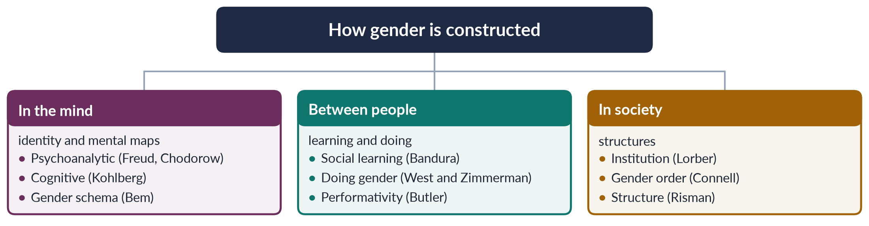
Figure 5 · The seven theories at a glance: from the mind to society.

10. The agents that construct gender in Pakistan
- Family: boys roam outside; girls learn housework early.
- School: textbooks show mothers cooking and fathers in offices.
- Religion and community: elders' advice on "proper" roles.
- Media: dramas reward the self-sacrificing wife.
- State and law: laws that assume a male head of household.

11. Critique

i) Weaknesses
Early theories made children look passive, but people resist and bargain. Strong constructionism can ignore the body — pregnancy and childbirth are real. And if gender is only local, why is male dominance so widespread?

ii) The modern answer
Most scholars now take an interactionist view: biology gives some tendencies, society shapes them, and people act on both.

iii) Which theory explains most?
No single theory is enough. Psychoanalytic and cognitive theories explain why gender feels so deep and personal; learning, doing gender and performativity explain how it is kept alive day by day; structural theories explain why it lasts even when individuals change their views. A policy to change gender in Pakistan must therefore work at all three levels — family and school, daily practice, and laws and institutions.

12. Conclusion
The theories place the making of gender in different places — the unconscious mind, learning, thinking, daily interaction, repeated performance and social structure. But they agree on one thing of great practical importance: gender roles are made, and what is made can be remade. For Pakistan, this means the gaps between women and men in literacy, work and power are not natural facts but social arrangements that education, law and daily practice can change.

Why this answer scores
- Every theory is named, linked to a thinker with a date, and explained by how it works.
- The theories move in order from the mind to society, shown in a tree diagram.
- Pakistani examples sit inside the headings.
- Short sub-headed paragraphs with key words in bold make it easy to mark.
- The critique and interactionist conclusion show judgement, not just memory.

Answer 3 · The Discipline of Gender Studies, and Women's Studies versus Gender Studies (CSS 2017)
AT A GLANCE · CSS 2017 · Q2 · 20 MARKS
Define and discuss the discipline of Gender Studies and also differentiate between Women's Studies and Gender Studies.

The answer map
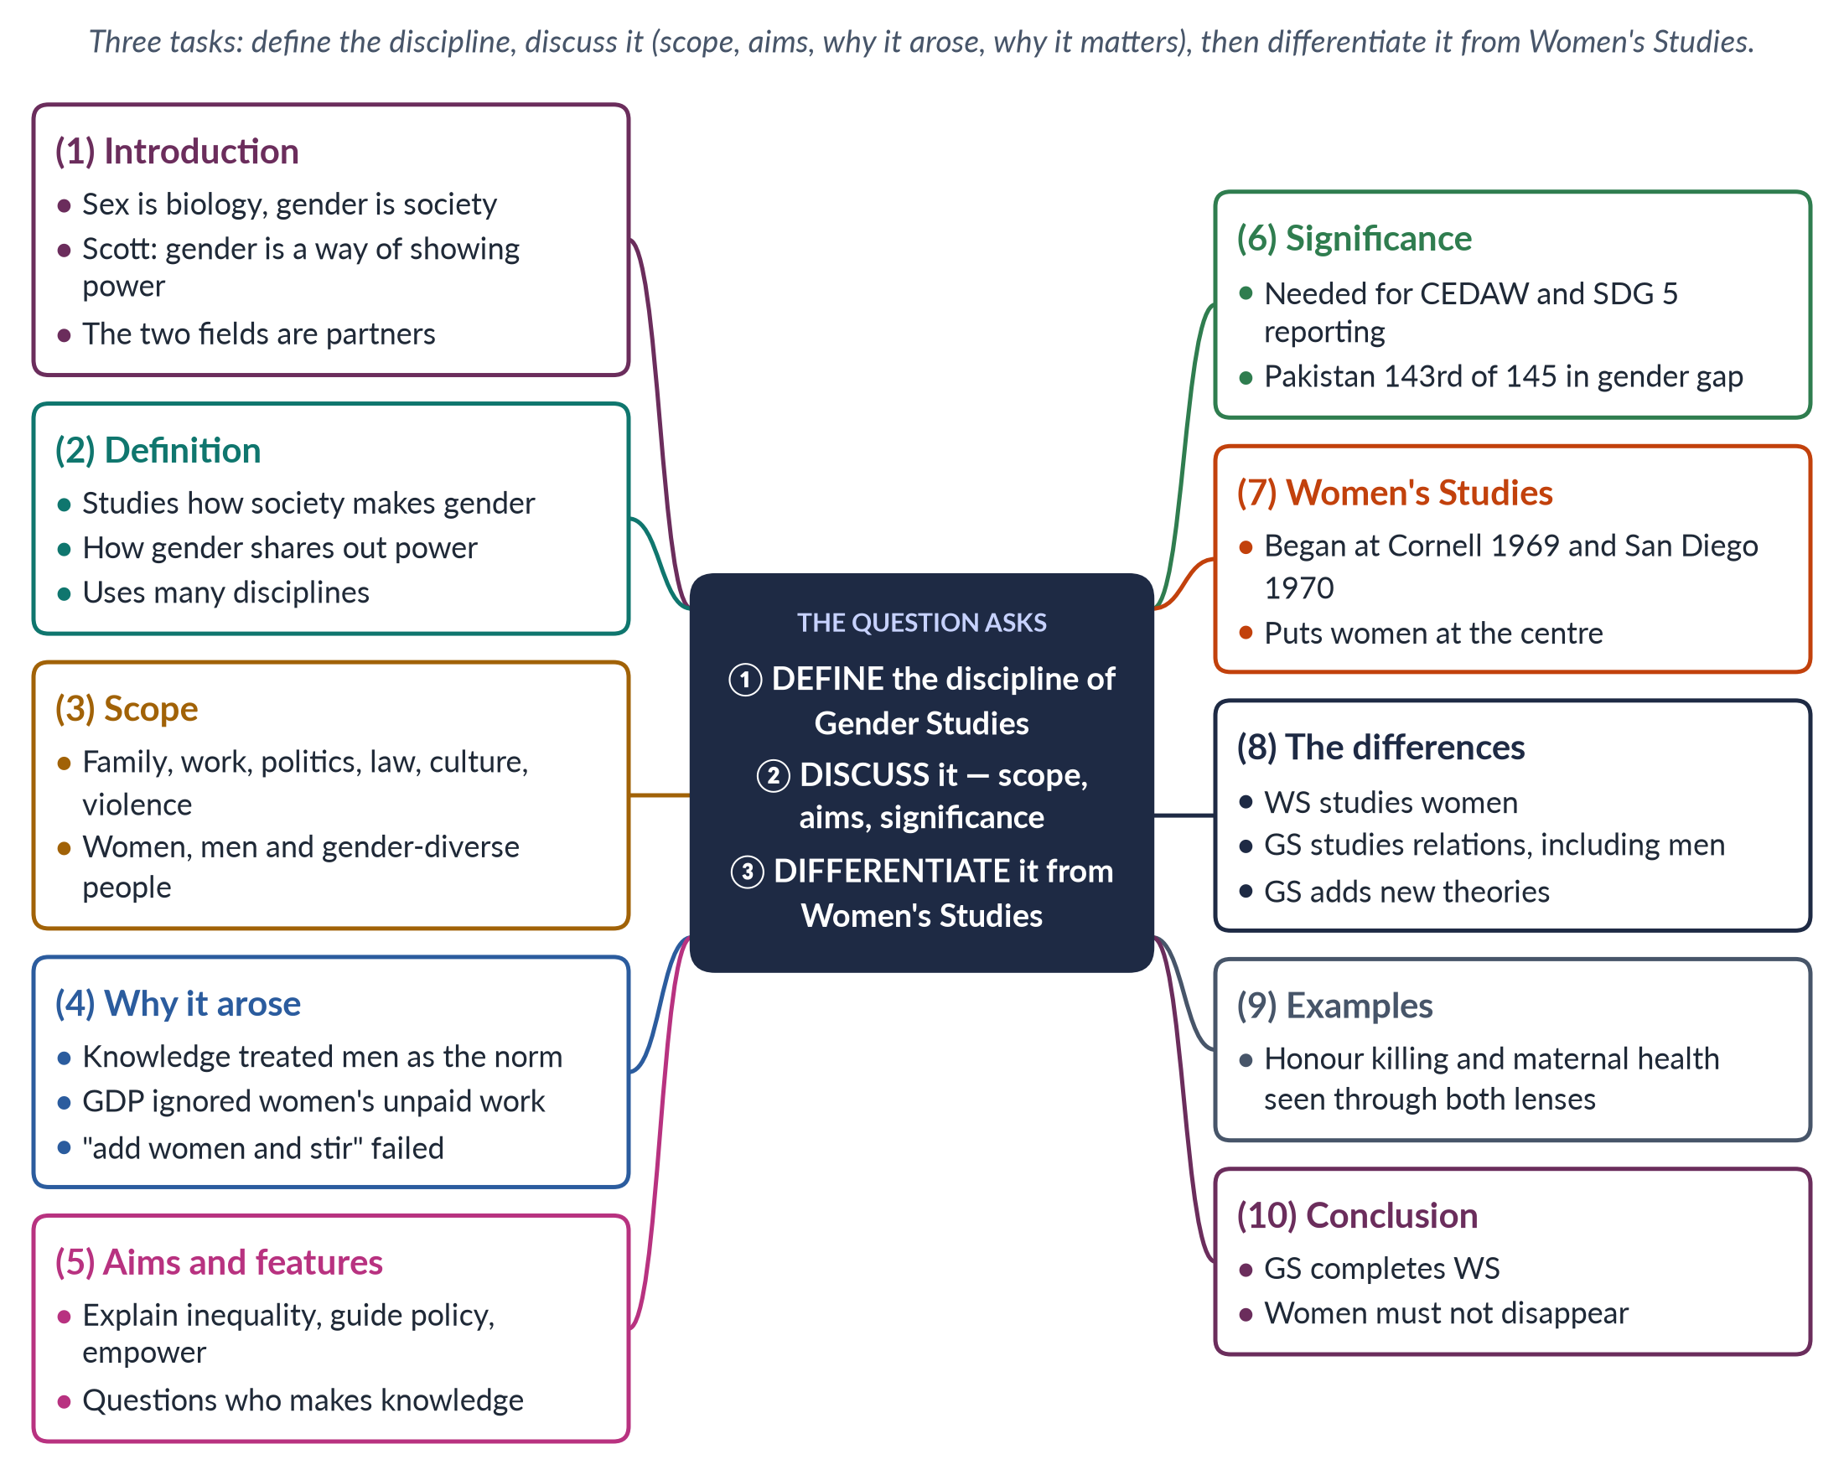
Figure 6 · The answer map: every branch is one numbered heading of the model answer below.

Decoding the question
Three command words. "Define" — give a precise definition. "Discuss" — explore the discipline: what it covers, why it arose, what it aims at and why it matters. "Differentiate" — give clear differences on named points, ideally in a table, with examples. "Discuss" carries the most marks.

The model answer

1. Introduction

i) Sex and gender
Sex means body differences between females and males. Gender means the roles, behaviour and power that society builds on those differences.

ii) Gender as power
The historian Joan Wallach Scott (1986) called gender "a primary way of signifying relationships of power" — one of the main ways a society shows who rules whom.

iii) The argument
Gender Studies is the discipline that studies this power. It grew out of Women's Studies and differs from it mainly by studying gender relations rather than women alone. Yet the two are best seen as partners in one project.

2. Defining the discipline
✦ DEFINITION
Gender Studies · the working definition
The academic field that studies how society makes femininity and masculinity, how this shares out power, money and chances between women, men and gender-diverse people, and how gender mixes with class, religion, race and other identities.
➜ Four key ideas: gender is made; it is about power; the field uses many disciplines; gender overlaps with other identities.

It is a discipline because it has its own departments, degrees, journals, ideas (patriarchy, gender roles, intersectionality) and methods. Its research methods include surveys, interviews, life histories and the analysis of laws, texts and budgets. It is multidisciplinary because it borrows from sociology, psychology, anthropology, history, economics, law and literature.

3. The scope of the discipline
Gender Studies covers every area where gender shapes life:
- identity and the body — how people become women, men or otherwise;
- family and home — marriage, care, inheritance, violence at home;
- work and economy — paid and unpaid work, the pay gap;
- politics and law — voting, representation, rights;
- culture — religion, language, media, education;
- global changes — globalisation, migration, climate change.
It studies women, men and gender-diverse people, and the ways gender overlaps with class, religion, ethnicity, disability and location.

4. Why the discipline arose

i) Men were the measure
Knowledge was androcentric — it treated men as the normal human. Carol Gilligan (1982) showed that theories of moral growth built on boys ranked girls' "ethic of care" as weaker.

ii) Women's work was invisible
Marilyn Waring (If Women Counted, 1988) showed that GDP ignores unpaid work — cooking, cleaning and caring.

iii) Adding women was not enough
"Add women and stir" — adding a chapter on women — left the old frameworks untouched. A field was needed that questioned them, and later studied men and relations too.

5. Aims and features

i) Aims
To make the invisible visible, to explain inequality (not just describe it), to question what looks natural, to guide policy and to empower.

ii) Features
It is committed to justice (joining study with action, called praxis); it asks who makes knowledge; and it is intersectional — it sees that a poor village woman and a rich city woman face different lives.

iii) Key ideas
The discipline's key ideas include patriarchy (a system of male power), gender roles (expected behaviour), socialisation (learning roles), intersectionality (overlapping disadvantages) and empowerment (gaining the power to choose).

6. Significance, especially for Pakistan
PAKISTAN ANGLE · WHY IT MATTERS HERE
Pakistan joined CEDAW in 1996 and promised SDG 5 (gender equality) by 2030. It ranked 143rd of 145 in the Global Gender Gap Report 2026, and only 24.4% of working-age women are in the labour force (LFS 2024–25). Understanding these gaps, and putting the laws on harassment (2010), honour crimes (2016) and violence at home into effect, needs gender expertise.

7. Women's Studies

i) Origin
Women's Studies began in the USA as "the academic arm of the women's movement": a course at Cornell (1969), the first programme at San Diego State (1970) and the National Women's Studies Association (1977).

ii) Features
It made women the subject of study, the knowers whose experience counts, and the beneficiaries of research.

iii) The shift to Gender Studies
From the 1980s, the idea of gender (Oakley 1972; Rubin 1975), men's studies (Connell 1987) and queer theory (about 1990) widened many programmes into Gender Studies.

iv) The same path in Pakistan
Pakistan's centres of 1989 began as "Women's Studies" centres; most have since renamed themselves "Gender Studies" departments — the same shift, a generation later.

8. The differences
Table 3 · Women's Studies and Gender Studies compared.
Point | Women's Studies | Gender Studies
Subject | Women's lives, history and work | Relations between women, men and gender-diverse people
Key idea | "Woman" and women's oppression | Gender as made by society and as power
Origin | Women's movement, late 1960s | Gender theory, men's studies, queer theory, 1980s–90s
Aim | Make women visible; end subordination | Explain the whole gender system
Theories | Liberal, radical, socialist feminism | Adds constructionism, queer theory, intersectionality
Risk | Treating all women as one group | Letting women disappear again

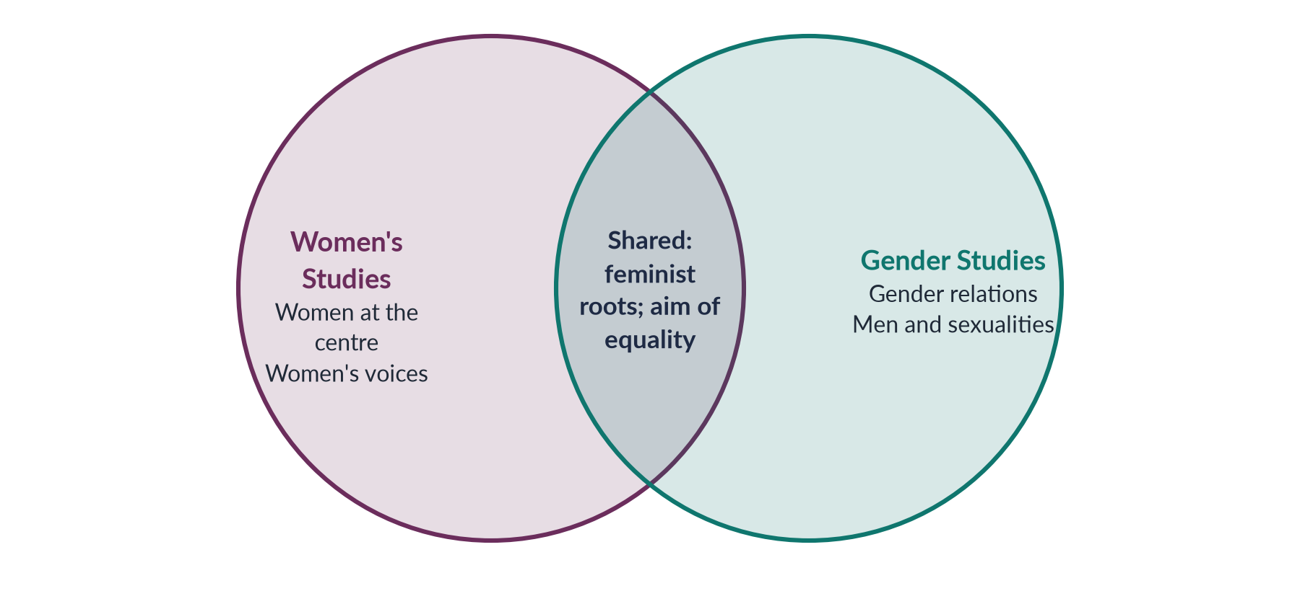
Figure 7 · What the two fields share, and what is distinctive to each.

9. Examples

i) Honour killing
Women's Studies centres the victims — their families' accounts and the failure of police to protect them. Gender Studies adds the killers and the system: how ghairat (honour) is taught to boys, how families bargain over "forgiveness", and how the law let killers escape until the 2016 amendment.

ii) Maternal health
Women's Studies records women's experience of childbirth. Gender Studies also studies who decides — husbands and mothers-in-law who control clinic visits, and male-led health budgets.

iii) Politics
Women's Studies counts women voters and legislators and the barriers they face. Gender Studies also studies how male party leaders choose candidates, and how a political culture of force and money keeps women out.

10. Conclusion
Gender Studies is the discipline that studies how gender is made and how it shares out power, across every part of life and every branch of knowledge. It differs from Women's Studies in its subject and key idea — relations rather than women alone — but not in its commitment. As Tania Modleski warned in Feminism Without Women (1991), the move to "gender" must not make women invisible again. In Pakistan, where women's basic health, education and work still need urgent attention, the two fields work best as partners. Women's Studies keeps the spotlight on women's lives; Gender Studies explains the system around them.

Why this answer scores
- All three command words — define, discuss, differentiate — have their own headings.
- The definition is simple and precise, and its key ideas are explained.
- "Discuss" is developed through scope, origins, aims and significance, with named evidence.
- A table, a Venn diagram and two examples make the differences concrete.
- The conclusion takes a clear view (partnership) and applies it to Pakistan.

Answer 4 · A Comprehensive Note on the Autonomy versus Integration Debate (CSS 2017)
AT A GLANCE · CSS 2017 · Q7 · 20 MARKS
Write a comprehensive note on the autonomy versus integration debate in Gender Studies.

The answer map
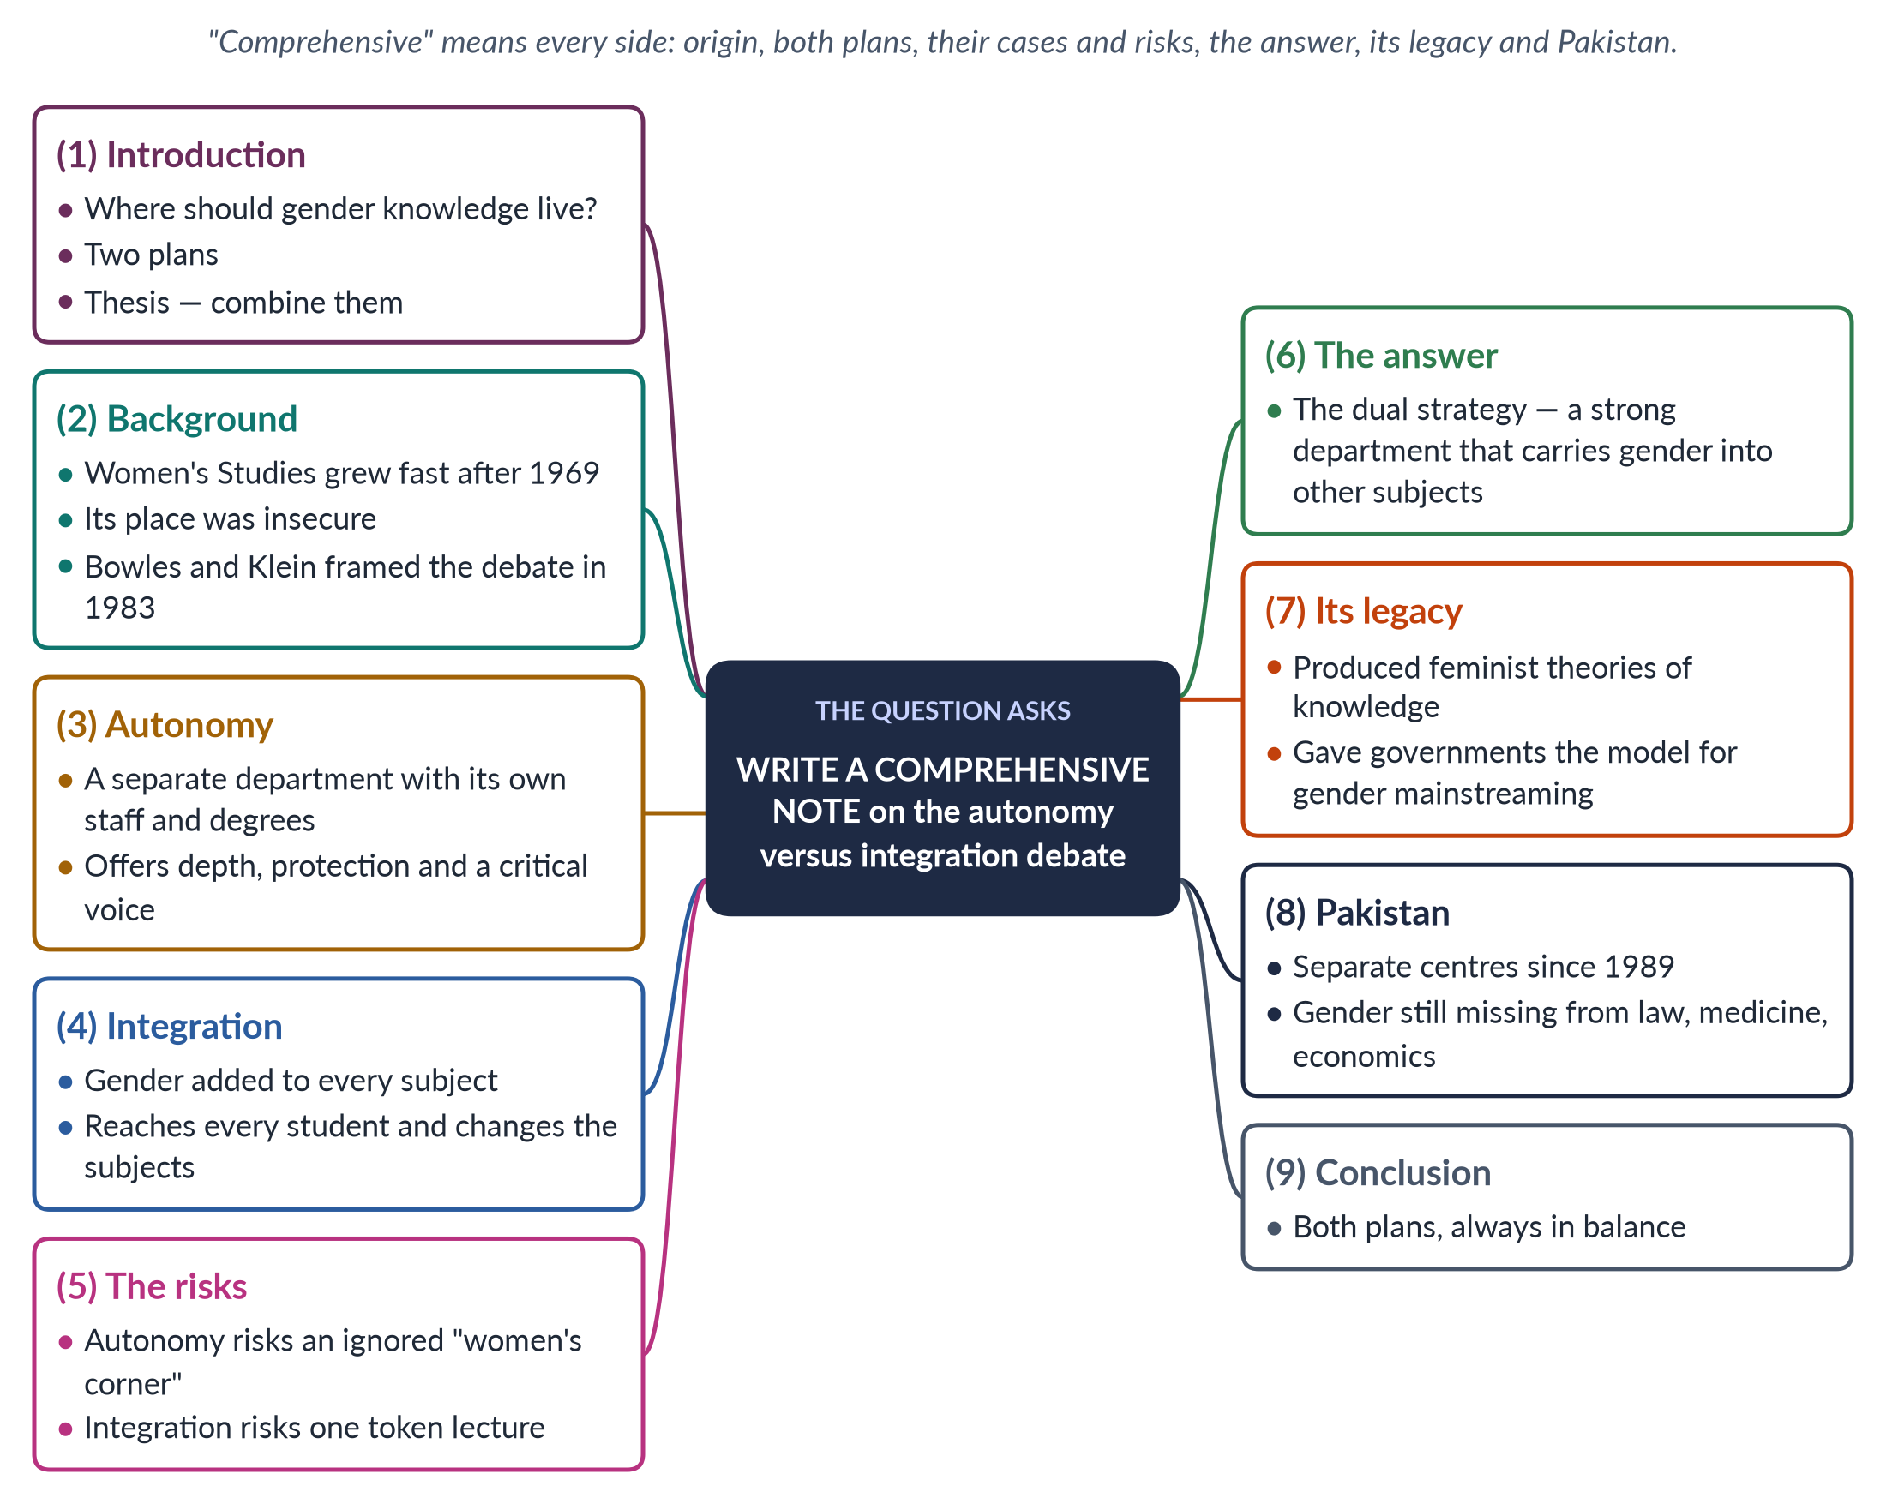
Figure 8 · The answer map: every branch is one numbered heading of the model answer below.

Decoding the question
"Write a comprehensive note" asks for full coverage, clearly organised: what the debate is, where it came from, both sides, their risks, how it is settled, and why it matters. "Comprehensive" warns against a one-sided answer. End with a judgement applied to Pakistan.

The model answer

1. Introduction

i) The question behind the debate
When Women's Studies entered universities in the late 1960s, its founders faced a big question: where should the new knowledge live? In a home of its own, or inside every existing home?

ii) The two plans
The first plan is autonomy (a separate department); the second is integration (gender in every subject). This is the autonomy versus integration debate.

iii) The argument
The debate shaped the field worldwide and is still a live choice in Pakistan. It is best settled not by choosing one side but by combining both.

2. Background

i) Rapid growth, insecure position
Women's Studies grew fast after the first course at Cornell (1969) and the first programme at San Diego State (1970). But its teachers were often junior women on short contracts, and critics called it ideology rather than scholarship.

ii) The book that framed the debate
Gloria Bowles and Renate Duelli Klein set out the debate in the introduction to Theories of Women's Studies (1983), a book on the FPSC reading list. They warned that integration without a strong separate base would water down feminist study.

iii) Why the question was urgent
Survival and influence were the same question seen from two sides. A separate department could survive as a recognised unit; integration could influence every other subject. The founders needed both, and argued over which should come first.

3. Autonomy

i) Meaning
Autonomy means Gender Studies as a separate department with its own teachers, courses, degrees, budget and research. In simple words: a house of its own. Example: a Department of Gender Studies awarding BS and PhD degrees.

ii) Arguments for autonomy
- Room for new ideas: new theories need a place where they are the main business.
- Depth: a full degree, not a single lecture.
- Protection: gender topics in other departments vanish when a friendly teacher leaves.
- Respect: degrees, budgets and journals show the field is serious.
- A critical voice: independence allows criticism of male bias elsewhere.

4. Integration

i) Meaning
Integration (or mainstreaming) means adding gender to the content of every subject. In simple words: changing everyone else's house. Example: a medical degree that teaches maternal health properly.

ii) Arguments for integration
- Relevance: economics without unpaid work, or medicine without women's bodies, is incomplete.
- Reach: every future doctor, lawyer and civil servant meets gender.
- No ghetto: gender is not left in a small corner.
- Real change: the subjects themselves are corrected.
- Cost and men: cheaper, and it involves men as teachers and students.

5. The risks of each plan

i) Ghettoisation — the risk of autonomy
The department becomes a small, separate "women's corner" — mostly female, ignored by others, and often dependent on donors.

ii) Dilution — the risk of integration
Gender is watered down to one token lecture, depends on a few willing teachers, and loses its expert depth.
IN SIMPLE WORDS
Autonomy is like a specialist hospital: deep expertise, but patients must travel to it. Integration is like training every family doctor: wide reach, but few experts. A health system needs both — and so does knowledge.

6. The answer: the dual strategy
Most universities now combine the two. Neither side "won" the debate; each supplied what the other lacked. In the dual strategy, a separate department trains specialists and does research, and works outward — training teachers of other subjects, sharing their courses and designing gender modules. Bowles and Klein themselves saw autonomy as the base from which integration should grow.
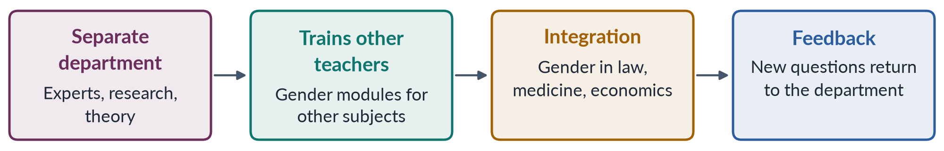
Figure 9 · The dual strategy: a separate base drives integration.

7. The legacy of the debate

i) New theories of knowledge
The integration project asked why subjects had ignored women. This produced feminist epistemology (the study of how we know). It changed research methods across the social sciences, encouraging research with women rather than on them. Sandra Harding (1986) asked whether "objective" science reflects the viewpoint of the men who made it.

ii) A model for governments
The dual strategy became the model for policy. The Beijing Platform for Action (1995) adopted a "twin track": gender mainstreaming in all policies (integration) plus special measures and women's ministries (autonomy).

iii) Institutions and curricula
The case for autonomy won departments, degrees and journals; the case for integration produced the curriculum transformation projects of the 1980s.

iv) A self-critical field
Constantly asking "are we being pushed aside, or swallowed up?" made the field self-critical. That habit helped it listen to Black, postcolonial and queer critics in the 1980s and 1990s, and to move from Women's Studies to Gender Studies.

8. The debate in Pakistan

i) Strong autonomy
Pakistan began with autonomy. The choice made sense: a new field needed a secure home before it could influence others. In 1989 the federal government set up Women's Studies centres at Quaid-i-Azam University and the Universities of Karachi, the Punjab, Peshawar and Balochistan. Many universities now offer degrees in Gender Studies.

ii) Weak integration
Most students of medicine, law, economics, engineering and education never meet gender. The risks of autonomy are visible: donor-dependent centres, mostly female students and little influence elsewhere.

iii) What Pakistan needs
Keep strengthening the departments, and deliberately carry gender into maternal health in medical colleges, family and criminal law in law schools, unpaid work in economics and gender-aware textbooks in teacher training. Local integration also answers the charge of a "Western agenda". When gender appears in a Pakistani law course on inheritance or a medical course on maternal deaths, it is plainly about Pakistan's own problems.

9. Conclusion
The autonomy versus integration debate asked where gender knowledge should live. Its answer is "in both places at once". Autonomy without integration leaves the field in a corner; integration without autonomy leaves it without experts. The balance must be kept every year: in good times departments can grow, while in budget cuts integrated teaching may be all that survives. The debate's lasting gift is the dual strategy — in universities and in government. In Pakistan, where the departments exist but the professions have barely begun to learn gender, the urgent task is now integration led by the departments.

Why this answer scores
- "Comprehensive" is honoured: origin, definitions, both cases, risks, the answer, legacy and Pakistan.
- Each plan has a simple definition with an example, then its arguments.
- The debate is credited to its source (Bowles and Klein, 1983), on the reading list.
- A flow diagram shows the dual strategy; a simple-words box explains the trade-off.
- The Beijing twin track link shows range; the Pakistani section shows relevance.

Answer 5 · Fundamental Differences between Gender Studies and Women's Studies; the Status of Women's Studies in Pakistan (CSS 2018)
AT A GLANCE · CSS 2018 · Q2 · 20 MARKS
What are the fundamental differences between Gender Studies and Women's Studies? Substantiate your argument(s) with examples. Highlight the current status of Women's Studies in Pakistan.

The answer map
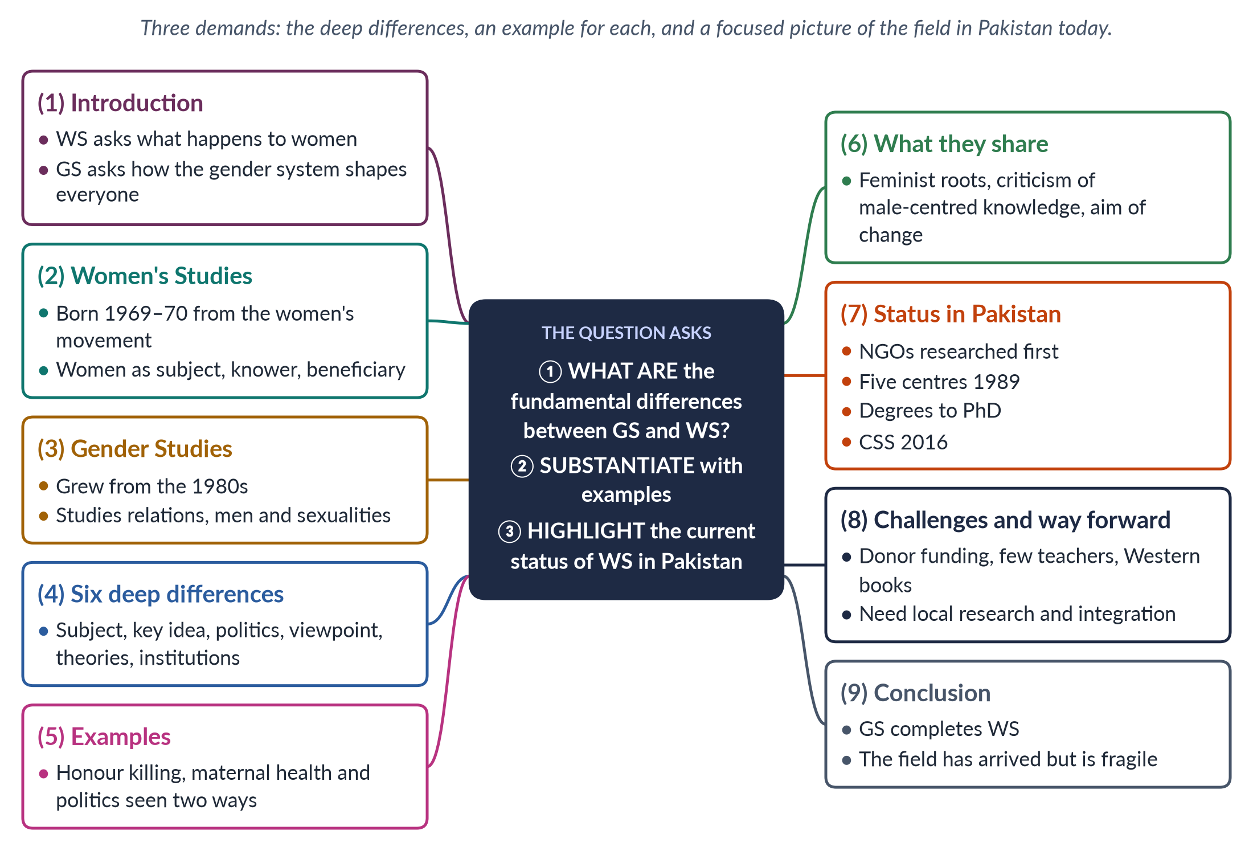
Figure 10 · The answer map: every branch is one numbered heading of the model answer below.

Decoding the question
"What are the fundamental differences" asks for the deep differences, not only a change of name. "Substantiate with examples" means every difference needs an illustration. "Highlight the current status" asks for a focused picture of the field in Pakistan today — institutions, achievements and problems.

The model answer

1. Introduction

i) Two related fields
Women's Studies and Gender Studies are often used as if they were the same. They are related — Gender Studies grew out of Women's Studies — but they differ in subject, key idea and politics.

ii) The difference in one line
Women's Studies asks what happens to women. Gender Studies asks how the whole gender system shapes everyone's life.

iii) Pakistan
In Pakistan both names are used, and the field they describe is established but still fragile.

2. Women's Studies

i) Origin
Women's Studies was born in American universities as "the academic arm of the women's movement": a course at Cornell (1969), the first programme at San Diego State (1970), and the National Women's Studies Association (1977).

ii) Its three features
Women became the subject of study, the knowers whose experience counts, and the beneficiaries of research. Its guiding question was: where are the women?

3. Gender Studies

i) Origin
From the 1980s many programmes became "Gender Studies". The idea of gender had grown — Ann Oakley (1972), Gayle Rubin's "sex/gender system" (1975), and Joan Scott's gender as "a primary way of signifying relationships of power" (1986).

ii) Wider subject
Men's studies (Raewyn Connell, 1987), queer theory (about 1990) and critics of a single "woman" widened the field to women, men, gender-diverse people and the relations between them.

4. The fundamental differences

i) Subject
Women's Studies studies women; Gender Studies studies gender relations. Example: one thesis records the lives of women home-based workers in Lahore; another studies how husbands, contractors and the law together shape that work.

ii) Key idea
Women's Studies centres on women's oppression; Gender Studies on gender as made by society and as power. Example: WS asks why women earn less; GS also asks why "providing" is tied to manhood, so men who earn less feel shamed.

iii) Politics
Women's Studies is openly woman-centred; Gender Studies keeps feminist roots but also studies masculinities and sexualities. Example: Gender Studies departments now research men's violence and transgender rights.

iv) Viewpoint and theory
Women's Studies uses research by and for women and liberal, radical and socialist feminism; Gender Studies uses many viewpoints and adds constructionism, queer theory and intersectionality. Example: a Women's Studies project on rural women might collect women's own life stories; a Gender Studies project might also interview husbands and elders, and use intersectionality to compare landless and landowning women.

v) Institutions
Pakistan's centres of 1989 were "Women's Studies" centres; most university units today are "Gender Studies" departments.

5. Examples that show the difference
Table 4 · One problem, two lenses.
Problem | Women's Studies lens | Gender Studies lens
Honour killing | The victims; failures of police and courts | Also ghairat and manhood; family bargaining over "forgiveness"; the law until 2016
Maternal health | Women's experience of childbirth and neglect | Also who decides — husbands, mothers-in-law, male-set budgets
Politics | Women voters and legislators; their obstacles | Also party gatekeeping by men; masculine political culture

These examples show why the difference is fundamental. Women's Studies documents a harm clearly; Gender Studies explains the system that produces it and finds where it can be broken. Policy needs both: proof of the problem, and a map of its causes.

6. What they share
Both share feminist roots, a rejection of male-centred knowledge, the use of many disciplines and an aim of change. Tania Modleski warned in Feminism Without Women (1991) that "gender" could hide women again — which is why many departments use the joint name "Women's and Gender Studies".
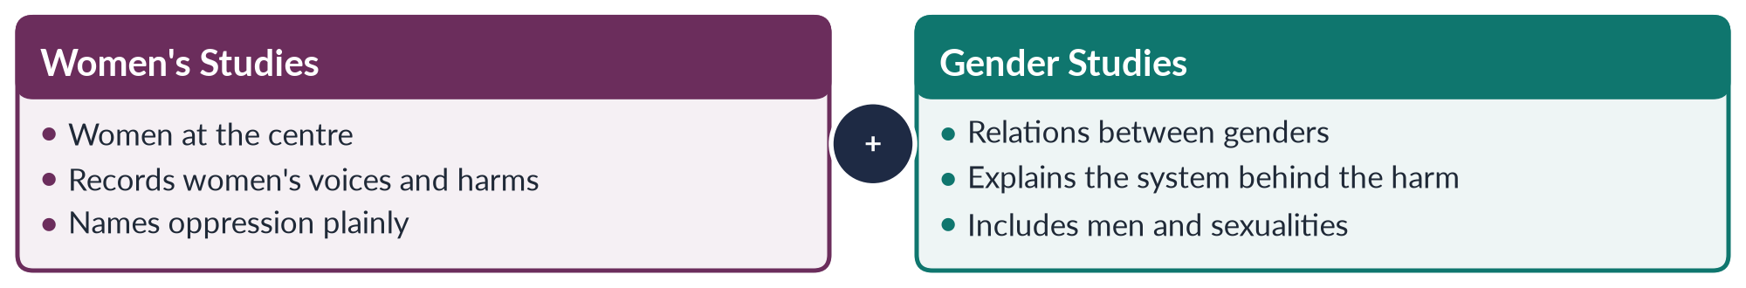
Figure 11 · Two lenses on one project.
The two fields also answer different policy needs. A ministry that wants to know how many girls are out of school needs the counting and recording of Women's Studies; a ministry that wants to know why — and what would change parents' decisions — needs the relational analysis of Gender Studies.

7. The current status in Pakistan

i) Early research
Research began with NGOs — Shirkat Gah (1975), the Women's Action Forum (1981), the Aurat Foundation (1986) — and with Mumtaz and Shaheed's Women of Pakistan (1987).

ii) Institutions
In 1989 the Ministry of Women's Development set up centres at Quaid-i-Azam University and the Universities of Karachi, Punjab, Peshawar and Balochistan. Many universities now offer BS, MPhil and PhD degrees; journals such as the Pakistan Journal of Gender Studies publish local work.

iii) Achievements
Research helped the laws on harassment (2010) and honour crimes (2016); graduates staff the National Commission on the Status of Women (2000); and the field became a CSS optional subject from CE-2016.

iv) Renaming
Most centres have renamed themselves "Gender Studies", and their research now covers masculinities, climate, digital harassment and transgender rights as well as women's legal status — the shift described in part one, happening in Pakistan.

8. Challenges and the way forward

i) Challenges
Donor-dependent funding, few trained teachers, a curriculum of Western books in English, weak data, social resistance to a supposed "Western agenda", and ghettoisation — mostly female students with little influence elsewhere.

ii) The way forward
Steady funding through the Higher Education Commission, PhD training, local research and books in Urdu, and integration of gender into law, medicine, economics and teacher training.

iii) An honest verdict
The field has arrived — degrees, journals, trained people and real influence on law. But it is not yet secure: its money comes and goes with donors, and its ideas have barely reached the other professions. Its strength in the next decade will depend on local roots and wider reach.

9. Conclusion
The fundamental difference between the two fields lies in their subject — women, or the gender system — and in the ideas and politics that follow. The examples show that Gender Studies does not replace Women's Studies but completes it by adding men, manhood and power. In Pakistan, the field has moved from activist research to university degrees and real influence on law; its next task is to secure its base and widen its reach. Both names will stay in use in Pakistan's universities — and both lenses will be needed.

Why this answer scores
- Five fundamental differences, each with its own sub-heading and example, as "substantiate" demands.
- A table and a comparison figure show the two lenses side by side.
- The status part is focused and current: early research, institutions, achievements, challenges.
- Key words in bold in short paragraphs make marking easy.
- The conclusion answers all three demands in one paragraph.

Answer 6 · An Essay on the Sex versus Gender Debate, Reflecting Nature versus Nurture (CSS 2018)
AT A GLANCE · CSS 2018 · Q3 · 20 MARKS
Write a comprehensive essay on the 'sex versus gender debate' in feminist philosophy and social sciences, reflecting the nature versus nurture argument.

The answer map
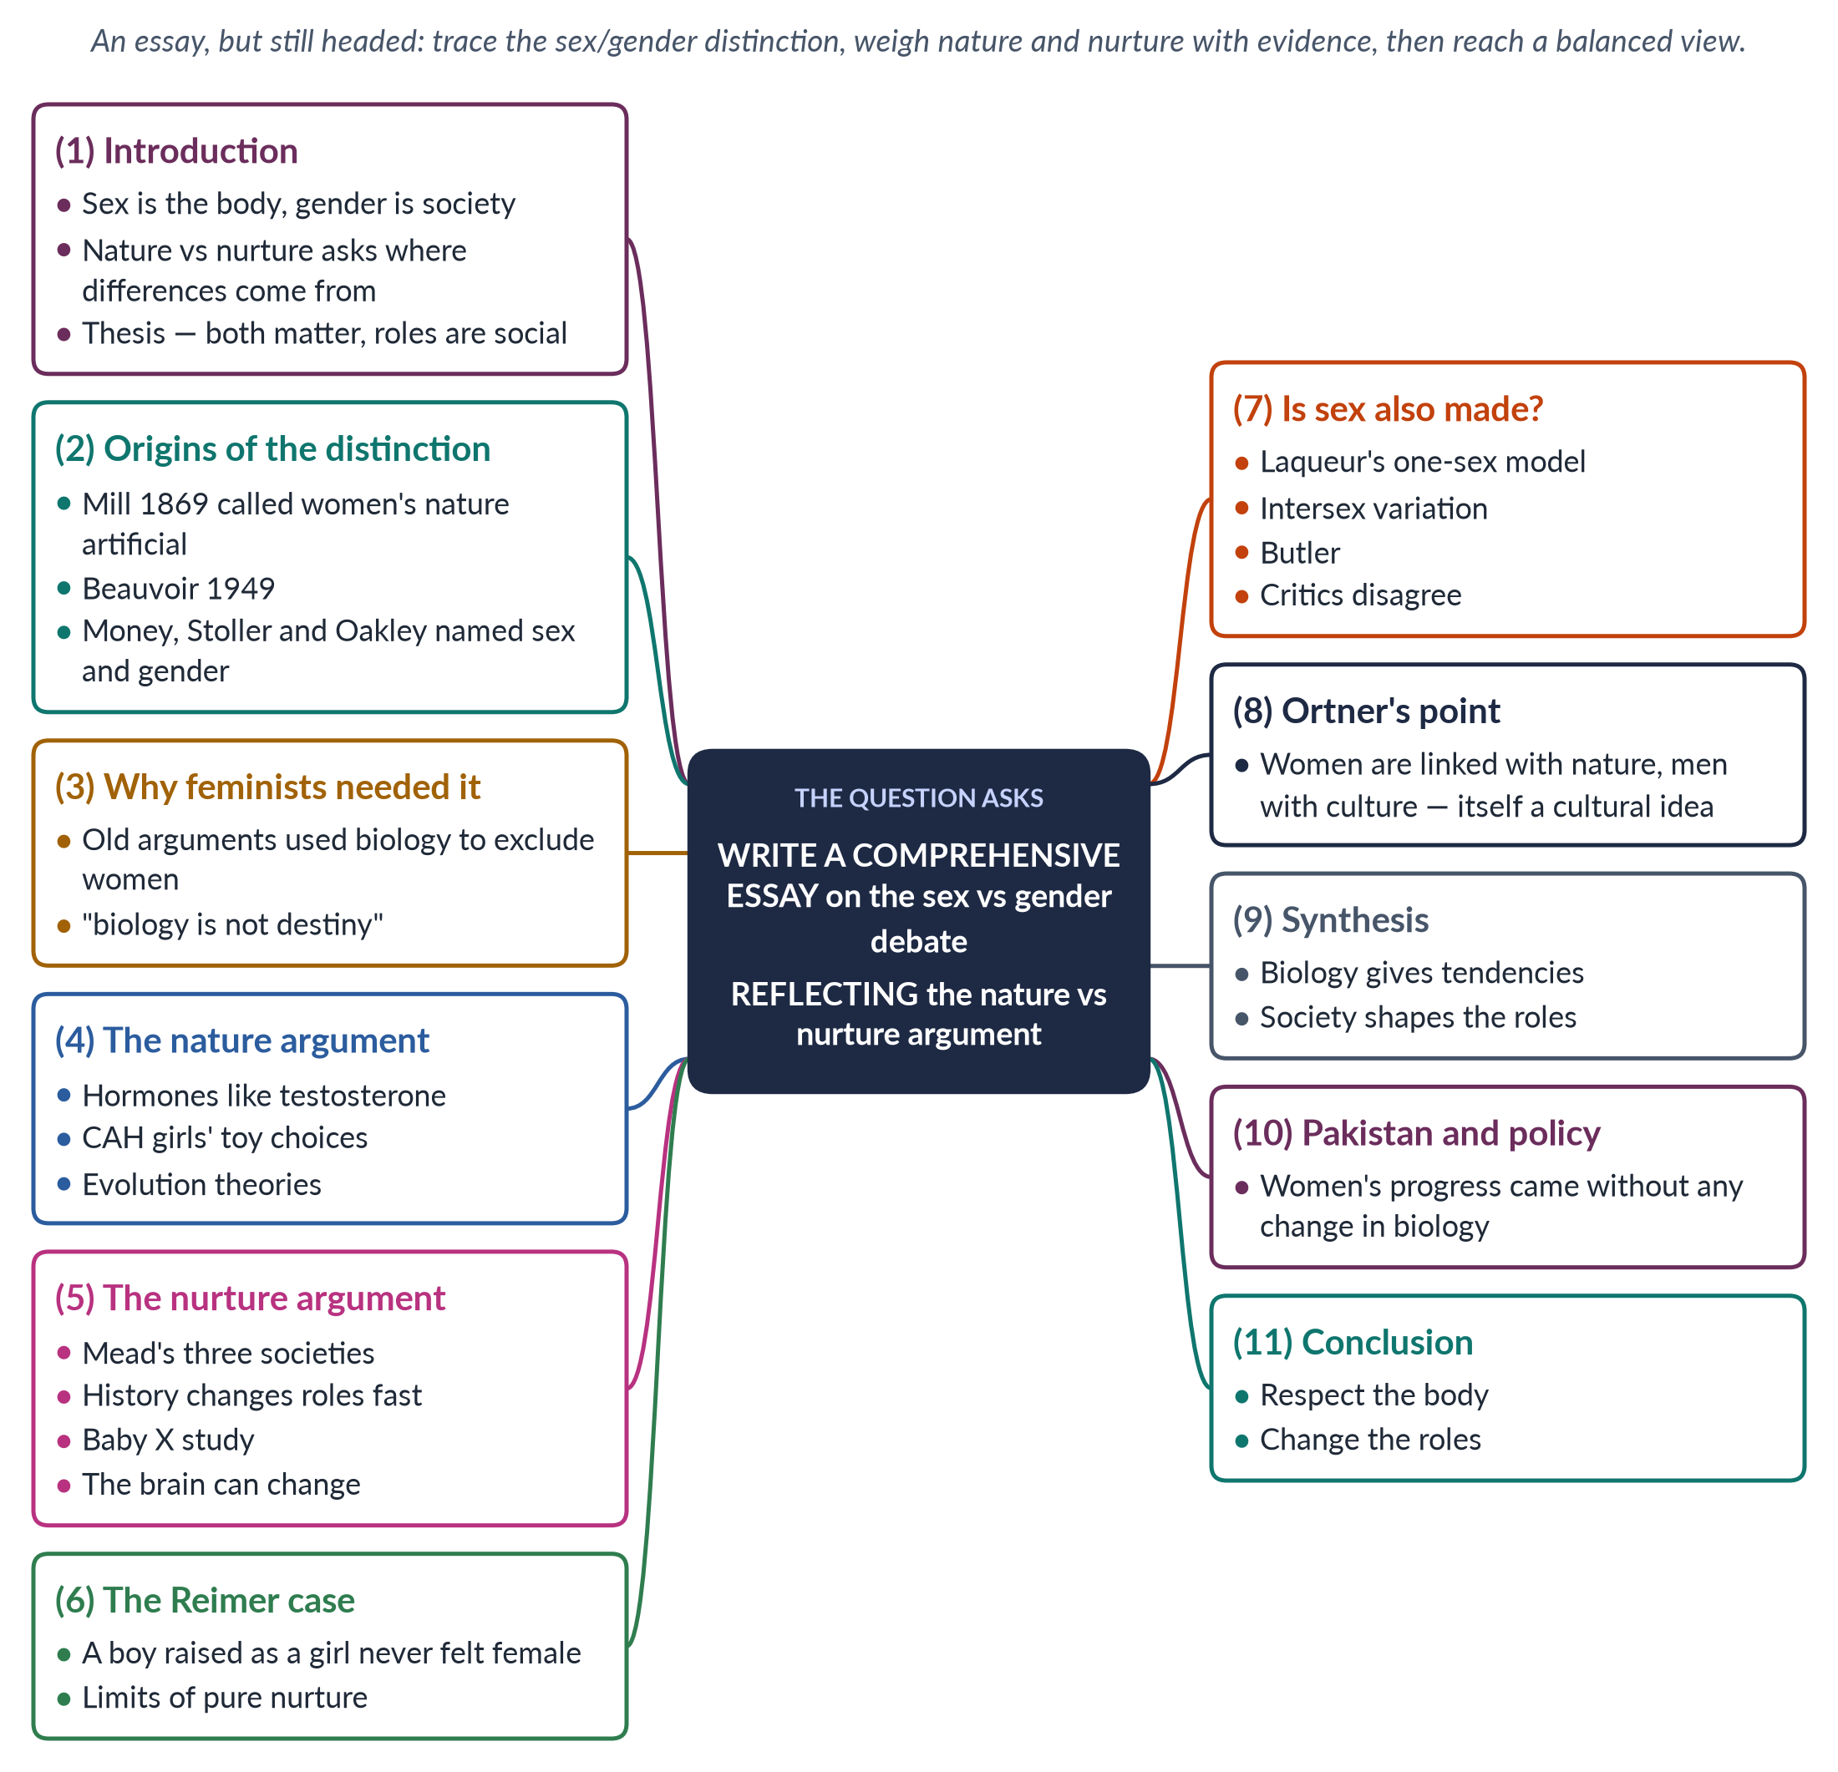
Figure 12 · The answer map: every branch is one numbered heading of the model answer below.

Decoding the question
"Write a comprehensive essay" allows a flowing style, but headings still help. The subject is the sex versus gender debate in two settings: feminist philosophy (Beauvoir, Butler) and the social sciences (Oakley, Mead, psychology). "Reflecting the nature versus nurture argument" means you must link the idea to the evidence: do differences come from biology or from upbringing?

The model answer

1. Introduction

i) The key terms
Sex means the body differences between females and males — chromosomes, hormones and organs. Gender means the roles, behaviour and identities that society builds on those differences.

ii) The two debates
The sex versus gender debate asks what is biological and what is social. The older nature versus nurture debate asks why women and men behave differently: because of genes and hormones, or because of upbringing.

iii) Why it matters, and the argument
The stakes are high. If women's position is natural, it cannot be changed; if it is social, it can. This essay argues that the evidence supports interaction: biology gives some tendencies, but society builds, ranks and can rebuild the roles.

2. Where the distinction came from

i) Early voices
The idea is old. John Stuart Mill wrote in 1869 that "what is now called the nature of women is an eminently artificial thing" — made by how women are treated. Simone de Beauvoir (1949) wrote: "One is not born, but rather becomes, a woman."

ii) The words themselves
The terms came from psychology and medicine. John Money first used "gender role" in 1955. Robert Stoller (Sex and Gender, 1968) separated biological sex from gender identity (the inner sense of self). Ann Oakley (Sex, Gender and Society, 1972) brought the distinction into sociology: sex is biological; gender is cultural.

3. Why feminists needed the distinction

i) Biology used against women
For centuries women's exclusion from education, property and politics was justified by "nature" — from Aristotle, who saw the female as an incomplete male, to Victorian doctors who warned that study would damage women's health.

ii) Breaking the chain
The sex/gender distinction broke this chain of reasoning. Feminists could accept real body differences, such as pregnancy, while denying that they decide who should vote, work or lead. "Biology is not destiny" became a slogan of the second wave of the women's movement.

4. The nature argument

i) Hormones
Before birth and at puberty, testosterone shapes the body and, many researchers argue, some behaviour.

ii) A natural experiment
Girls with congenital adrenal hyperplasia (CAH) are exposed to high male hormones before birth. On average they show a greater liking for toys usually preferred by boys (Berenbaum and Hines, from 1992).

iii) Averages and evolution
Across many societies, men are on average stronger and more physically aggressive. Sociobiology (E. O. Wilson, 1975) and evolutionary psychology argue that evolution gave men and women different strategies that still shape behaviour.

5. The nurture argument

i) Different cultures
Margaret Mead (1935) found gentle men and women among the Arapesh, fierce men and women among the Mundugumor, and women in charge among the Tchambuli. The same biology produced very different "masculine" and "feminine" behaviour.

ii) Fast change in history
In the World Wars women did "men's work" in factories. Within two generations women became most university students in many countries. Biology did not change; society did.

iii) Adults treat babies differently
In "Baby X" studies (Condry and Condry, 1976), adults watched the same baby cry. Told it was a boy, they called it angry; told it was a girl, they called it afraid.

iv) The brain can change
Cordelia Fine (Delusions of Gender, 2010) showed that many claimed brain differences are weak. Daphna Joel (2015) found that most brains are a "mosaic", not simply male or female.
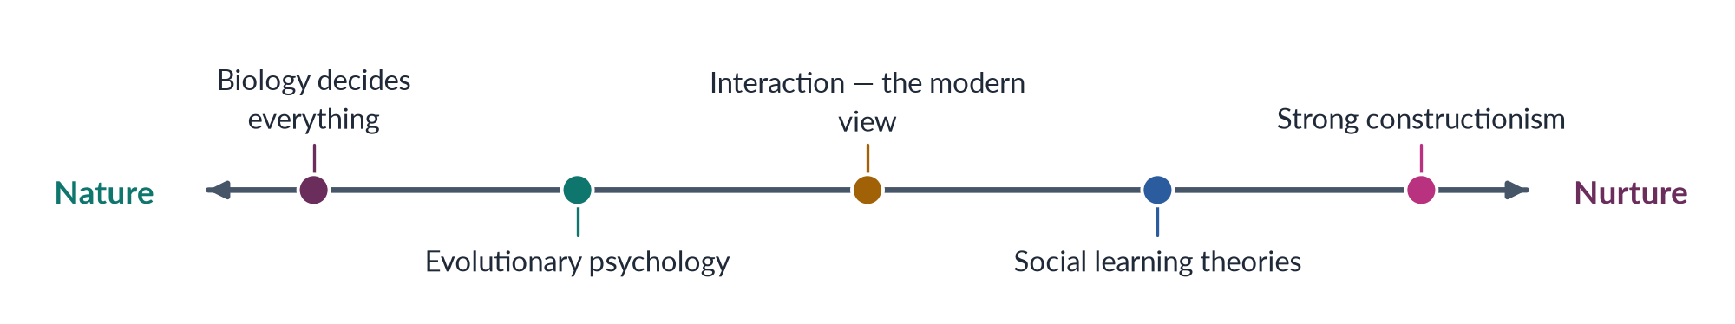
Figure 13 · Where the positions stand in the nature–nurture debate.

6. The David Reimer case
In 1966 a Canadian baby boy, David Reimer, lost his penis in a failed circumcision. On John Money's advice he was raised as a girl, and Money reported the case as proof that gender is learnt. In fact Reimer never felt female, returned to living as a man in his teens, and later spoke of the harm done to him. The case warns against pure nurture — and against forcing any gender on a person.

7. Is sex also made by society?

i) The case for yes
Thomas Laqueur (Making Sex, 1990) showed that Europe moved from a one-sex model (the female body as an inside-out male body) to a two-sex model in the eighteenth century, partly for social reasons. Intersex variation — about 0.018% to 1.7% of births, depending on the definition — shows that bodies do not always fit two boxes. Judith Butler (1990) suggested that sex may be "always already gender".

ii) The case for no
Critics reply that reproduction needs two kinds of cells, that most people fit clearly, and that sorting bodies is not creating them.

8. Ortner: nature and culture as a gendered pair
The anthropologist Sherry Ortner ("Is Female to Male as Nature Is to Culture?", 1974) noticed that cultures everywhere link women with nature (childbirth, home) and men with culture, and rank culture higher. The very idea that women are "closer to nature" is therefore cultural — part of what the debate must explain.

9. The synthesis: interaction
Most scholars now take an interactionist view:
- biology gives tendencies and limits, not destiny;
- culture shapes, strengthens or reverses them;
- the two act on each other throughout life.
In short, sex is a biological reality whose meaning and consequences are social, and gender is a social creation that works on real bodies.

10. Pakistan and policy

i) The evidence at home
Women's literacy has risen to about 53% (Census 2023). Women now serve as Supreme Court judges, fighter pilots and, since 2024, a provincial chief minister. None of this needed a change in biology — only in education, law and opportunity.

ii) The policy lesson
Remove the social barriers that gender creates, and meet the real bodily needs of sex, such as maternal health care. When someone says women are "naturally" unfit for politics or engineering, the distinction lets us ask for evidence — and Pakistani women's achievements are the answer.

11. Conclusion
The sex/gender distinction freed women from the argument that the body decides their destiny; the nature–nurture debate supplied the evidence for and against that freedom. Nature explains some average differences; nurture explains their form, their ranking and their variety across cultures and centuries. The wisest conclusion is neither biological determinism nor pure constructionism, but an interaction that respects the body while insisting that the roles built on it are human-made — and so open to change.

Why this answer scores
- It covers both settings named in the question: feminist philosophy and the social sciences.
- The nature–nurture debate is argued with evidence on both sides, not opinion.
- The Reimer case and the "is sex made?" section show depth and balance.
- A spectrum diagram places the positions at a glance.
- A clear thesis runs from introduction to conclusion, applied to Pakistan and policy.

Answer 7 · Gender Studies versus Women's Studies; the Historical Need, Scope and Significance of Gender Studies, with Reference to Pakistan (CSS 2019)
AT A GLANCE · CSS 2019 · Q2 · 20 MARKS
How do you differentiate the discipline of Gender Studies from that of Women's Studies? Historically trace the need for the establishment of Gender Studies as a distinct discipline and its scope and significance, with special reference to Pakistan.

The answer map
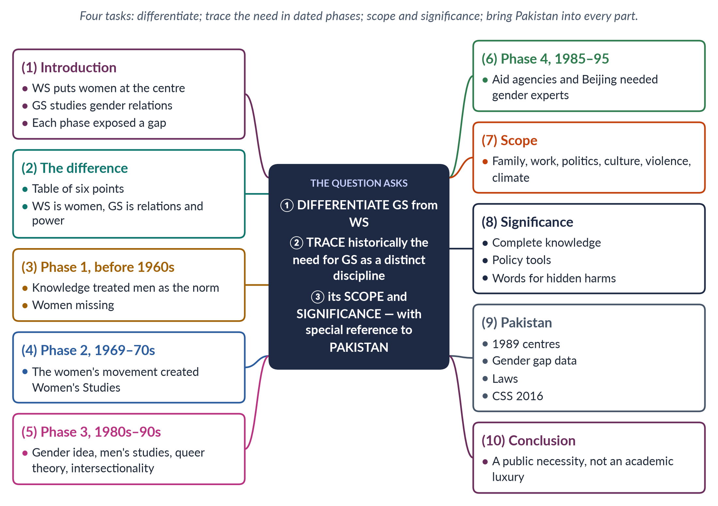
Figure 14 · The answer map: every branch is one numbered heading of the model answer below.

Decoding the question
"How do you differentiate" asks for the differences, best in a table. "Historically trace the need" asks for a chronological account of why a separate discipline had to be created — in dated phases. "Its scope and significance" asks what it covers and why it matters. "With special reference to Pakistan" applies to the whole answer, not just one paragraph.

The model answer

1. Introduction

i) Definitions
Women's Studies is the field, begun around 1969–70, that puts women at the centre of study. Gender Studies studies how society makes femininity and masculinity, how this shares out power, and how gender overlaps with class, religion and other identities.

ii) The argument
Gender Studies became a separate discipline because, phase by phase, scholars, activists and governments found that a women-only lens — valuable as it was — could not explain the whole system of gender. In Pakistan, where the gaps between women and men are among the widest in the world, that discipline is a practical necessity.

2. How the two differ
Table 5 · Women's Studies and Gender Studies.
Point | Women's Studies | Gender Studies
Subject | Women's lives, history and experience | Relations among women, men and gender-diverse people
Key idea | "Woman"; women's oppression | Gender as made by society and as power
Period | Late 1960s onwards | 1980s–1990s onwards
Theories | Liberal, radical, socialist feminism | Adds constructionism, queer theory, intersectionality
Includes men? | Rarely | Yes — masculinities are a core subject
In Pakistan | The centres of 1989 | Today's Gender Studies departments

3. The historical need — Phase 1: knowledge without women (before the 1960s)

i) Men as the measure
For centuries knowledge was androcentric — it treated men as the normal human. History told the story of kings and wars; psychology studied boys; medicine tested medicines on men; economics counted only paid work.

ii) "Nature" as an excuse
Women's exclusion was justified as natural, from Aristotle to Victorian science. The first need was simple: half of humanity was missing from what universities taught.

4. Phase 2: the women's movement creates Women's Studies (1960s–1970s)

i) Questions without answers
The second-wave women's movement asked why women earned less, why violence at home was ignored and why so few women held power. Universities had no answers.

ii) A new field
Women's Studies was born as "the academic arm of the women's movement": a course at Cornell (1969), the first programme at San Diego State (1970), the National Women's Studies Association (1977). In South Asia, India's report Towards Equality (1974) sparked a similar movement.

5. Phase 3: the limits of Women's Studies (1980s–1990s)
Women's Studies soon met its own limits, which created the need for Gender Studies:
1. The idea of gender showed that the real subject was a relationship: Oakley (1972), Rubin's "sex/gender system" (1975), Scott's gender as "a primary way of signifying relationships of power" (1986).
2. Men are gendered too. Connell's Gender and Power (1987) showed that manhood has its own rankings and costs.
3. Gender diversity. Queer theory (about 1990) brought in people the two-box model ignored.
4. "Woman" is not one group. bell hooks (1981) and Chandra Talpade Mohanty (1984) showed that Women's Studies often described only white, Western, middle-class women. Intersectionality (Crenshaw, 1989) — the idea that disadvantages overlap — became central.

6. Phase 4: governments need gender experts (1985–1995)

i) From WID to GAD
Aid agencies found that projects aimed only at "women" left power relations untouched. They moved from Women in Development to Gender and Development.

ii) Beijing
The Beijing Platform for Action (1995) made gender mainstreaming — checking every policy for its effect on women and men — a world-wide promise. This created demand for gender expertise that only a separate discipline could supply.
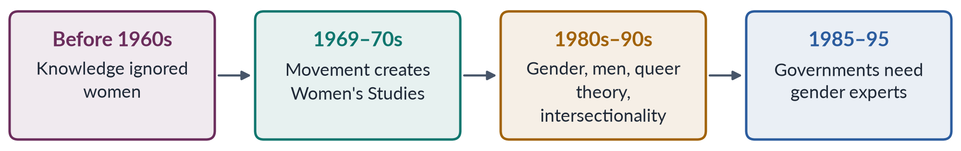
Figure 15 · Why a distinct discipline of Gender Studies was needed: four phases.

7. The scope of Gender Studies

i) What it covers
Identity and the body; family and home; work and the economy; politics, law and the state; culture, religion, language and media; violence and security; and global changes — colonialism, globalisation, migration and climate change.

ii) A widening scope
Today it also studies digital harassment, bias in data and artificial intelligence, care work and migration, and the lives of gender-diverse people. In Pakistan, research ranges from home-based workers in Punjab to women in the 2022 floods in Sindh and Balochistan.

8. The significance of Gender Studies

i) Academic
It produces complete, less biased knowledge and new ideas — the care economy, intersectionality, gender budgeting.

ii) Policy
It supplies the data and analysis governments need for gender mainstreaming, gender budgeting and reports under CEDAW and the SDGs.

iii) Social
It gives society words for hidden harms — harassment, domestic violence, unpaid care — so they can be named and remedied.

9. With special reference to Pakistan

i) How the need was felt here
The need was first felt by activists and researchers — Shirkat Gah (1975), the Women's Action Forum (1981), the Aurat Foundation (1986). Before 1989 there was almost no systematic data on women's work, health or legal status.

ii) The universities respond
In 1989 the government set up Women's Studies centres at Quaid-i-Azam University and the Universities of Karachi, Punjab, Peshawar and Balochistan. Most have since become Gender Studies departments. CEDAW (joined 1996) and the gender machinery of the 2000s — the National Commission on the Status of Women (2000) and the Gender Reform Action Plan — needed trained specialists.
PAKISTAN ANGLE · WHAT THE DISCIPLINE DOES FOR PAKISTAN
Pakistan ranked 143rd of 145 in the Global Gender Gap Report 2026. Only 24.4% of working-age women are in the labour force (LFS 2024–25) and women's literacy is about 53% (Census 2023). Explaining these gaps, designing the laws of 2010–2025 on harassment, honour crimes and violence at home, and training the staff of the NCSW all need gender expertise. Gender Studies became a CSS optional subject from CE-2016.

iii) Remaining challenges
The field still faces donor-dependent funding, few trained teachers and the charge of being a "Western agenda". Its answer must be careful research rooted in Pakistan's own society.

10. Conclusion
Gender Studies differs from Women's Studies by studying gender relations rather than women alone. It was needed because, phase by phase, knowledge, movements and governments found that a women-only lens could not explain the whole system — its men, its sexualities, its overlaps and its policies. Its scope is as wide as social life, and its significance is academic, political and social. In Pakistan, where gender gaps shape the nation's development, it is not an academic luxury but a public necessity.

Why this answer scores
- All four demands have their own headings, and Pakistan runs through the answer.
- "Historically trace" is answered in order, in four dated phases, shown in a flow diagram.
- The difference is set out in a clear table.
- Scope and significance are separated, each with evidence.
- Short sub-headed paragraphs with key words in bold make the answer easy to mark.

Answer 8 · Deconstructing the Word "Gender" (CSS 2020)
AT A GLANCE · CSS 2020 · Q2 · 20 MARKS
Gender has multiple meanings. How do you deconstruct the word 'GENDER'?

The answer map
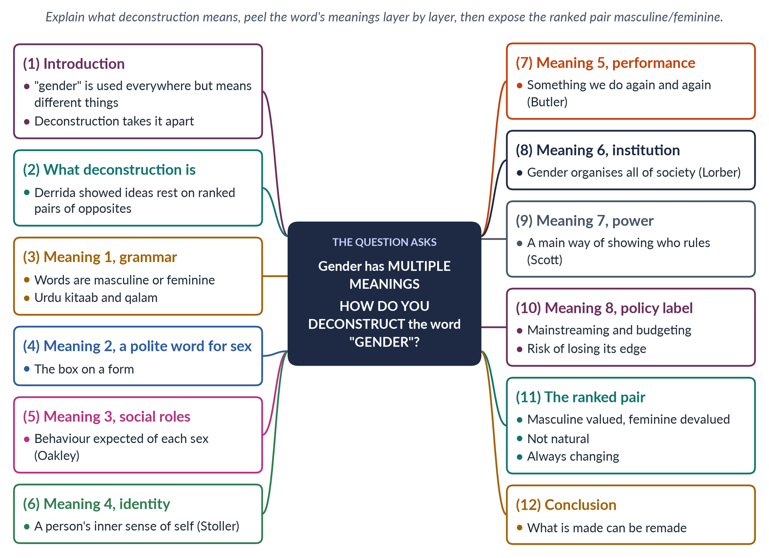
Figure 16 · The answer map: every branch is one numbered heading of the model answer below.

Decoding the question
The question gives a claim — gender has multiple meanings — and asks "how do you deconstruct" the word. "Deconstruct" is a technical word: it means taking an idea apart to show its layers, hidden assumptions and rankings. The examiner wants (a) what deconstruction means, (b) the different meanings of gender, each with a thinker, and (c) the ranked pair masculine/feminine that the word hides.

The model answer

1. Introduction

i) A word used everywhere
Few words are used as often as "gender" — on official forms, in aid projects, in university departments, in sermons and on television. Yet it rarely means the same thing twice.

ii) What the answer will do
To deconstruct the word is to take it apart, show the layers of meaning packed into it, and expose the assumptions and rankings it hides. Taken apart, "gender" is not one thing but a set of meanings running from grammar to identity to power — and at its centre lies a ranked pair that is social, not natural.

2. What deconstruction means

i) Derrida's idea
The French philosopher Jacques Derrida (Of Grammatology, 1967) argued that Western thinking is built on pairs of opposites — reason/emotion, culture/nature, mind/body, public/private. In each pair the first word is treated as better and the second as lower. To deconstruct is to reveal these rankings and show that the opposition is made, not natural.

ii) Why feminists used it
Feminists noticed that the "better" side of each pair is linked with men (reason, culture, public life) and the "lower" side with women (emotion, nature, home). So deconstruction became a feminist tool.

3. Meaning 1 — gender as grammar
The word comes from the Latin genus ("kind"), through Old French gendre. For centuries it meant only grammar. In Urdu, kitaab (book) is feminine and qalam (pen) masculine, verbs change with the speaker's gender, and a mixed group is addressed in the masculine. This oldest meaning shows how deeply a two-gender division is built into language.

4. Meaning 2 — a polite word for sex
On forms and in daily speech, "gender" often simply means "male or female". This is the loosest meaning. It hides the very distinction the concept was created to make, and treats social roles as if they were as fixed as the body. When a form asks for "gender" but offers only "male" and "female", it quietly treats a social idea as a fact of biology.

5. Meaning 3 — gender as social roles
For Ann Oakley (Sex, Gender and Society, 1972), gender is cultural: the roles, behaviour and expectations society attaches to each sex — the man as earner, the woman as homemaker. In this sense gender changes between societies and over time. Example: in parts of rural Pakistan a married woman is expected to stay at home; in Pakistan's cities many married women work in banks and offices.

6. Meaning 4 — gender as identity
Since Robert Stoller (Sex and Gender, 1968), gender also means a person's inner sense of self — being a woman, a man, both or neither. This meaning is at stake in debates on transgender rights, including Pakistan's Transgender Persons (Protection of Rights) Act 2018.

7. Meaning 5 — gender as performance
For Candace West and Don Zimmerman ("Doing Gender", 1987), gender is something we do in daily life. For Judith Butler (Gender Trouble, 1990), it is performative — repeated acts create the appearance of a natural gender. Here gender is a verb, not a noun. If gender is something done, it can also be done differently.

8. Meaning 6 — gender as an institution
For Judith Lorber (Paradoxes of Gender, 1994), gender is a social institution, like the economy or religion, that organises all of social life. For Barbara Risman (2004), it is a social structure working on individuals, interactions and institutions. Example: inheritance customs, dowry and the lack of childcare at work shape women's lives whatever individuals believe.

9. Meaning 7 — gender as power
✦ QUOTATION
Joan Wallach Scott · "Gender: A Useful Category of Historical Analysis" (1986)
"Gender is a constitutive element of social relationships based on perceived differences between the sexes, and gender is a primary way of signifying relationships of power."
➜ In simple words: gender is a main way of showing and justifying power — used to rank not only women and men, but even nations ("the motherland") and political rivals ("unmanly").

10. Meaning 8 — gender as a policy label
Since the 1990s "gender" has become a technical word of governments and donors — gender mainstreaming, gender budgeting, gender focal persons. Critics warn that in this sense the word can lose its political meaning, becoming a box to tick rather than a power relation to change.
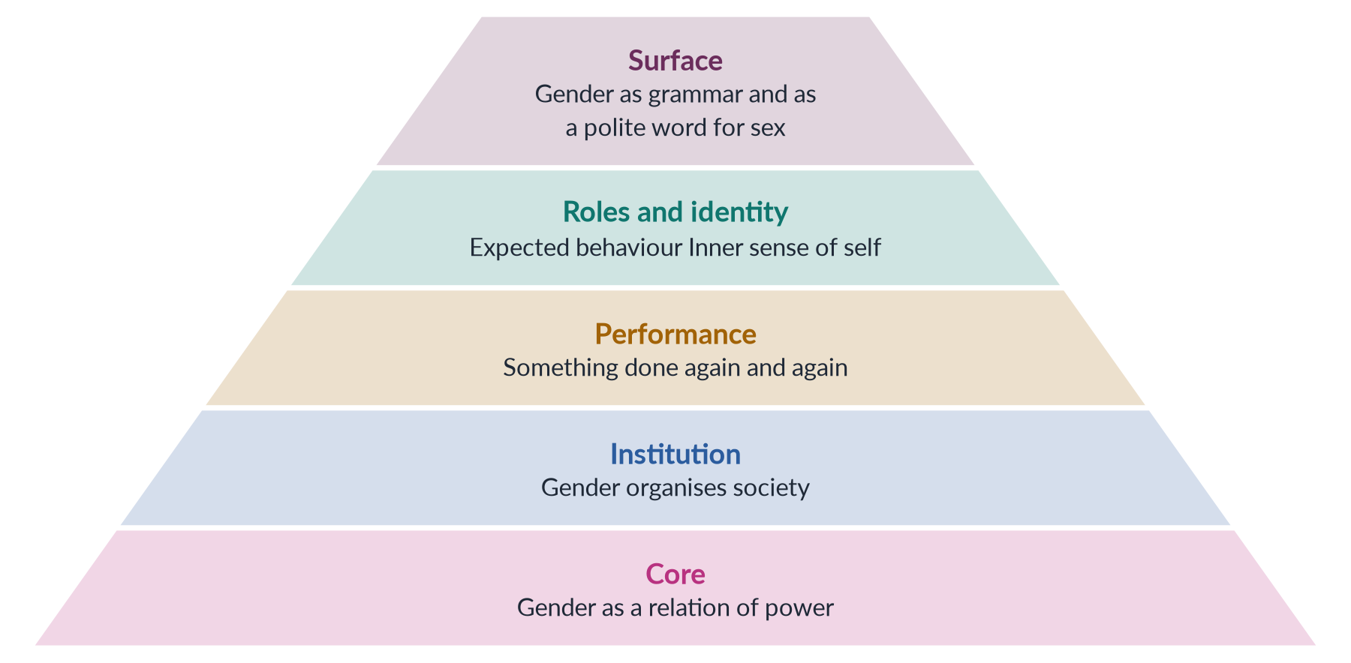
Figure 17 · Deconstructing "gender": from the surface meaning down to the deepest layer.
IN SIMPLE WORDS
To deconstruct "gender" is like peeling an onion: under the everyday meaning ("male or female") lie roles, under the roles lie identities and performances, and at the centre lies a structure of power.

11. The ranked pair inside "gender"
Table 6 · The pair packed inside "gender".
"Masculine" (valued more) | "Feminine" (valued less)
Reason | Emotion
Strength | Weakness
Culture | Nature
Public life | Home
Independence | Dependence
Leadership | Obedience

i) It is ranked
The "masculine" column is valued, rewarded and paid more.

ii) It is not natural
Every person has qualities from both columns — what Sandra Bem called androgyny.

iii) It keeps changing
The lists change with time and place. Pakistani women now excel in medicine, engineering and law — fields once called "logical" and male — while care and compassion are honoured in the country's Sufi traditions, whose great saints were mostly men.

iv) One life, all the layers
A single Pakistani girl lives every layer at once: the grammar of Urdu, the "F" on her identity card, the housework given to her as a daughter, her own sense of self, the way she learns to sit and dress in public, the inheritance customs around her, the power of her father and brothers, and the "gender" projects that try to widen her chances.

12. Conclusion
Taken apart, "gender" holds at least eight meanings: grammar, a word for sex, roles, identity, performance, institution, power and policy label. Beneath them lies a ranked pair that places the "masculine" above the "feminine" and presents that ranking as natural. Deconstruction shows that the ranking is made, not given. That is its practical value: what has been made can be remade — in language, in law and in daily life.

Why this answer scores
- It explains the method (Derrida) before using it.
- Eight meanings, each with a thinker and date, show range and precision.
- A layered pyramid figure shows the meanings from surface to core.
- The table and four points actually deconstruct the ranked pair, rather than just list it.
- Pakistani examples sit inside the headings, and the conclusion draws the practical lesson.

Answer 9 · "Language Is Gendered" — What It Implies, with Examples (CSS 2020)
AT A GLANCE · CSS 2020 · Q4 · 20 MARKS
'Language is gendered.' What does this imply? Explain with examples.

The answer map
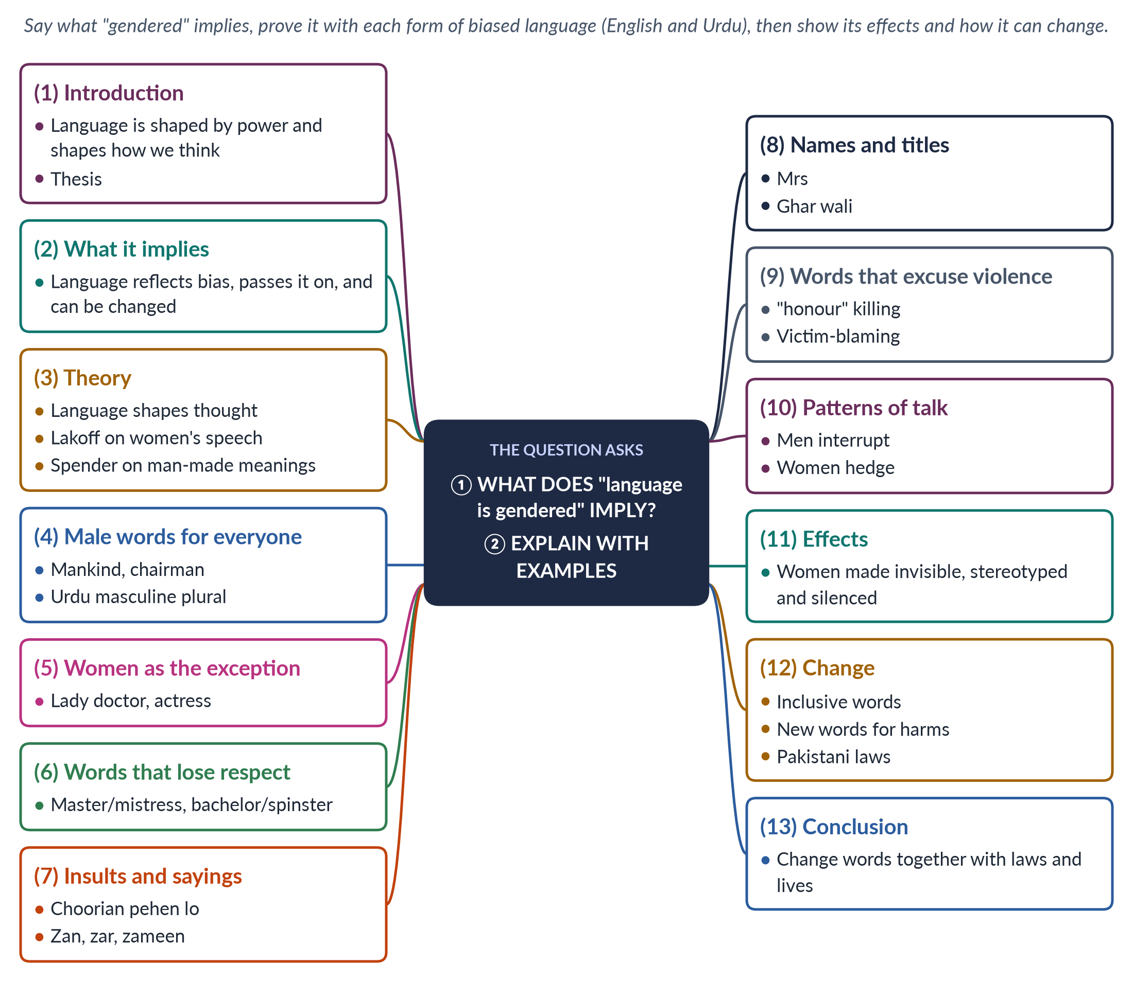
Figure 18 · The answer map: every branch is one numbered heading of the model answer below.

Decoding the question
The question quotes a statement and asks two things: "what does this imply?" — what it means to say language is gendered, and what follows — and "explain with examples". The examiner wants both the idea (why language matters) and concrete examples, ideally from English and Urdu. End with the effects and how language can change.

The model answer

1. Introduction

i) Language is not neutral
Language is not a clear window on the world. It is made by society, shaped by those with power, and it shapes how its speakers think in return.

ii) The statement
To say language is gendered is to say that its words, grammar and patterns of use carry assumptions about women and men — usually placing men at the centre and women at the edge.

iii) The argument
The statement implies that language both mirrors and maintains gender inequality — and that changing language is part of changing that inequality.

2. What the statement implies
1. Language reflects gender ranking. Its words and sayings record a society's beliefs about men and women.
2. Language passes the ranking on. Children learn these beliefs as they learn to speak, so each generation inherits them.
3. Language can be changed. Because it is social, not natural, deliberate change in language can support social change.

3. The theory behind the claim

i) Language shapes thought
The Sapir–Whorf hypothesis, in its mild form, says the language we speak influences how we think. Feminist linguists applied this idea to gender.

ii) Lakoff and Spender
Robin Lakoff (Language and Woman's Place, 1975) argued that girls are taught a hesitant "women's language". Dale Spender (Man Made Language, 1980) argued that men, as the more powerful group, have controlled what words mean — until the 1970s, for example, there was no term for "sexual harassment".

4. Male words used for everyone
Male words are used for all people: "mankind", "man-made", "manpower", "chairman", "every student must bring his book". Studies find that readers tend to picture men when they meet such words. In Urdu, a mixed group of men and women is addressed with masculine plural verbs. Implication: women become invisible in public roles.

5. Women treated as the exception
Where a job is assumed to be male, a woman in it is "marked": "lady doctor", "woman pilot", "female engineer", "actress", "poetess". The man is simply a "doctor"; the woman is an exception. Implication: women's place in public life is treated as unusual.

6. Words that lose respect
Words for women tend to lose status over time — what Muriel Schulz (1975) called the semantic derogation of women. "Master" still means someone in control; "mistress" gained sexual meanings. "Sir" stays respectful; "madam" can be an insult. "Bachelor" is neutral; "spinster" suggests failure. Implication: the same role is valued in a man and lowered in a woman.

7. Insults and sayings
Womanhood is used as an insult to men, and sayings fix stereotypes of women. In Urdu, a man accused of cowardice is told "choorian pehen lo" ("put on bangles"); "aurat ki aql" ("a woman's wit") means foolishness; and "zan, zar, zameen" ("women, gold and land") names women beside property as the causes of fights. In English, "throws like a girl" works the same way. Implication: being a woman is treated as a lesser condition.

8. Names and titles
Women are often named through men: "Mrs" plus the husband's name in English; "ghar wali" ("the one of the house") or "bachon ki ammi" ("the children's mother") in Urdu, where many men avoid saying their wife's name in public. Women's titles ("Miss" or "Mrs") reveal marriage in a way men's ("Mr") do not. Even official forms in Pakistan have long asked a woman for her "father's or husband's name", but rarely ask a man for his wife's. Implication: a woman's identity is defined by her relationship to men.

9. Words that excuse violence
Language can excuse violence. "Honour killing" presents murder as a defence of honour; "she provoked him" shifts blame onto the victim; "eve-teasing" makes street harassment sound playful. That is why Pakistan's 2016 law speaks of crimes committed "in the name or pretext of honour" — calling honour an excuse, not a justification.

10. Patterns of talk
Gender shapes how people are heard. Lakoff described women's hedges ("sort of") and tag questions ("isn't it?"). Don Zimmerman and Candace West (1975) found that men interrupted women far more than the reverse. Deborah Tannen (1990) contrasted women's "rapport talk" with men's "report talk". Implication: women's contributions in classrooms, offices and parliaments can be discounted.
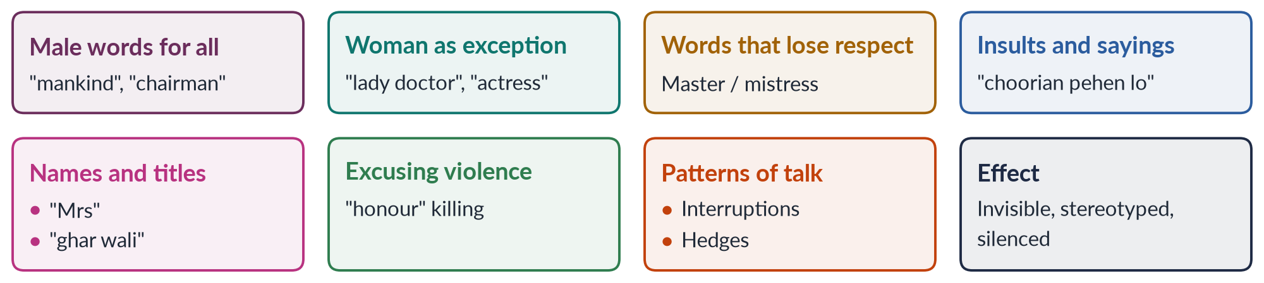
Figure 19 · The forms of gendered language, with one example each.

11. The effects of gendered language
- Invisibility: male words erase women from public roles.
- Stereotyping: sayings fix women as weak or foolish.
- Lower value: women's words and roles lose respect.
- Normal violence: soft words make harm look acceptable.
- Silence: without a word for an experience, it cannot be named or reported.

12. Changing gendered language

i) Inclusive words
"Chairperson", "police officer", "humankind", "they" for an unknown person. The United Nations has issued guidelines on gender-inclusive language.

ii) New words for old harms
"Sexual harassment", "domestic violence", "femicide", "glass ceiling" have named harms that once had no name.

iii) Pakistan's laws
The Protection against Harassment of Women at the Workplace Act 2010 made harassment a legal wrong. The 2016 honour-crimes law refused to treat honour as a justification. The Transgender Persons Act 2018 used respectful terms such as khawaja sira. The name "Aurat March" turns aurat into a word of pride.

iv) A word of caution
Changing "chairman" to "chairperson" does not by itself put women in the chair, and critics warn against policing everyday speech. Language change works best together with change in law, education and opportunity, so that new words describe a new reality.

13. Conclusion
"Language is gendered" implies that our words and grammar carry a ranking in which men are the norm and women the exception, the lesser or the absent — and that this ranking is passed on each time a child learns to speak. The examples, from "mankind" to "choorian pehen lo", show how deep the pattern runs in English and Urdu. For a civil servant, the lesson is practical: the wording of laws, forms, job notices and police reports matters. Because language is social, it can change — and when it changes together with law and practice, it helps make equality thinkable.

Why this answer scores
- It answers "what does this imply?" directly, in three points, before the examples.
- Theory (Sapir–Whorf, Lakoff, Spender) lifts it above a list.
- Every form has English and Urdu examples and a stated implication.
- A grid figure summarises the forms at a glance.
- The Pakistani laws, the caution and the conclusion show judgement.

Answer 10 · How the Autonomy–Integration Debate Contributed to the Development of the Field (CSS 2021)
AT A GLANCE · CSS 2021 · Q2 · 20 MARKS
Discuss in detail how the autonomy and integration debate in Gender Studies has made an important contribution to the development of the field of knowledge.

The answer map
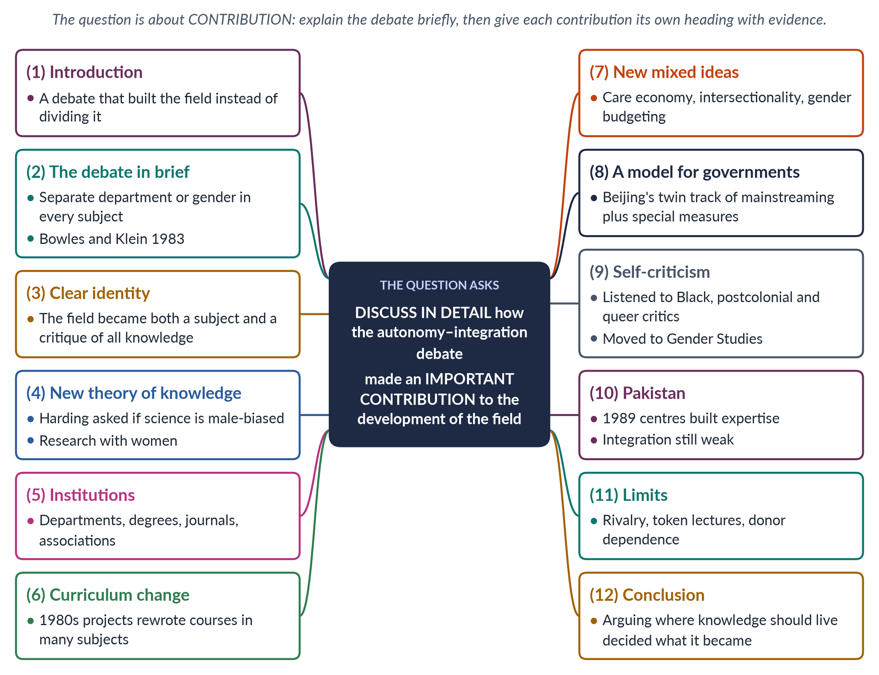
Figure 20 · The answer map: every branch is one numbered heading of the model answer below.

Decoding the question
"Discuss in detail" asks for a developed, evidenced discussion. The focus is not the debate itself but its contribution to the development of the field. A candidate who spends most of the answer on the arguments for autonomy and integration has missed the question. Explain the debate briefly; then give each contribution its own heading with evidence.

The model answer

1. Introduction

i) A productive argument
Debates are often seen as signs of division. The autonomy versus integration debate was instead one of the most productive arguments in the history of the field.

ii) What it forced scholars to decide
In deciding where the new knowledge should live, scholars had to decide what it was, how it should be produced and whom it should serve. The debate therefore shaped the field's identity, theory, institutions and influence on policy.

2. The debate in brief

i) Two plans
Autonomy means a separate department with its own teachers, degrees and research. Integration means adding gender to every existing subject.

ii) Its source
Gloria Bowles and Renate Duelli Klein set out the debate in Theories of Women's Studies (1983). They argued that integration without a separate base would water down feminist study.

iii) The risks
Autonomy risked ghettoisation — becoming an ignored "women's corner". Integration risked dilution — becoming one token lecture. The contributions of the debate came from the effort to solve this dilemma. Neither side won outright; each forced the other to improve.

3. It gave the field a clear identity

i) Arguing for autonomy
To argue for a separate department, scholars had to show that Women's Studies had its own questions, ideas and methods — that it was more than a collection of topics.

ii) Arguing for integration
To argue for integration, they had to show that gender mattered to every subject.

iii) The result
Together the two arguments produced a mature self-understanding: the field is both a subject with its own core and a critique of all knowledge — a lens every discipline needs.

4. It produced a new theory of knowledge

i) Why were women left out?
The integration project forced scholars to ask why the old subjects had ignored women. This led to feminist epistemology — the study of how we know.

ii) Harding and standpoint theory
Sandra Harding (The Science Question in Feminism, 1986) asked whether "objective" science reflects the viewpoint of the men who made it. Standpoint theory argued that women's social position gives insights that powerful groups miss.

iii) The effect
These ideas changed research methods across the social sciences, encouraging research with women rather than on them.

5. It built institutions
The case for autonomy won departments, degrees up to PhD, journals, research centres and professional bodies such as the US National Women's Studies Association (1977). Without these institutions the field could not have trained the scholars who later built Gender Studies, masculinity studies and queer theory.

6. It changed the curriculum
The case for integration produced the curriculum transformation projects of the 1980s. Teachers of history, literature, sociology, psychology and medicine rewrote their courses to include women's experience and gender analysis. Many changes — women writers in literature courses, social history in history courses, women's health in medicine — became permanent.

7. It created new mixed ideas
Because the field lived both inside and outside the old subjects, it became a meeting place where methods mixed. New ideas were born at the borders — the care economy (the value of unpaid care work), gender budgeting (checking a budget's effect on women and men) and intersectionality (overlapping disadvantages). The debate helped the field move from multidisciplinary (subjects side by side) to interdisciplinary (subjects mixed).

8. It gave governments a model

i) The dual strategy
The academic answer — a separate base that drives integration — became a model for policy.

ii) Beijing's twin track
The Beijing Platform for Action (1995) adopted a twin-track approach: gender mainstreaming in all policies (integration) plus special measures and national women's ministries (autonomy). The academic debate thus shaped how governments — including Pakistan's — organise their gender work.

9. It taught the field to question itself

i) A habit of self-examination
The constant question — "are we being pushed aside, or swallowed up?" — made the field self-critical.

ii) Listening to critics
That habit helped it absorb the criticism of Black, postcolonial and queer scholars in the 1980s and 1990s, who said "woman" had been defined too narrowly. The move from Women's Studies to Gender Studies was partly a product of this self-examination.
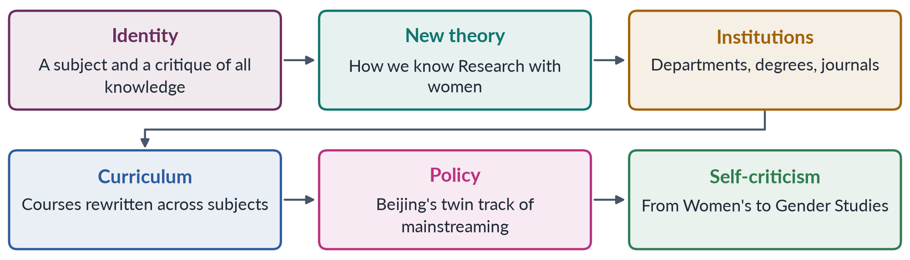
Figure 21 · From debate to development: six contributions.

10. The debate and Pakistan

i) Autonomy chosen first
The federal government chose autonomy in 1989, creating Women's Studies centres at Quaid-i-Azam University and the Universities of Karachi, Punjab, Peshawar and Balochistan. These centres built the country's first body of gender research and trained its gender specialists.

ii) Integration lagging
But gender has barely reached medicine, law, economics and teacher education, leaving the field partly ghettoised.

iii) The same logic in the state
The debate's logic already shapes the state: the National Commission on the Status of Women (2000) works alongside gender units inside ministries — autonomy and integration together.

iv) An example of integration at work
When a Pakistani medical college teaches maternal health with gender analysis — asking not only what kills mothers but who decides whether they reach a clinic — it is using the integration strategy that the debate created.

11. The limits of the contribution
The debate was not wholly positive. In some places it hardened into rivalry between "separatists" and "integrationists". Integration sometimes produced only token change — a single lecture on women in a large course. And in poorer countries autonomy often depended on foreign donors, whose priorities shaped research. These limits show that the debate's value lay in combining the two plans, not in the victory of either.

12. Conclusion
The autonomy–integration debate built the field more than it divided it. It gave the field a clear identity, produced a new theory of knowledge, built institutions, changed curricula, created new mixed ideas, gave governments the model of gender mainstreaming and taught the field to question itself. In short, the argument over where gender knowledge should live helped decide what it became. For Pakistan, its lasting lesson is that Gender Studies must be both a strong discipline of its own and a presence in every other.

Why this answer scores
- It answers the real question — the contribution — with six separate headings, each evidenced.
- The debate is summarised briefly and not allowed to take over.
- Evidence is precise: Bowles and Klein (1983), Harding (1986), NWSA (1977), Beijing (1995).
- A flow diagram summarises the six contributions.
- The limits section shows balance, and Pakistan is applied throughout.

Answer 11 · Masculinity and Femininity — Natural or Social? The Theoretical Debates (CSS 2021)
AT A GLANCE · CSS 2021 · Q3 · 20 MARKS
Masculinity and femininity are deeply engraved realities since the distant past in human history. Discuss various theoretical debates on their construction to make explicit whether the formation of both is a natural or social reality. Support your arguments with real-life examples.

The answer map
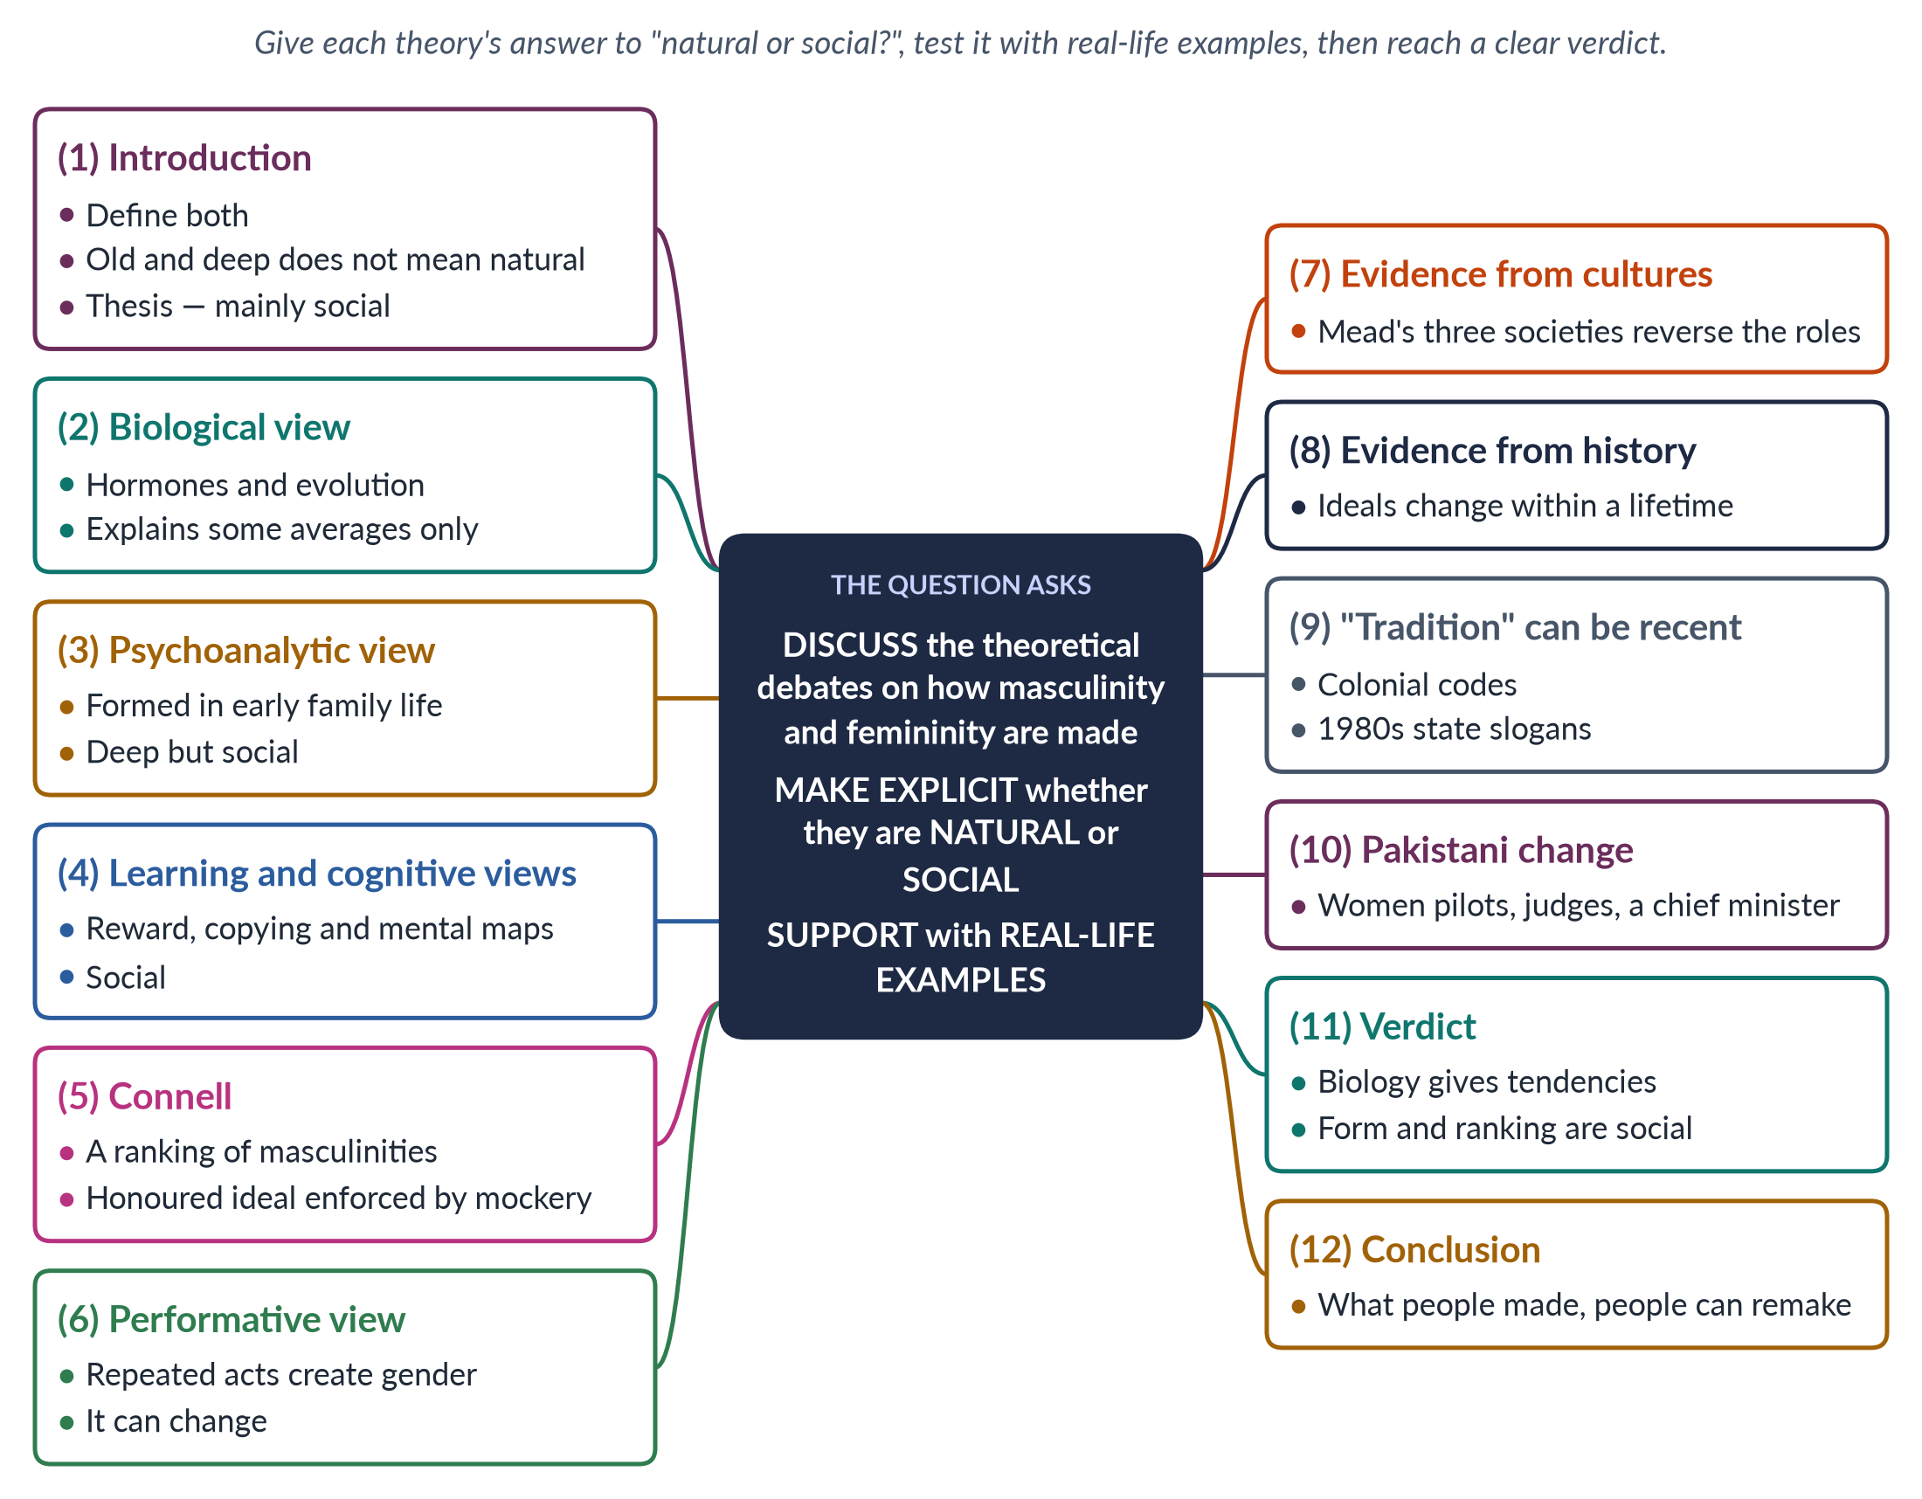
Figure 22 · The answer map: every branch is one numbered heading of the model answer below.

Decoding the question
The question makes a claim — masculinity and femininity are "deeply engraved realities since the distant past" — and asks you to discuss the theoretical debates on how they are made, to make explicit whether they are natural or social, and to support your argument with real-life examples. You must take a clear position. The phrase "since the distant past" invites you to test whether age and depth prove that something is natural.

The model answer

1. Introduction

i) Definitions
Masculinity is the behaviour and ideals society expects of men — strength, courage, control, providing. Femininity is the behaviour and ideals society expects of women — modesty, care, gentleness, obedience.

ii) Old is not the same as natural
It is true that these ideals are ancient and deeply felt. But age and depth do not prove that something is natural: slavery and caste were also ancient and deeply engraved. Both were once defended as "natural" too — and both were shown to be human-made.

iii) The argument
This answer argues that biology gives some tendencies, but the form, content and ranking of masculinity and femininity are social — and therefore changeable.

2. The biological view: natural

i) What it says
Biological theories trace gender differences to chromosomes and hormones, especially testosterone, linked with muscle and, on average, physical aggression. Sociobiology (E. O. Wilson, 1975) and evolutionary psychology argue that evolution gave men and women different strategies that still shape behaviour.

ii) Its strength and weakness
It explains some average differences found in many societies. But the averages overlap heavily, and biology cannot explain why the ideals differ so much between societies — or change within one lifetime.

3. The psychoanalytic view: social, through the family

i) Freud and Chodorow
Freud argued that gender identity forms through early family conflicts and copying the same-sex parent. Nancy Chodorow (1978) showed that because mothers do almost all childcare, girls learn to care while boys learn to separate and hide feelings.

ii) Example and verdict
Where fathers are distant and mothers raise children alone, boys often learn that manhood means distance from anything "feminine". Verdict: social, but so deep that it feels natural.

4. Learning and cognitive views: social

i) Social learning
Albert Bandura showed that children learn gender through reward, punishment and copying. A boy who cries is told "mard ko dard nahi hota" ("a man feels no pain"); a girl who plays outside late is told good girls stay home.

ii) Cognitive and schema theories
Lawrence Kohlberg (1966) showed that children work out their gender in stages; Sandra Bem (1981) showed that they build a mental map of "for boys" and "for girls". Verdict: social.

5. Connell: masculinities as a ranking of power
✦ THINKER
Raewyn Connell · *Gender and Power* (1987); *Masculinities* (1995)
Every society has a gender order. Hegemonic masculinity — the honoured ideal — sits above complicit, marginalised and subordinated masculinities, while emphasised femininity is built around pleasing men. Most men gain the "patriarchal dividend" even if they do not match the ideal.
➜ Masculinity is plural and ranked — a social structure, not a biological essence.

Real-life example: in Pakistan, the ghairat-mand man who controls "his" women is honoured, while a man who shares housework may be mocked as joru ka ghulam ("his wife's slave") — proof that the ranking is actively enforced.

6. The performative view: social and changeable
Candace West and Don Zimmerman (1987) argued that gender is something we do in daily life; Judith Butler (1990) that it is performative — repeated acts create the appearance of a natural core. On this view, the "deep engraving" of masculinity and femininity is the result of centuries of repetition, not of nature.

7. Evidence from other cultures
Margaret Mead (Sex and Temperament in Three Primitive Societies, 1935) found that among the Arapesh both sexes were gentle, among the Mundugumor both were fierce, and among the Tchambuli women were in charge while men were decorative. If the same biology produces such different masculinities and femininities, biology cannot be their main cause.

8. Evidence from history
Ideals change. During the World Wars women worked in factories and fields. In nineteenth-century Europe upper-class femininity meant fragility, while working-class women did heavy labour. In South Asia, ideals of manhood have ranged from the warrior to the Sufi saint whose virtues were humility and compassion. Ideals that change within a generation cannot be fixed by nature. Pakistani families themselves show this: many grandmothers never went to school, while their granddaughters study medicine and engineering.

9. "Tradition" is often recent
Many "traditional" gender norms are newer than they look. British colonial rule brought Victorian ideals of women's place in the home and hardened customary law. In Pakistan, chador aur chaar-diwari ("the veil and the four walls") was promoted as state policy in the 1980s. What looks timeless often has a traceable history — itself evidence that it is social.
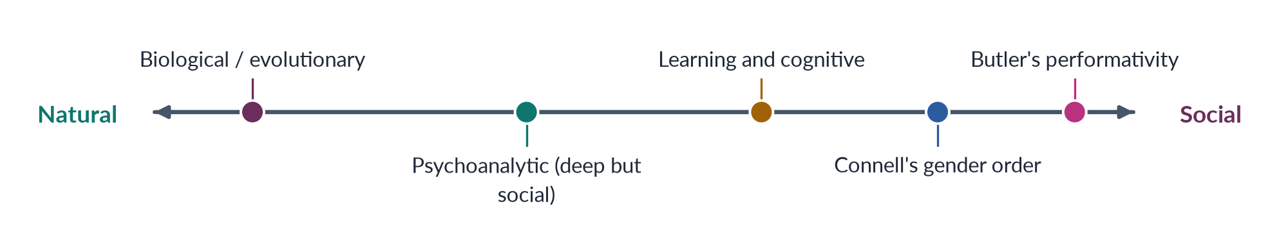
Figure 23 · The theories placed between "natural" and "social".

10. Change in Pakistan
PAKISTAN ANGLE · MASCULINITIES AND FEMININITIES ARE CHANGING
Women now serve as fighter pilots, police officers, Supreme Court judges and, since 2024, a provincial chief minister. Women's literacy has risen to about 53% (Census 2023). More fathers share childcare, and campaigns involve men against violence. The sharif aurat who never leaves home and the man whose worth lies only in control are giving way, unevenly, to new ideals.

11. The verdict: natural or social?

i) What biology explains
Biology explains some average tendencies — for example, in physical strength.

ii) What society explains
Society explains the content of the ideals, the value placed on each, and the rules that enforce them — mockery, honour codes, law and upbringing.

iii) Why the ranking matters most
Even where biology explains a difference, it cannot explain why the "masculine" side is paid and honoured more. That ranking comes from property, law, religion and custom, which is why it differs from society to society.

iii) The answer
The evidence supports an interactionist verdict: masculinity and femininity are a social reality built on a biological base. Biology may deal the cards, but society writes the rules of the game — and rules can be rewritten.

12. Conclusion
Masculinity and femininity are indeed deeply engraved — but engraving is a human act. Biological theories explain a few average differences. Psychoanalytic, learning, sociological and performative theories explain how those differences are built up, ranked and enforced. The evidence from other cultures and from rapid change in history shows that the ideals are social. The conclusion carries a hopeful message for Pakistan: ideals that people made, people can remake.

Why this answer scores
- It takes an explicit position, as the question demands, and defends it.
- Each theory is linked to a thinker and judged "natural or social".
- Real-life examples, many Pakistani, sit inside the headings.
- Evidence from cultures, history and recent "traditions" tests the claim "since the distant past".
- A spectrum figure places the theories, and the verdict is clear.

Answer 12 · The Multidisciplinary Nature of Gender Studies (CSS 2022)
AT A GLANCE · CSS 2022 · Q2 · 20 MARKS
Discuss in detail the multidisciplinary nature of Gender Studies.

The answer map
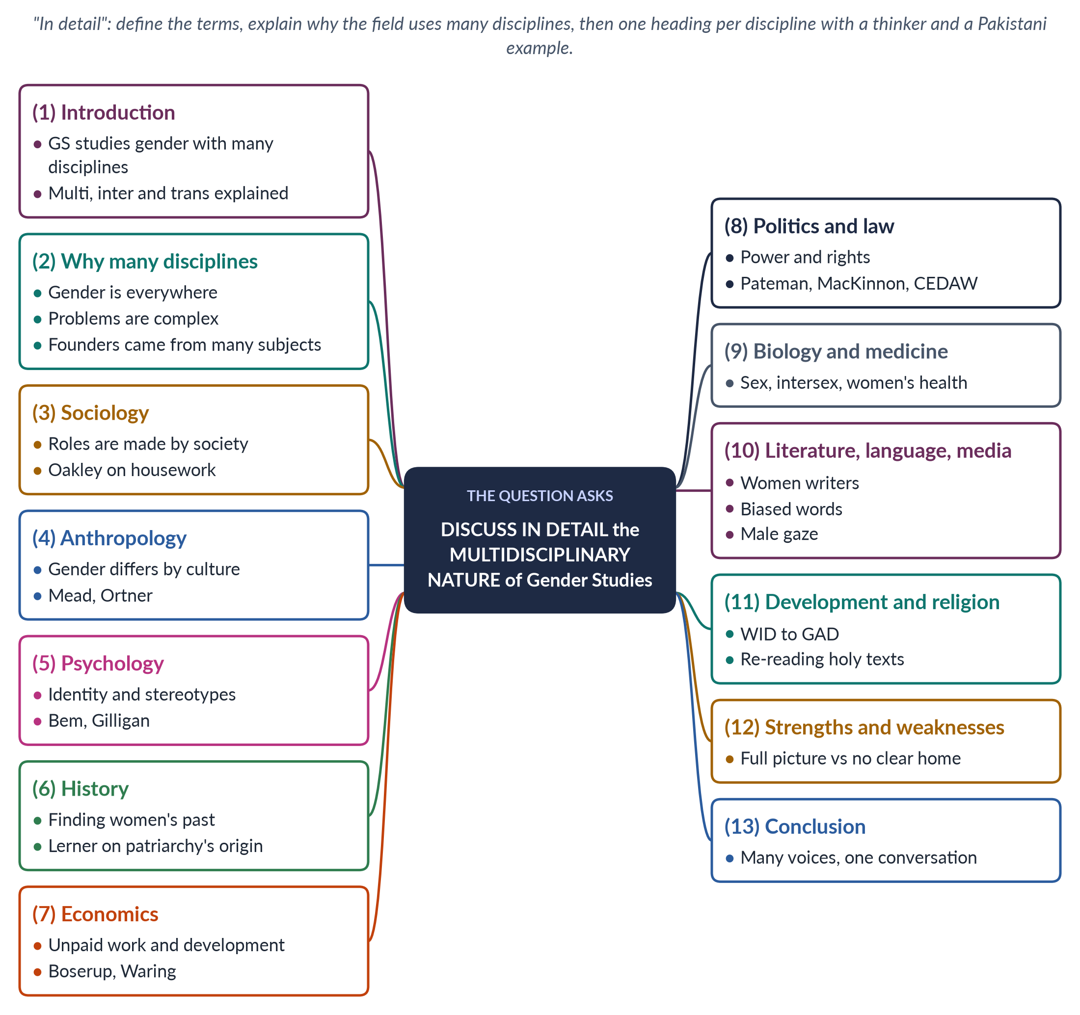
Figure 24 · The answer map: every branch is one numbered heading of the model answer below.

Decoding the question
"Discuss in detail" asks for depth: not a list of disciplines, but what each one adds, with evidence. Define "multidisciplinary" clearly (and separate it from "interdisciplinary"), explain why the field uses many disciplines, go through the disciplines, and weigh the strengths and weaknesses.

The model answer

1. Introduction

i) Definition
Gender Studies studies how society makes femininity and masculinity and how this shares out power and chances.

ii) Three key terms
- Multidisciplinary — several disciplines study gender side by side.
- Interdisciplinary — their methods are mixed into new ideas.
- Transdisciplinary — work goes beyond the university, with activists and communities.

iii) The argument
This breadth is not an accident. It is the field's method. It follows from the nature of gender itself, which runs through every part of human life.

2. Why Gender Studies uses many disciplines
1. Gender is everywhere — in bodies, minds, families, markets, laws, religions and languages.
2. Its problems are complex. Why are only 24.4% of working-age Pakistani women in the labour force (LFS 2024–25)? The answer needs economics (jobs, wages), sociology (family rules), law (harassment, maternity rights), transport planning, psychology (safety) and politics.
3. Its founders came from many subjects — English, history, sociology and psychology — and brought their methods with them.
4. It criticises all knowledge. To show that a discipline is male-centred, you must work inside it.

3. Sociology

i) Contribution
Sociology gives the key idea that social roles are made by people. It studies socialisation, the family and the division of labour.

ii) Thinker and example
Ann Oakley (The Sociology of Housework, 1974) showed that housework is real, tiring, unpaid work. Pakistan: studies of how purdah rules limit women's movement and work.

4. Anthropology

i) Contribution
Anthropology shows that gender differs from culture to culture.

ii) Thinkers and example
Margaret Mead (1935) found very different "masculine" and "feminine" behaviour among the Arapesh, Mundugumor and Tchambuli. Sherry Ortner (1974) linked women's lower status to their association with "nature"; Michelle Rosaldo (1974) to their confinement to the home. Pakistan: studies of watta satta (exchange marriage) and honour.

5. Psychology

i) Contribution
Psychology studies how gender identity and stereotypes form.

ii) Thinkers and example
Sandra Bem (1974) measured androgyny — having both "masculine" and "feminine" traits. Carol Gilligan (1982) found a female "ethic of care" ignored by older theories. Pakistan: research on women's depression and the effects of violence at home.

6. History

i) Contribution
History recovers women's lives — "her-story" — and shows that gender arrangements change.

ii) Thinker and example
Gerda Lerner (The Creation of Patriarchy, 1986) traced male rule to the ancient Middle East — so it had a beginning, and can have an end. Pakistan: recovering the roles of Fatima Jinnah, Begum Jahanara Shahnawaz and Begum Ra'ana Liaquat Ali Khan in the Pakistan Movement.

7. Economics

i) Contribution
Economics studies gender in work, income and development.

ii) Thinkers and example
Ester Boserup (1970) showed that development ignored women farmers; Marilyn Waring (1988) showed that GDP ignores unpaid work. Feminist economics measures care work through time-use surveys. Pakistan: the pay gap, home-based workers and rural women's unpaid farm work.

8. Political science and law

i) Contribution
Political science studies power and representation; law turns analysis into rights.

ii) Thinkers and example
Carole Pateman (The Sexual Contract, 1988) argued that the famous "social contract" hid women's subordination. Catharine MacKinnon (1979) argued that sexual harassment is sex discrimination. Pakistan: the 60 reserved seats; Articles 25 and 34 of the Constitution; the harassment law of 2010; CEDAW (joined 1996).

9. Biology and medicine
Biology gives the facts of sex difference — and evidence of variation, such as intersex conditions. Medicine studies women's health, long neglected. Pakistan: 186 maternal deaths per 100,000 live births (PMMS 2019); anaemia; reproductive health.

10. Literature, language and media
Elaine Showalter's "gynocriticism" recovers women writers. Robin Lakoff (1975) and Dale Spender (1980) show how language carries bias. Laura Mulvey (1975) described the "male gaze" of cinema. Pakistan: writers such as Ismat Chughtai, Kishwar Naheed and Fahmida Riaz; how dramas and adverts show women.

11. Development and religious studies
Development studies built the WID, WAD and GAD approaches and tools such as Caroline Moser's gender planning (1993). Religious studies re-read holy texts from a woman's view — Amina Wadud (1992) and Fatima Mernissi. Pakistan: the Benazir Income Support Programme, which pays women directly; debates in the Council of Islamic Ideology.
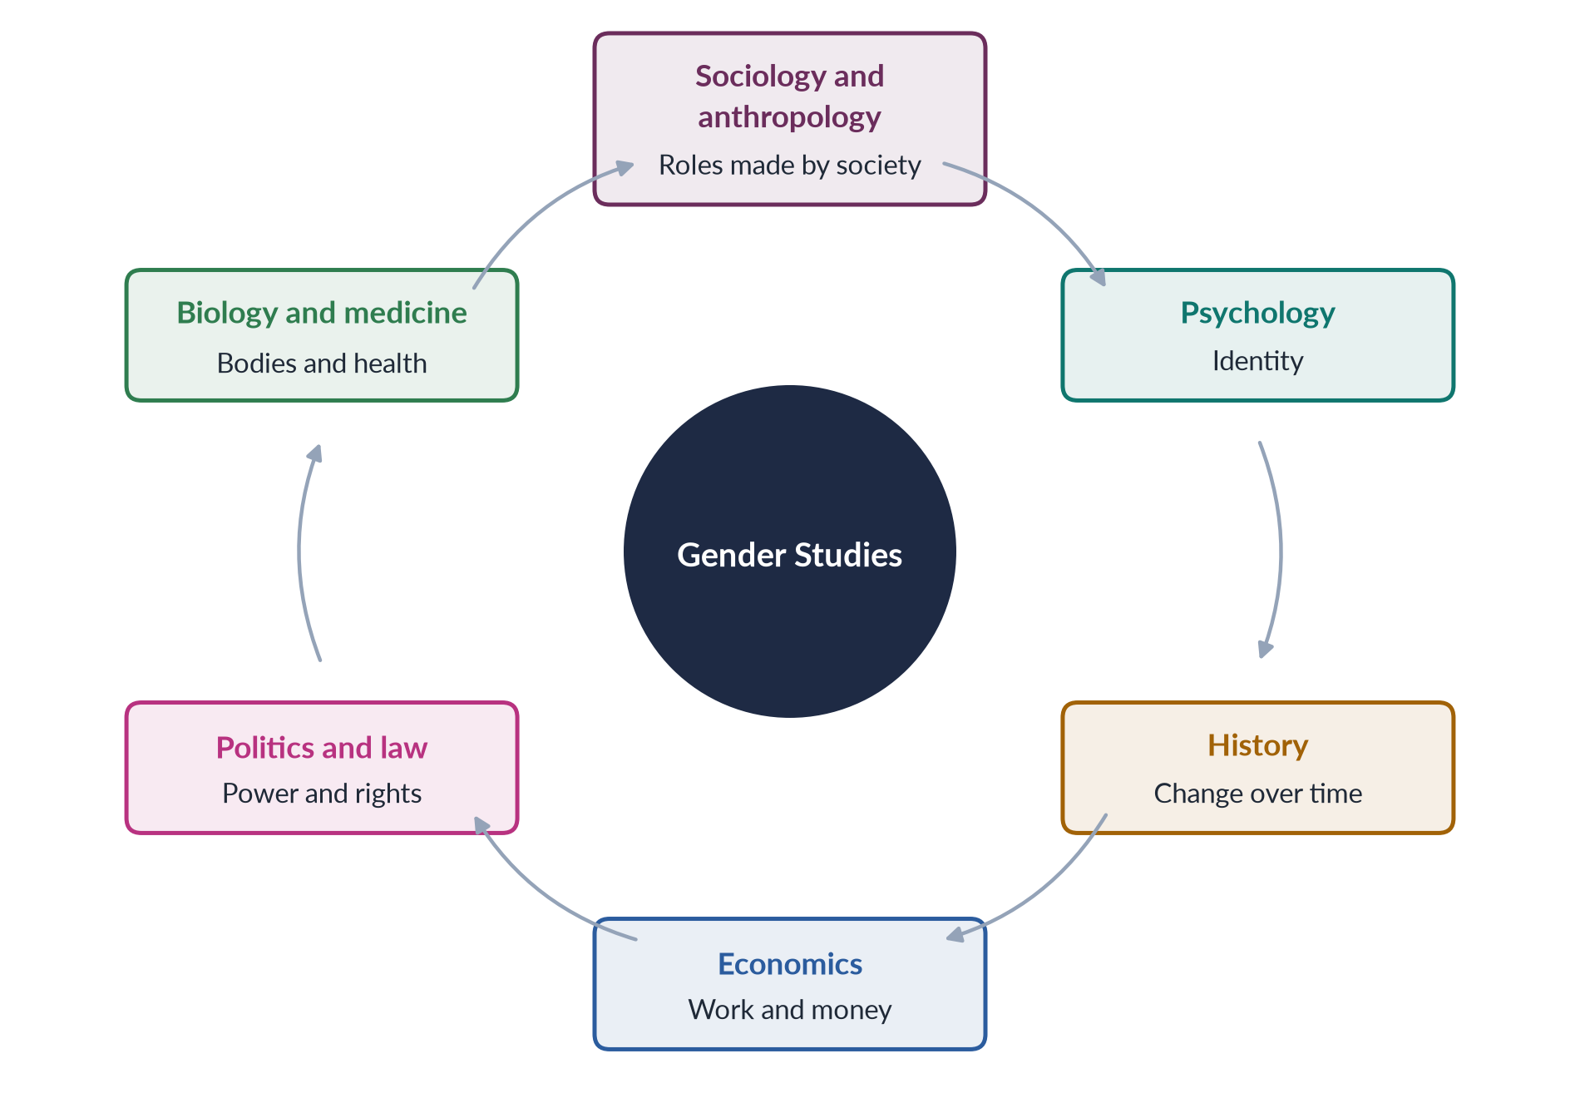
Figure 25 · Gender Studies at the centre, fed by many disciplines.

12. Strengths and weaknesses

i) Strengths
A complete picture of complex problems; new ideas born where disciplines meet (care economy, intersectionality, gender budgeting); direct usefulness for policy; many research methods.
These strengths explain why development agencies, courts and parliaments increasingly turn to gender experts: their problems never belong to one discipline alone.

ii) Weaknesses
Critics say the field has no core of its own; teachers are often trained in one discipline only; number-based and story-based methods can clash.

iii) The link to the autonomy debate
Above all, many disciplines raise the question of where the field should live. Because gender belongs to every subject, some want it integrated into all; because it has its own ideas, others want an autonomous department. Most universities do both. In Pakistan, the departments exist, but most other subjects still teach without any gender content — so integration is the urgent next step.
EXAMPLE · ONE PAKISTANI PROBLEM, MANY DISCIPLINES
Child marriage: sociology explains family pressures; anthropology the customs of exchange and honour; psychology the trauma for the girl; medicine the risks of early pregnancy; economics the lost schooling; law the Act of 1929, Sindh's law of 2013 and Islamabad's law of 2025; religious studies the debate in the Council of Islamic Ideology. Only a multidisciplinary field can put these pieces together.

13. Conclusion
Gender Studies uses many disciplines because gender is everywhere. Sociology gives it the idea of construction, anthropology the proof of variety, psychology the study of identity, history the evidence of change, economics the measure of work, politics and law the study of power and rights, biology the facts of the body, literature and media the study of images, and development and religious studies the tools of change. Its strength is the conversation between these voices — and in Pakistan, where gender shapes health, education, work, law and violence alike, that conversation is exactly what policy needs.

Why this answer scores
- Multidisciplinary is defined and separated from inter- and trans-disciplinary.
- The reasons come before the disciplines.
- Each discipline has its own heading with a contribution, a thinker with a date and a Pakistani example.
- A cycle figure and a worked example (child marriage) show the idea in action.
- The strengths–weaknesses section links to the autonomy debate, showing command of the topic.

Answer 13 · The Status of Gender Studies in Pakistan and Views on Autonomy versus Integration (CSS 2023)
AT A GLANCE · CSS 2023 · Q2 · 20 MARKS
Write a note on the status of Gender Studies in Pakistan. Give your views on the autonomy versus integration debate in Gender Studies.

The answer map
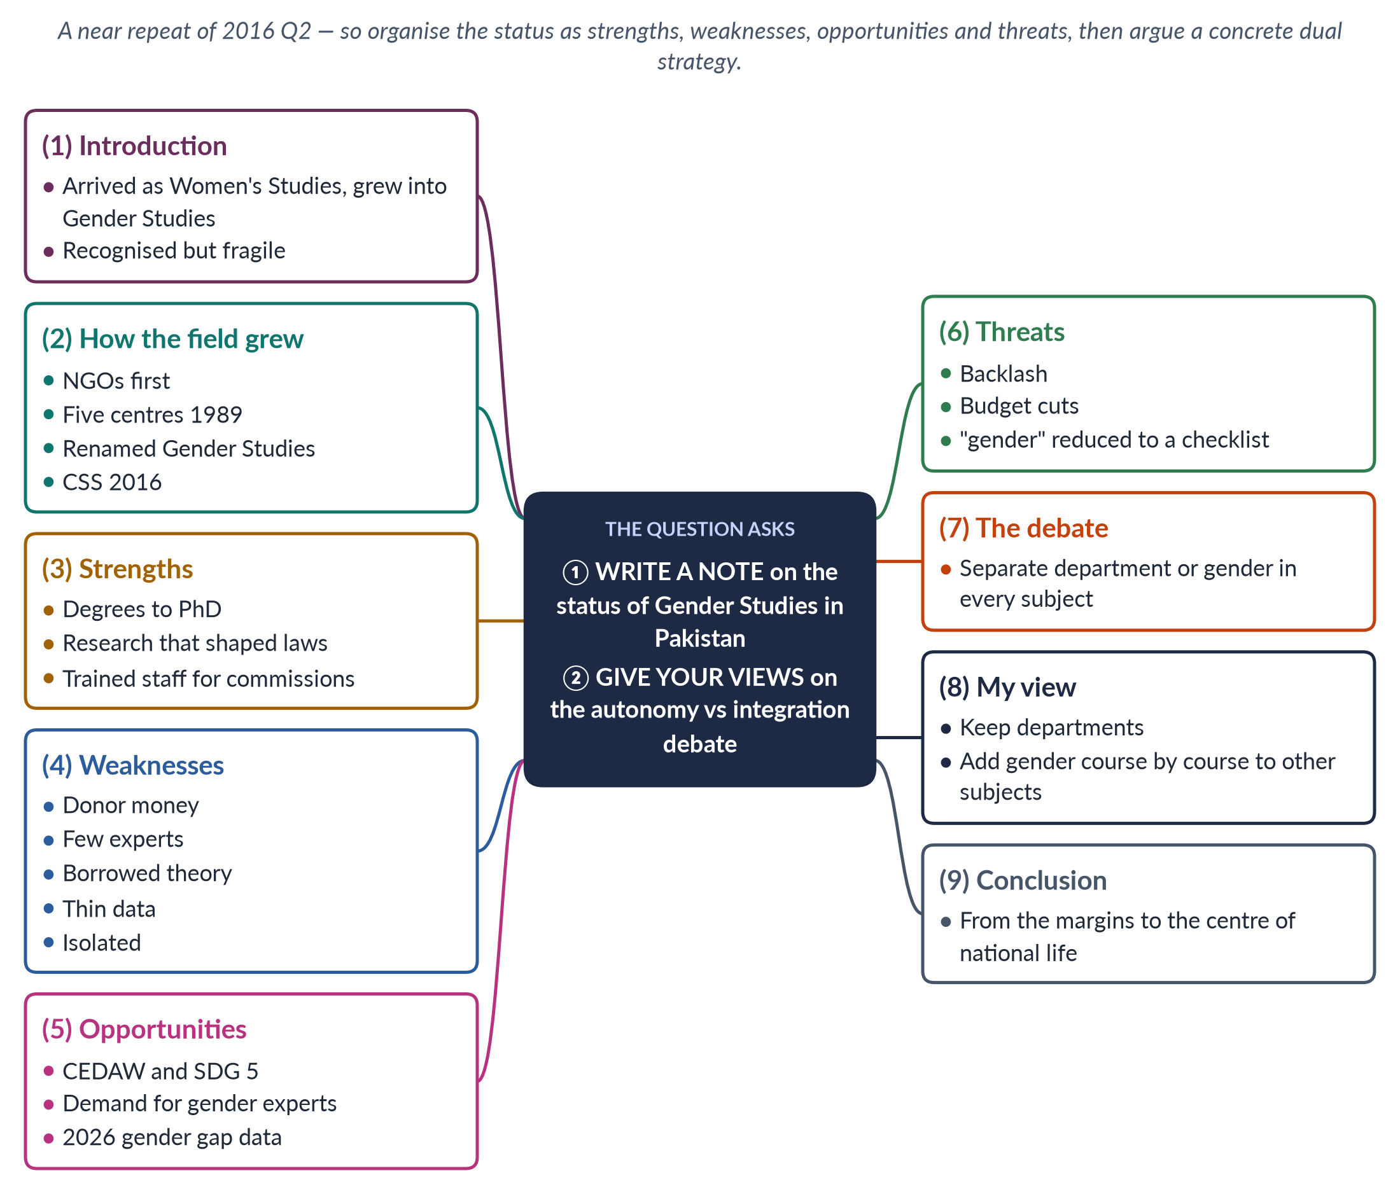
Figure 26 · The answer map: every branch is one numbered heading of the model answer below.

Decoding the question
This question is almost the same as 2016 Q2, but it says "Gender Studies", not "Women's Studies". Show that you know the field has moved from one to the other. "Write a note on the status" asks for an organised assessment; a SWOT structure (strengths, weaknesses, opportunities, threats) gives it quickly. "Give your views" asks for a clear position on the debate — best made concrete by saying how integration should work in Pakistan.

The model answer

1. Introduction

i) Definition
Gender Studies studies how society makes gender and how gender shares out power, money and chances between women, men and gender-diverse people.

ii) The Pakistani journey
The field arrived in Pakistan as Women's Studies and has grown into the study of gender relations, including men and gender-diverse people.

iii) Why the wording matters
The examiner asked almost the same question in 2016. The change in wording — Gender rather than Women's Studies — is itself part of the answer: it shows how the field has grown since then.

iv) The argument
After more than three decades the field is recognised and productive but fragile. Its future depends on how it settles the debate between autonomy and integration. My view: Pakistan needs both, deliberately combined, with the departments leading the effort to carry gender into every profession.

2. How the field grew

i) Research outside the universities
Research on women began with Shirkat Gah (1975), the Women's Action Forum (1981) and the Aurat Foundation (1986).

ii) The centres of 1989
The Ministry of Women's Development created Women's Studies centres at Quaid-i-Azam University and the Universities of Karachi, Punjab, Peshawar and Balochistan.

iii) Growth and renaming
Most centres became Gender Studies departments; programmes spread to other universities; and from CE-2016 Gender Studies became a CSS optional subject. The research agenda has widened too — from women's legal status to masculinities, climate and disaster, digital harassment and transgender rights.

3. Strengths
- Degrees: BS, MPhil and PhD programmes at many public universities.
- Research: work on violence, honour crimes, family law, politics, work and health, in journals such as the Pakistan Journal of Gender Studies.
- Trained people: graduates staff the National Commission on the Status of Women (2000), provincial commissions, protection centres and NGOs.
- Impact on law: evidence behind the laws on harassment (2010), acid attacks (2011), honour killing (2016) and violence at home (Punjab 2016; Islamabad 2025).

4. Weaknesses
- Donor money that comes and goes with projects.
- Few experts, especially PhD-qualified teachers outside the big cities.
- Borrowed theory: mostly Western books in English; little theory from Pakistan's own history and religious traditions.
- Thin data: small studies; little long-term research.
- Isolation: mostly women students and staff; little influence on other departments.

5. Opportunities
- Promises to keep: Pakistan's duties under CEDAW (joined 1996) and SDG 5 need gender data and experts.
- Rising demand: gender units in ministries, harassment committees under the 2010 Act, protection authorities and private companies all need trained staff.
- A clear agenda: Pakistan ranked 143rd of 145 in the Global Gender Gap Report 2026; only 24.4% of working-age women are in the labour force (LFS 2024–25); women's literacy is about 53% (Census 2023).
- Digital reach: online courses and open journals can reach students far from big universities.

6. Threats
- Backlash: the charge of a "Western" or "anti-family" agenda, sharpened by controversies such as the debate over the Transgender Persons Act.
- Budget cuts in public universities.
- Co-option: "gender" reduced to a donor checklist instead of an analysis of power.
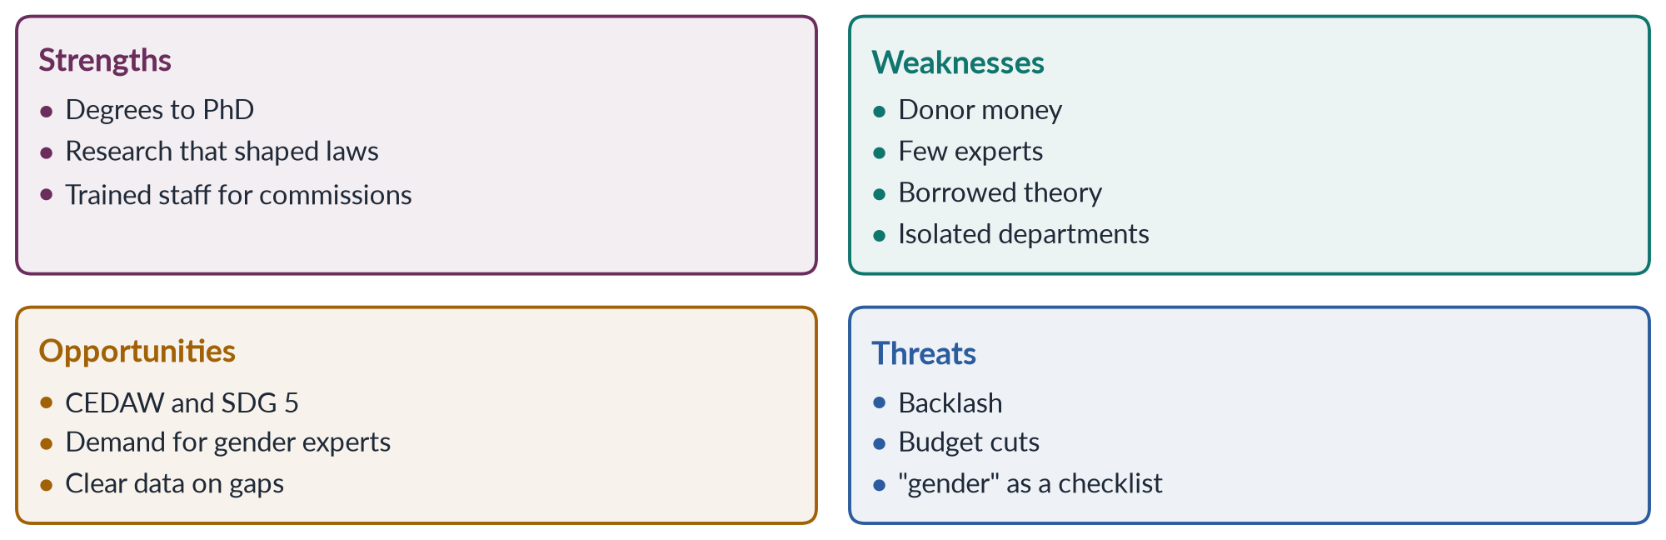
Figure 27 · The status of Gender Studies in Pakistan: strengths, weaknesses, opportunities, threats.
The picture is of a field that has arrived but not settled. It has proved its value; it has not yet secured its future. Its strengths and opportunities are real, but its weaknesses — money, people and theory — leave it exposed to backlash and budget cuts.

Why this matters for the debate
The weaknesses point directly to the second part of the question. The field's isolation is the classic risk of autonomy — ghettoisation. Its thin reach into law, medicine and economics shows how little integration has happened. So the status of the field and the autonomy–integration debate are two sides of one problem.

7. The autonomy versus integration debate

i) Origin
Gloria Bowles and Renate Duelli Klein (Theories of Women's Studies, 1983) set out the debate.

ii) Autonomy
Autonomy means a separate department with its own teachers, degrees and research. It gives depth and a critical voice, but risks ghettoisation — an ignored "women's corner".

iii) Integration
Integration means adding gender to every subject. It gives reach and real change, but risks dilution — one token lecture. Bowles and Klein saw autonomy as the base from which integration should grow.

8. My view: a concrete dual strategy for Pakistan

i) Where Pakistan stands
Pakistan has built autonomy but neglected integration: the departments exist, while the rest of the curriculum barely mentions gender.

ii) What integration should look like
Table 7 · Gender content Pakistan should integrate, subject by subject.
Subject | Gender content
Medicine and nursing | Maternal health, reproductive rights, caring for survivors of violence
Law | Family law, inheritance, the pro-women laws of 2006–2025
Economics and business | Unpaid care work, the pay gap, gender budgeting
Education | Gender-aware textbooks; keeping girls in school
Engineering and planning | Safe transport, lighting, toilets and workplaces for women
Civil-service training | Gender analysis of policy; harassment law; CEDAW and SDG reporting

iii) Who should lead it
The departments should train the teachers, share the courses and supply the research. This answers the fear of token integration: trained specialists, approved content and Higher Education Commission support, not individual goodwill. A small start is possible at once: a compulsory gender module in every law, medical and teacher-training degree, taught by trained staff.

iv) Why it answers the critics
Gender taught inside a Pakistani law course on inheritance or a medical course on maternal deaths is plainly about Pakistan's own problems — the best reply to the "Western agenda" charge. It also mirrors the state's own twin track since Beijing (1995): women's institutions plus gender mainstreaming across ministries.

9. Conclusion
Gender Studies in Pakistan has real strengths — degrees, research, trained people and influence on law — but it still depends on donors, lacks experts and sits in a corner of the university. The autonomy versus integration debate should be settled in favour of both: departments strong enough to produce expertise and local theory, and a deliberate programme to carry gender into every profession. Only then will the field move from the margins of the university to the centre of national life.

Why this answer scores
- It spots the near repeat and answers it freshly through a SWOT structure, shown as a figure.
- The status is current (2026 data; the 2025 Islamabad law) and evidenced.
- The debate is credited to its source and summarised precisely, with each side's risk.
- The view is concrete: a subject-by-subject plan, not a vague "both".
- The conclusion joins the two parts.

Answer 14 · Gender Studies versus Women's Studies; the Multidisciplinary Nature of Gender Studies (CSS 2023)
AT A GLANCE · CSS 2023 · Q3 · 20 MARKS
Differentiate between Gender Studies and Women's Studies. Discuss in detail the multidisciplinary nature of Gender Studies.

The answer map
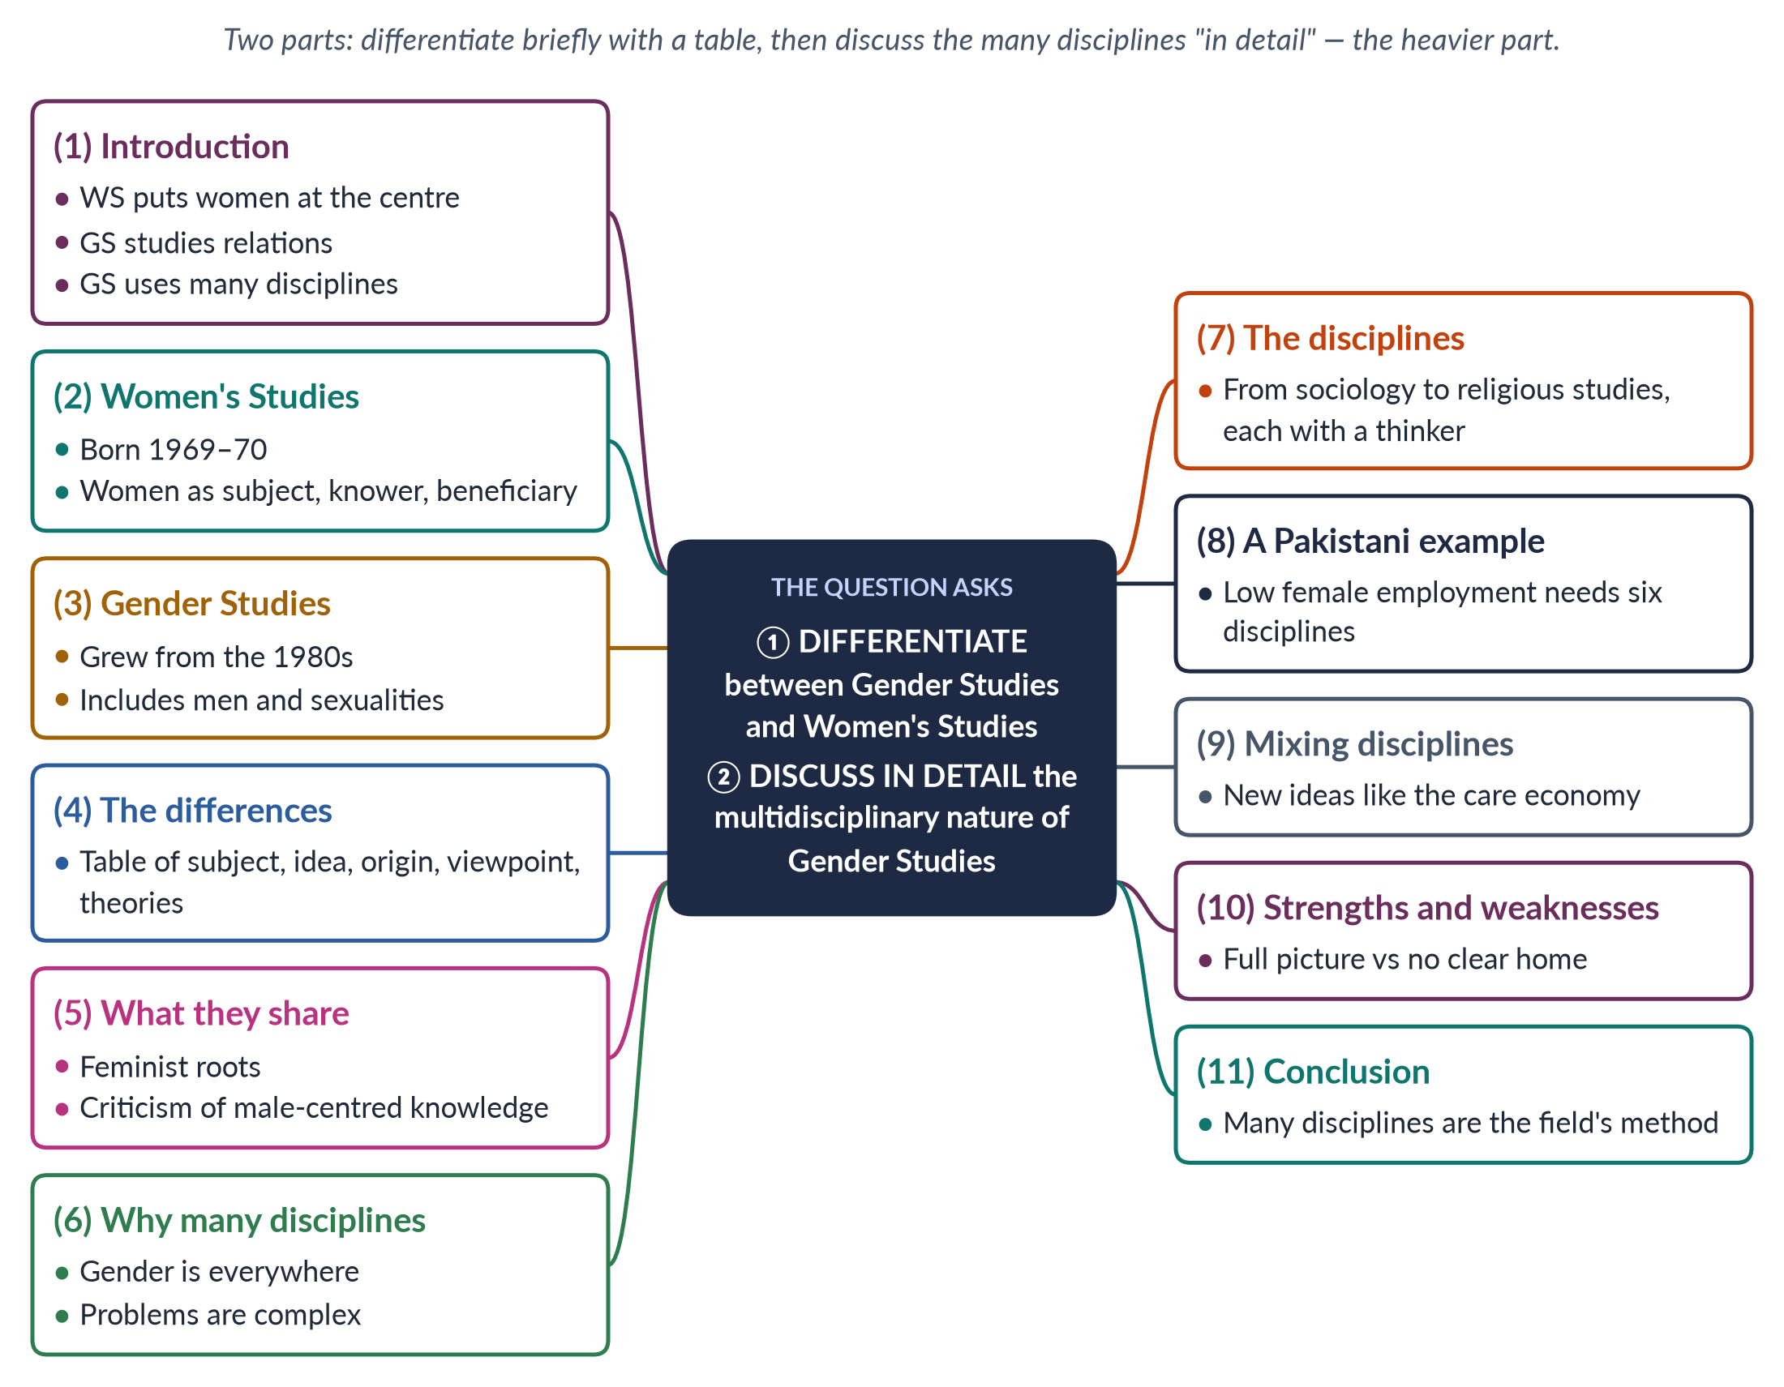
Figure 28 · The answer map: every branch is one numbered heading of the model answer below.

Decoding the question
Two command words. "Differentiate" asks for clear differences — a table works best. "Discuss in detail" asks for a full account of the multidisciplinary nature: what it means, why the field has it, what each discipline adds, and what it costs. Give about one-third of the answer to the first part and two-thirds to the second, which "in detail" marks as heavier.

The model answer

1. Introduction

i) Definitions
Women's Studies is the field, begun around 1969–70 as "the academic arm of the women's movement", that puts women at the centre of study. Gender Studies grew out of it from the 1980s and studies how society makes femininity and masculinity and how this shares out power among women, men and gender-diverse people.

ii) The argument
The two differ in subject and key idea but share a feminist commitment. What most marks out Gender Studies is its multidisciplinary nature: it studies gender with the tools of every field that gender touches — which is every field.

2. Women's Studies

i) Origin
It began with a course at Cornell (1969), the first programme at San Diego State (1970) and the National Women's Studies Association (1977).

ii) Features
It made women the subject of study, the knowers whose experience counts, and the beneficiaries of research. Its question was: where are the women?

3. Gender Studies

i) Origin
From the 1980s the idea of gender (Ann Oakley, 1972; Joan Scott, 1986), men's studies (Raewyn Connell, 1987) and queer theory (about 1990) widened the field.

ii) Features
It studies gender relations, including men, masculinities and sexualities, and gender as a structure of power.

iii) In Pakistan
Pakistan's centres of 1989 began as "Women's Studies" centres; most are now "Gender Studies" departments.

4. The differences
Table 8 · Women's Studies and Gender Studies compared.
Point | Women's Studies | Gender Studies
Subject | Women's lives, history and experience | Relations between women, men and gender-diverse people
Key idea | "Woman"; women's oppression | Gender as made by society and as power
Origin | Women's movement, late 1960s | Gender theory, men's studies, queer theory, 1980s–90s
Viewpoint | By and for women | Many viewpoints, including men's
Theories | Liberal, radical, socialist feminism | Adds constructionism, queer theory, intersectionality
Honour killing | Studies the victims and failures of justice | Also studies ghairat, manhood and family bargaining

5. What they share
Both share feminist roots, a rejection of male-centred knowledge, the use of many disciplines and an aim of change. Tania Modleski's warning in Feminism Without Women (1991) — that "gender" could make women invisible again — explains why many departments use the joint name "Women's and Gender Studies".

6. Why Gender Studies uses many disciplines

i) Definitions
Multidisciplinary means several disciplines studying gender side by side. As the field has grown it has also become interdisciplinary — mixing them into new ideas.

ii) Reasons
1. Gender is everywhere — bodies, minds, families, economies, laws, religions and languages.
2. Its problems cross boundaries; no single discipline can solve them.
3. Its founders came from many departments.
4. To expose male bias in a subject, you must work inside it.

7. What each discipline adds
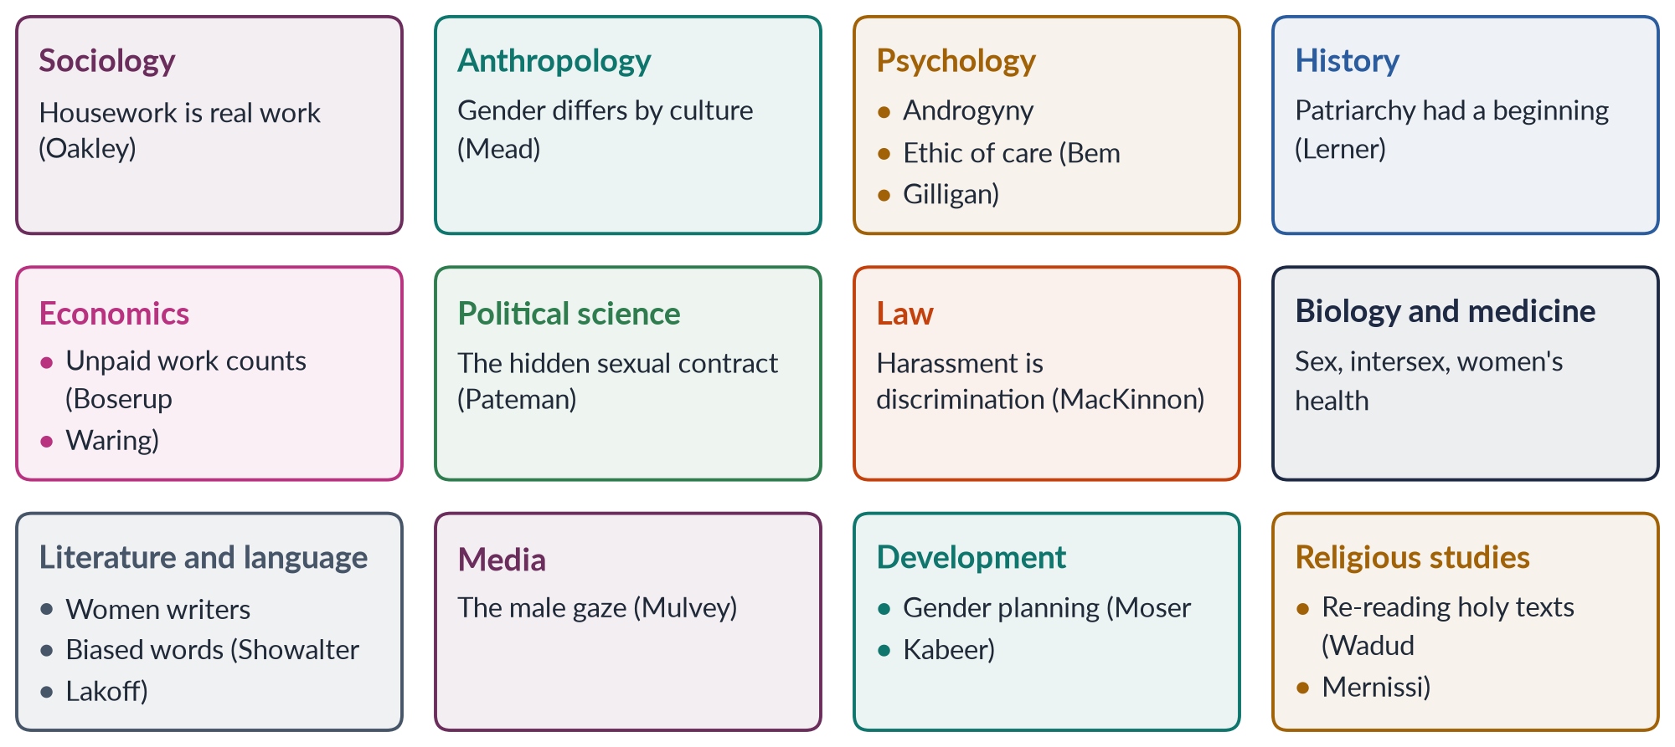
Figure 29 · The disciplines of Gender Studies, each with its key thinker.

i) Sociology and anthropology
Sociology shows that roles are made by society; Ann Oakley (1974) showed housework is real work. Anthropology proves that gender varies: Margaret Mead's Arapesh, Mundugumor and Tchambuli (1935); Sherry Ortner's link between women and "nature" (1974).

ii) Psychology and history
Psychology studies identity and stereotypes — Sandra Bem's androgyny (1974), Carol Gilligan's ethic of care (1982). History recovers women's past and shows patriarchy had a beginning (Gerda Lerner, 1986).

iii) Economics, politics and law
Economics measures women's work — Ester Boserup (1970) on women farmers, Marilyn Waring (1988) on unpaid labour. Political science and law study power and rights — Carole Pateman's The Sexual Contract (1988), Catharine MacKinnon on harassment (1979), and CEDAW (1979).

iv) Biology, medicine and culture
Biology and medicine give the facts of sex, variation and women's health — in Pakistan, 186 maternal deaths per 100,000 live births (PMMS 2019). Literature, language and media study representation — Showalter's gynocriticism, Lakoff's "women's language" (1975), Mulvey's "male gaze" (1975).

v) Development and religion
Development studies turn analysis into practice — Moser's gender planning (1993), Kabeer's empowerment. Religious studies re-read Islamic texts from a woman's view — Amina Wadud and Fatima Mernissi.

8. A Pakistani example
Only 24.4% of working-age Pakistani women are in the labour force (Labour Force Survey 2024–25). Economics measures the gap; sociology explains family rules on women's work; law examines harassment and maternity protection; planning studies unsafe transport; psychology studies women's fear of public space; political science asks whether policy-makers care. No single discipline could explain the problem — which is exactly why Gender Studies must use many. And no single ministry could solve it: the answer needs education, labour, transport, law and social welfare working together — the policy mirror of a multidisciplinary field.

9. Mixing disciplines: new ideas
The disciplines do not only sit side by side; they blend. When economists and sociologists work together on unpaid care, the idea of the care economy is born. When lawyers and doctors work together on the medical evidence in rape trials, survivor-centred justice develops. This move from multidisciplinary to interdisciplinary work has produced the field's most original ideas, such as intersectionality and gender budgeting.

10. Strengths and weaknesses

i) Strengths
A complete picture; new ideas; direct usefulness for policy; many research methods.

ii) Weaknesses
Critics say the field has no core method; teachers are often trained in one discipline; number-based and story-based methods can clash.

iii) The link to the autonomy debate
Many disciplines raise the question of the field's home — the autonomy versus integration debate. Because gender belongs to every subject, some want it integrated; because it has its own ideas, others want separate departments. The best answer for Pakistan combines the two.

11. Conclusion
Women's Studies and Gender Studies differ in subject and key idea — women, or gender relations — but form one intellectual project. Gender Studies' defining feature is its multidisciplinary nature: sociology, anthropology, psychology, history, economics, politics, law, biology, literature, media, development and religious studies each supply a piece of the picture. For the examiner, the key point is that using many disciplines is not a weakness to excuse but the field's method — gender can only be understood where the disciplines meet. In Pakistan, where gender shapes every social problem from maternal deaths to low female employment, that combined picture is the foundation of good policy.

Why this answer scores
- The weighting follows the command words: a short table for "differentiate", a detailed treatment for "discuss in detail".
- Every discipline is linked to a named thinker with a date; a grid figure shows the whole part at a glance.
- The Pakistani example shows why many disciplines matter in practice.
- The section on mixing disciplines shows understanding beyond a list.
- The link to the autonomy debate shows command of the whole topic.

Answer 15 · Masculinity and Femininity Defined; Where Traditional Gender Roles Come From (CSS 2023)
AT A GLANCE · CSS 2023 · Q4 · 20 MARKS
Define the terms masculinity and femininity. In your opinion, where do traditional gender roles come from?

The answer map
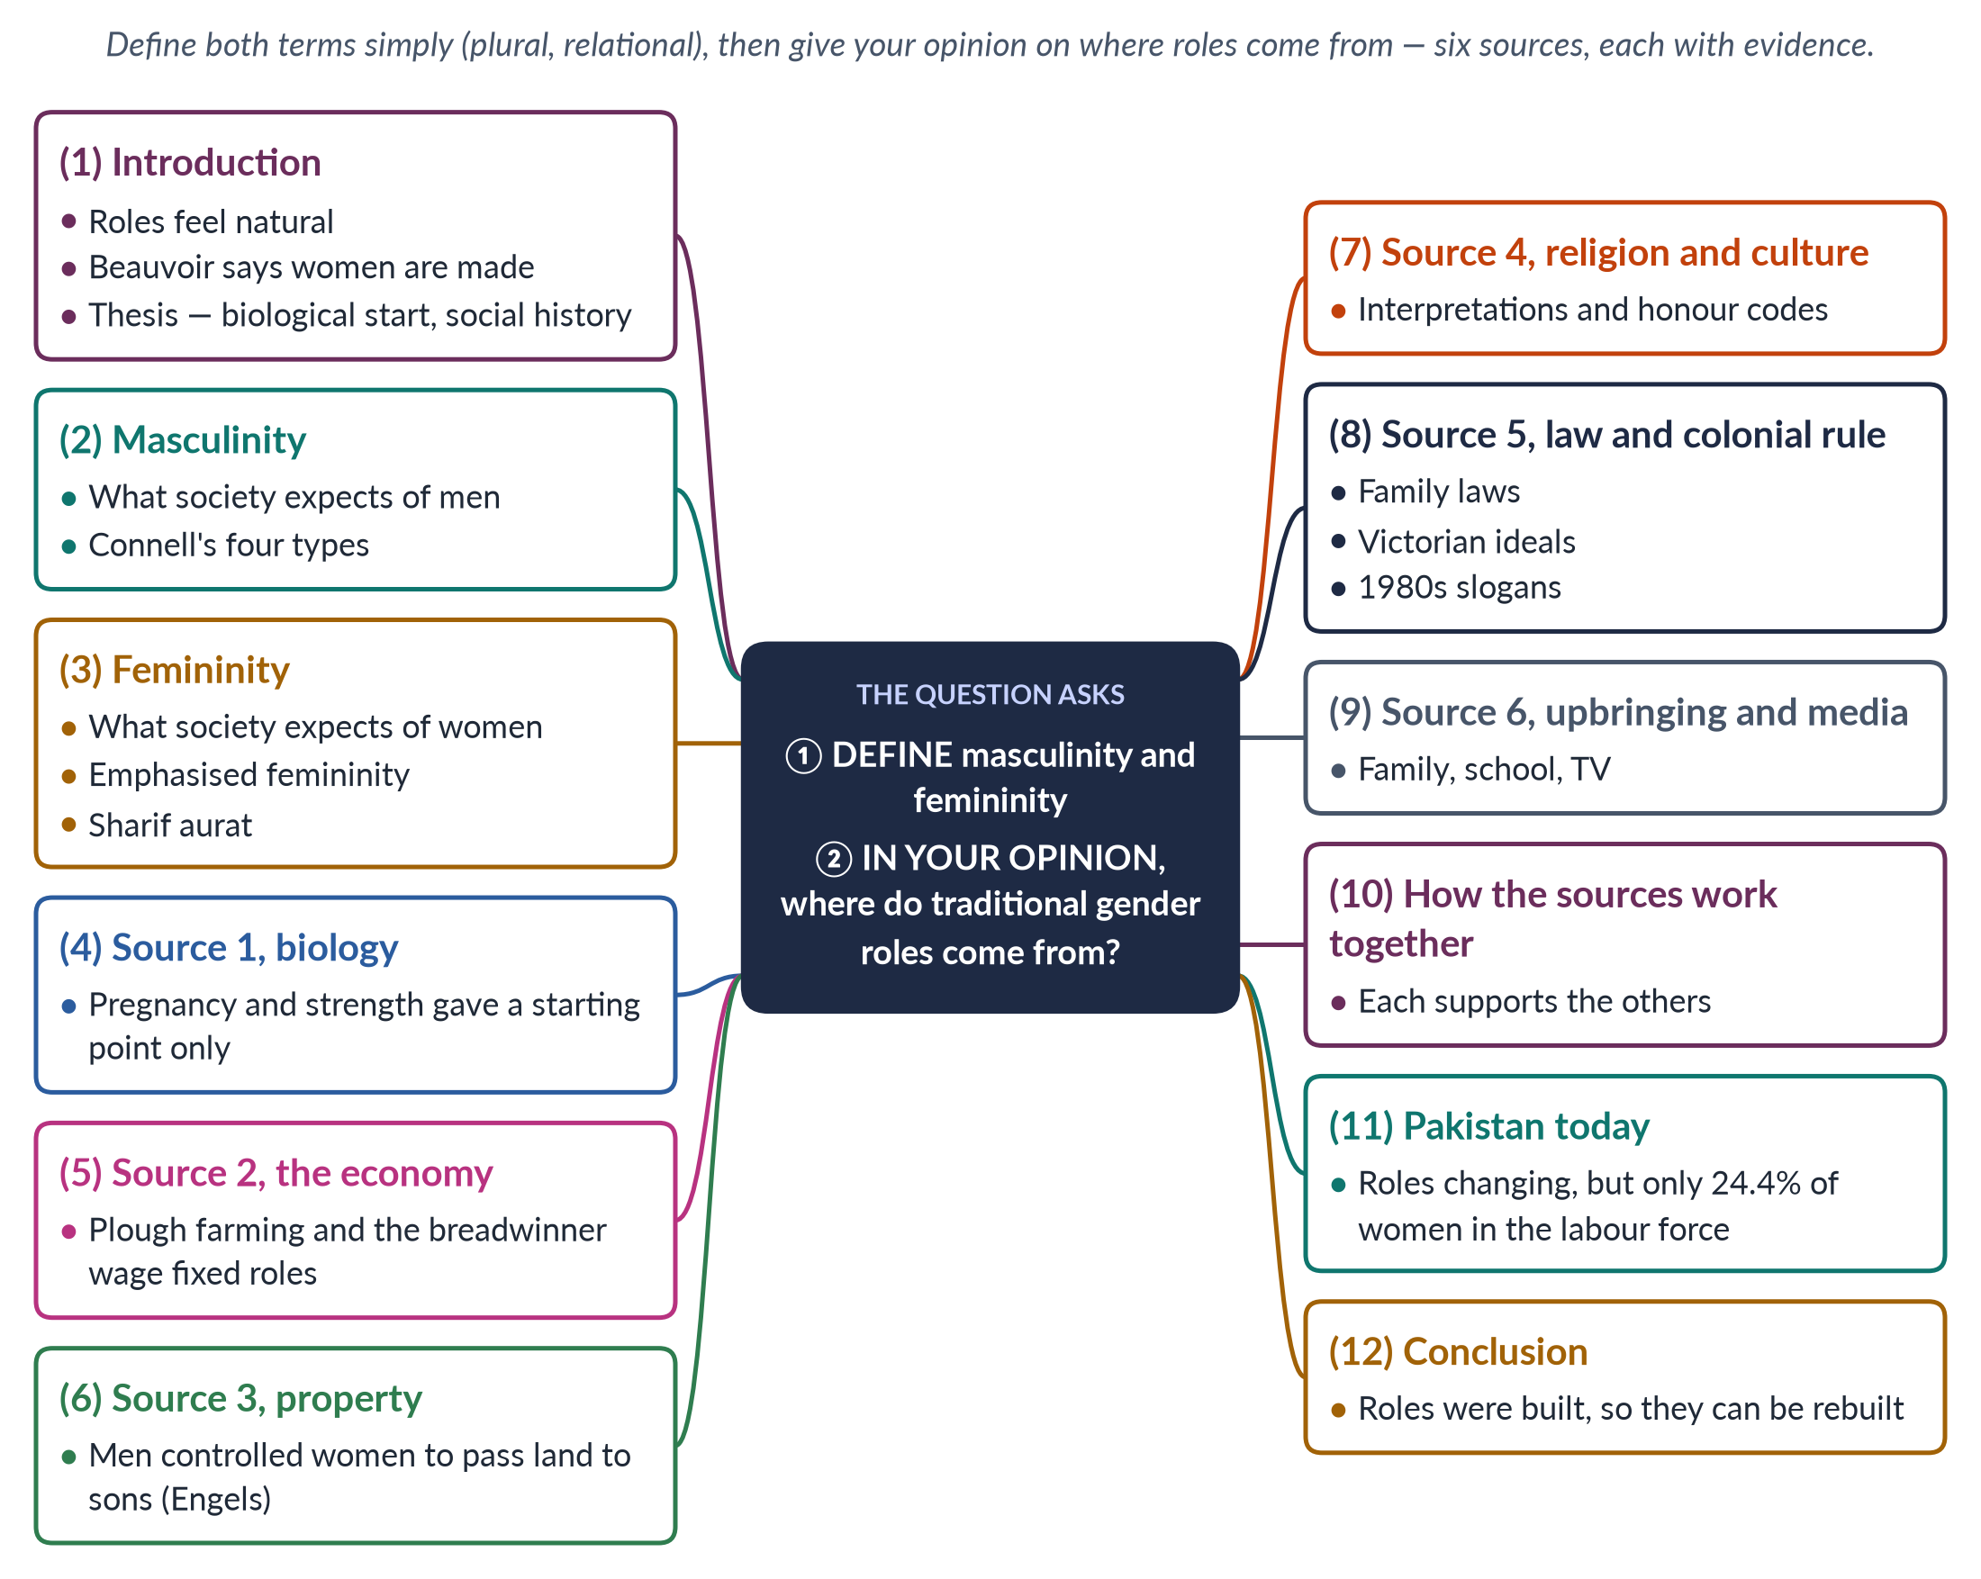
Figure 30 · The answer map: every branch is one numbered heading of the model answer below.

Decoding the question
"Define" asks for clear definitions of two terms — the best show that each is plural, relational and changeable. "In your opinion" invites your own view, but it still needs evidence. "Where do traditional gender roles come from?" is a question about causes: give several sources, explain how each works, and reach a judgement.

The model answer

1. Introduction

i) Roles that feel natural
In most societies, including Pakistan's, it seems natural that men should earn and lead while women should care and keep the home.

ii) Beauvoir's challenge
Simone de Beauvoir warned in 1949 that "one is not born, but rather becomes, a woman". Masculinity and femininity are the ideals through which people "become" men and women.

iii) My view
In my opinion, traditional roles have a biological starting point but a social history. The economy, property, religion, law and upbringing turned small biological differences into rigid, unequal rules — which is why the rules can change.

2. Masculinity defined
✦ DEFINITION
Masculinity · what society expects of men
The behaviour, qualities, roles and ideals a society links with being a man — usually strength, courage, hiding emotion, providing for the family and authority over dependants.
➜ Masculinity is plural (many forms), relational (defined as "not feminine") and ranked.

Connell's four masculinities
Raewyn Connell (Masculinities, 1995) showed that masculinities are ranked:
- Hegemonic — the most honoured way of being a man, justifying men's power;
- Complicit — most men, who do not match the ideal but gain the "patriarchal dividend";
- Marginalised — men placed lower by class or ethnicity;
- Subordinated — men looked down on as "unmanly".
Pakistan: the ghairat-mand man who protects and controls the family's women is the honoured ideal in many communities.

3. Femininity defined
✦ DEFINITION
Femininity · what society expects of women
The behaviour, qualities, roles and ideals a society links with being a woman — usually modesty, gentleness, care, beauty, obedience and sacrifice for the family.
➜ Femininity is usually defined in relation to — and in the service of — the dominant masculinity.

Connell called the honoured form emphasised femininity — femininity built around pleasing men. In Pakistan the ideal of the sharif aurat (respectable woman) who guards the family's izzat (honour) plays this role; women who work late, speak out or choose their own husbands may be condemned.

4. Source one: biology and childbirth
Pregnancy and breastfeeding tied women to young children for long periods, and men's greater average upper-body strength shaped some tasks. Biology explains why some division of work first appeared. But it cannot explain why that division became a hierarchy, why it differs so much between societies, or why it lasts when strength no longer matters for most jobs.

5. Source two: the economy

i) The plough
Ester Boserup (1970) noticed that societies which farmed with the heavy plough developed sharper gender roles than those using the hoe. The economists Alesina, Giuliano and Nunn (2013) found that people whose ancestors used the plough still hold less equal views today.

ii) The factory
Industry later separated home from work and created the ideal of the male breadwinner and the dependent housewife.

6. Source three: property and inheritance
Friedrich Engels (The Origin of the Family, Private Property and the State, 1884) argued that when men gathered property, they wanted to pass it to their own sons, so they came to control women's sexuality and keep them at home — "the world historical defeat of the female sex". In South Asia, control of land and the denial of daughters' inheritance show how property and gender roles remain linked.

7. Source four: religion and culture
Religious interpretations, customs and honour codes give roles to men and women and make them feel sacred. These interpretations are debated within every tradition — Muslim scholars such as Amina Wadud and Fatima Mernissi argue that some patriarchal readings reflect culture more than revelation — but in daily life they are a powerful source of "traditional" roles.

8. Source five: law, the state and colonial rule

i) Law
Laws on marriage, guardianship, inheritance and nationality write roles into the state. For example, laws that name the father as the natural guardian of children assume that men hold authority in the family, even where mothers do all the caring.

ii) Colonial rule and recent "tradition"
British rule brought Victorian ideals of women's place in the home and hardened customary law. In Pakistan, chador aur chaar-diwari ("the veil and the four walls") was promoted as an ideal in the 1980s — a reminder that "tradition" is sometimes recent policy.

9. Source six: upbringing and media

i) How children learn
Social learning theory (Albert Bandura) and gender schema theory (Sandra Bem, 1981) explain how children absorb roles through reward, copying and mental maps.

ii) Examples
Families give boys freedom and girls housework; textbooks show mothers cooking and fathers in offices; television dramas reward the self-sacrificing wife; adverts sell detergents to women and cars to men.

10. How the sources work together
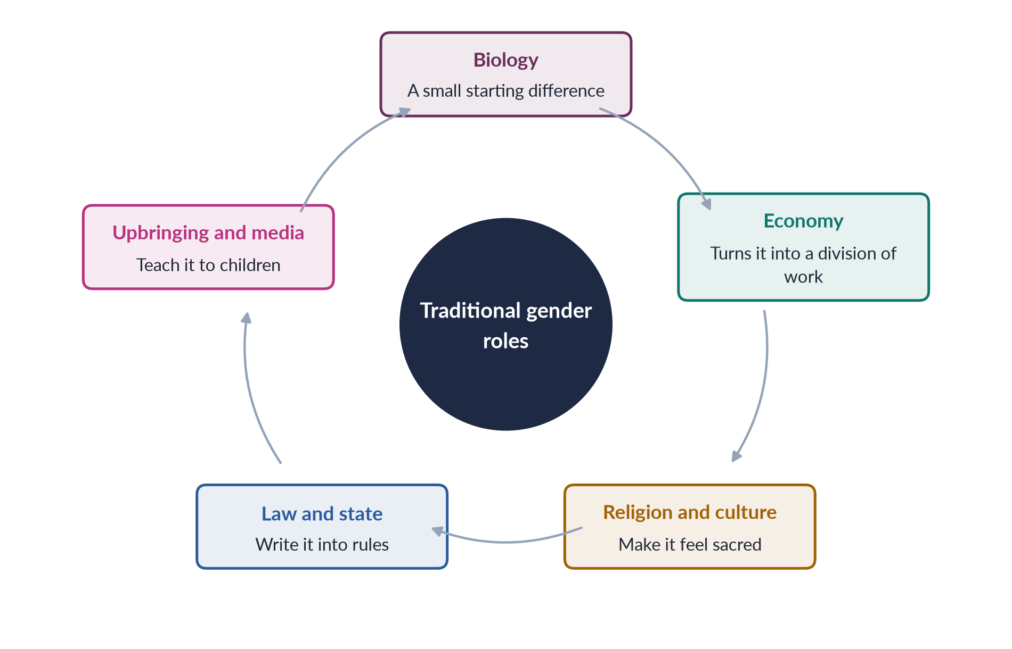
Figure 31 · How the six sources of traditional roles reinforce each other.
The sources support each other. A biological difference is exaggerated by the economy, justified by culture, written into law and then taught to children as "the way things are". This chain is why traditional roles feel so natural — and why changing them needs action on several fronts at once. Changing only one link — for example passing a law — is weakened if the others stay the same.

11. Pakistan today
The strongest evidence that roles are social is that they change. Women's literacy has risen to about 53% (Census 2023); women serve as Supreme Court judges, fighter pilots and, since 2024, a provincial chief minister; more fathers share childcare. Yet only 24.4% of working-age women are in the labour force (LFS 2024–25), showing how strong traditional roles remain. A fair critic would add that many people freely choose and value caring roles; the problem is not the roles themselves but their compulsory, unequal and unpaid character.

12. Conclusion
Masculinity and femininity are the ideals through which a society makes men and women — plural, ranked and changeable. In my opinion, traditional roles come from a combination of sources: biology gave a starting point, but the economy, property, religion and culture, law and the state, and daily upbringing built it into a rigid hierarchy and passed it on. Because the roles were built, they can be rebuilt — and Pakistan's own recent history shows that they already are being.

Why this answer scores
- Both terms are defined simply and precisely, with Connell's types and Pakistani ideals.
- "In your opinion" is answered with a clear thesis, stated at the start and the end.
- Six sources, each with its own heading and evidence (Boserup, Alesina et al., Engels, Bandura, Bem).
- A cycle figure shows how the sources reinforce each other.
- Balance: biology is acknowledged, not dismissed, and freely chosen roles are respected.

Answer 16 · Short Note: Is "Sex" Also a Social Construct? (CSS 2024)
AT A GLANCE · CSS 2024 · Q8(A) · 10 MARKS
Write short notes on: Is 'sex' also a social construct?

The answer map
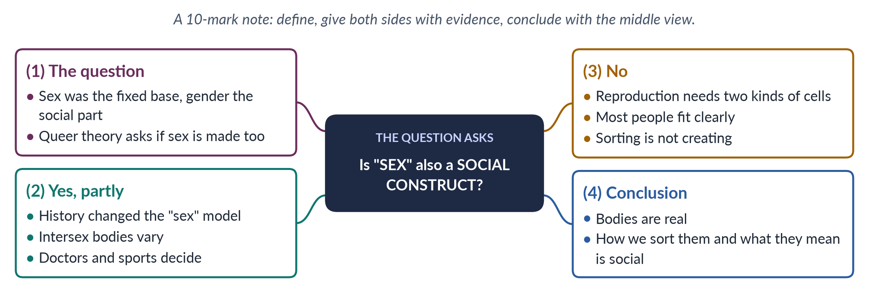
Figure 32 · The answer map for the short note: every branch is one headed point.

Decoding the question
A short note of 10 marks: about 550–650 words, three or four headed points, evidence in each, and a clear conclusion. It is a yes/no debate; the examiner rewards a note that gives both sides and reaches a reasoned middle view.

The model answer

1. The question

i) The old distinction
Since Ann Oakley's Sex, Gender and Society (1972), Gender Studies has separated sex — body differences in chromosomes, hormones and organs — from gender, the roles and identities society builds on them. Sex was the fixed natural base; gender the social building on top.

ii) The new question
From about 1990, queer theorists asked whether even "sex" is partly shaped by society — who decides how many sexes there are, and where the lines fall?

2. The case that sex is partly made by society

i) History
Thomas Laqueur (Making Sex, 1990) showed that European medicine long used a "one-sex" model, seeing the female body as an inside-out male body. It moved to the modern "two-sex" model only in the eighteenth century — partly for social and political reasons.

ii) Bodies vary
Some people are born intersex, with bodies that do not fit the usual male or female pattern. Estimates range from about 0.018% (Leonard Sax, 2002) to about 1.7% (Anne Fausto-Sterling) of births — depending on the definition, which is itself a human choice.

iii) People decide
Doctors long assigned intersex babies to one sex using social tests, and sports bodies keep changing the tests for who may compete as a woman. The boundaries of "sex" are drawn by people.

iv) Butler
Judith Butler (Gender Trouble, 1990) argued that we can only see bodies through gender categories, so "sex" may be "always already gender".

v) What "yes" does not mean
The "yes" side does not claim that bodies are imaginary. It claims that the lines we draw between categories — and the importance we give them — are human decisions that have changed over time.

3. The case that sex is biological

i) Reproduction
Human reproduction needs two kinds of reproductive cells (eggs and sperm) — the biological basis of two sexes.

ii) Most people fit clearly
The great majority of people are plainly female or male; variation at the edges does not erase the categories.

iii) Sorting is not creating
Societies sort bodies and give them meaning; they do not create chromosomes or hormones.

iv) Real consequences
Sex matters for medicine — pregnancy, maternal health, many diseases. Critics such as Martha Nussbaum (1999) warn that calling sex a construct can distract from these material problems, which are central in countries like Pakistan.
ISLAMIC PERSPECTIVE · VARIATION RECOGNISED IN CLASSICAL ISLAMIC LAW
Classical Islamic law recognised the khuntha — a person with features of both sexes — and gave detailed rules for such persons, while keeping a two-sex legal framework. This tradition acknowledged bodily variation long before modern queer theory.

4. Conclusion
Sex is not simply a social construct: bodies, chromosomes and reproduction are biological realities. But how many categories exist, where the lines are drawn, which differences count, and what they mean for a person's rights and role are decided by societies and have changed over time. The best answer is that sex is a biological fact seen through social categories. This middle view explains both why the two-sex model is so widely used and why intersex people have often been treated unfairly by it. Both sides agree on one practical point: intersex people and Pakistan's khawaja siras deserve dignity and protection — the very question later tested in Pakistan's courts over the Transgender Persons Act 2018.

Why this answer scores
- It fits the short-note format: four headed points, about 600 words.
- It explains why sex was questioned before arguing either side.
- Both sides are evidenced (Laqueur, Sax and Fausto-Sterling, Butler; reproduction, sorting vs creating, Nussbaum).
- The khuntha box adds a distinctive, relevant angle.
- The conclusion takes a careful middle view and links to Pakistan.

Answer 17 · Social Constructionism, Queer Theory and the Transgender Debate in Pakistan (CSS 2026)
AT A GLANCE · CSS 2026 · Q2 · 20 MARKS
Critically examine the theoretical arguments of social constructionism and queer theory regarding the categories of sex and gender. How do these arguments illuminate contemporary debates about transgender rights and the controversies over the Transgender Persons (Protection of Rights) Act 2018 in Pakistan? Support your answer with examples from legal debates and activism.

The answer map
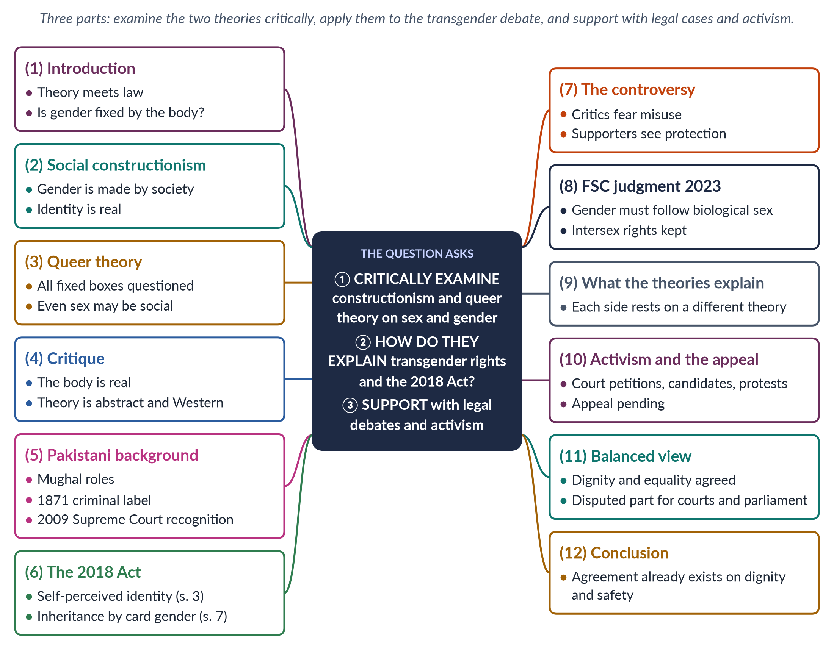
Figure 33 · The answer map: every branch is one numbered heading of the model answer below.

Decoding the question
The longest question in the record, with three demands. "Critically examine" the two theories — their arguments and their weaknesses — "regarding the categories of sex and gender". "How do these arguments illuminate" the transgender debate and the 2018 Act — apply the theory. "Support your answer with examples from legal debates and activism" — cite the courts, the Act and activists. A balanced conclusion is essential on this sensitive subject.

The model answer

1. Introduction

i) Theory meets law
Few debates in Pakistan show so clearly how academic theory shapes public life as the debate over transgender rights.

ii) The central question
At its heart lies a question Gender Studies has argued about for fifty years: are sex and gender natural and fixed, or partly made by society?

iii) The argument
Social constructionism says gender is made by society; queer theory questions whether even sex is simply natural. These ideas explain why Pakistan's Transgender Persons (Protection of Rights) Act 2018 was first celebrated and then fiercely contested — and why its central question is still before the courts.

2. Social constructionism

i) The claim
Constructionism holds that gender — roles, behaviour, identity — is made by society, not given by nature. Simone de Beauvoir (1949) wrote that "one is not born, but rather becomes, a woman"; Ann Oakley (1972) separated biological sex from cultural gender; Berger and Luckmann (1966) showed how human-made arrangements come to feel natural.

ii) What it means for identity
For constructionists, gender identity — a person's inner sense of being a woman, a man or neither — is a real social and psychological fact that need not follow the body.

3. Queer theory

i) Origins
Queer theory emerged around 1990 from Michel Foucault (1976), Judith Butler (Gender Trouble, 1990), Eve Sedgwick (1990) and Teresa de Lauretis, who coined the term.

ii) Its claims
It says categories of sex, gender and sexuality have a history; that society is organised by heteronormativity (the assumption of two opposite genders); and that identities are performed, not fixed. Butler suggested sex may be "always already gender". Laqueur (1990) and Fausto-Sterling (1993) showed that the sorting of bodies has changed over time and that intersex variation complicates a strict two-box model.

4. A critical examination

i) The body is real
Critics reply that reproduction needs two kinds of cells, that most people are clearly female or male, and that societies sort bodies but do not create them.

ii) Too abstract and Western
Martha Nussbaum (1999) called Butler's work obscure and far from poor women's struggles. Others say queer theory reflects Western debates and fits poorly with societies built around family and religion.

iii) Tension with feminism
Some feminists argue that dissolving the category "woman" weakens protections based on sex.

iv) The theories' strength
Their strength is showing that categories which seem natural have histories — a point South Asian history itself confirms.

5. The Pakistani background

i) From honour to exclusion
Khawaja siras held respected roles in Mughal households. The British Criminal Tribes Act 1871 branded "eunuchs" a criminal class. After 1947 the community was largely shut out of education, work and inheritance.

ii) Recognition in 2009
In 2009 the Supreme Court (Dr Muhammad Aslam Khaki case) ordered the state to recognise khawaja siras as equal citizens with a separate category on identity cards — making Pakistan one of the first countries to recognise a third gender. The 2017 Census counted 10,418 transgender persons, a figure activists called far too low.

6. The 2018 Act
The Act, passed with support from all main parties:
- defined intersex, khawaja sira and transgender persons;
- gave the right to be recognised by self-perceived gender identity (section 3);
- banned discrimination in education, jobs, health care and public places;
- set inheritance by the gender on the identity card (section 7);
- protected the rights to vote and hold office.
Human-rights groups praised it as one of the most progressive laws of its kind.

7. The controversy

i) The critics
From 2022, religious parties, some scholars and the Council of Islamic Ideology argued that self-declaration could be misused, could in effect allow same-sex marriage, and conflicted with Islamic rules on gender and inheritance. Senate bills proposed medical boards.

ii) The supporters
Transgender activists, human-rights groups and many lawyers argued that critics misrepresented the law, that medical tests are degrading, and that no evidence of misuse had been shown.

8. The Federal Shariat Court judgment (2023)
On 19 May 2023 the Federal Shariat Court held that the provisions on self-perceived gender identity (section 2(f) and section 3) and inheritance (section 7) were against the injunctions of Islam, ruling that gender must match biological sex. It affirmed that intersex persons and khawaja siras keep all the rights of citizens. The Court drew a line between intersex variation (recognised, like the khuntha in classical fiqh) and identity separate from biological sex (not recognised).

9. What the theories explain
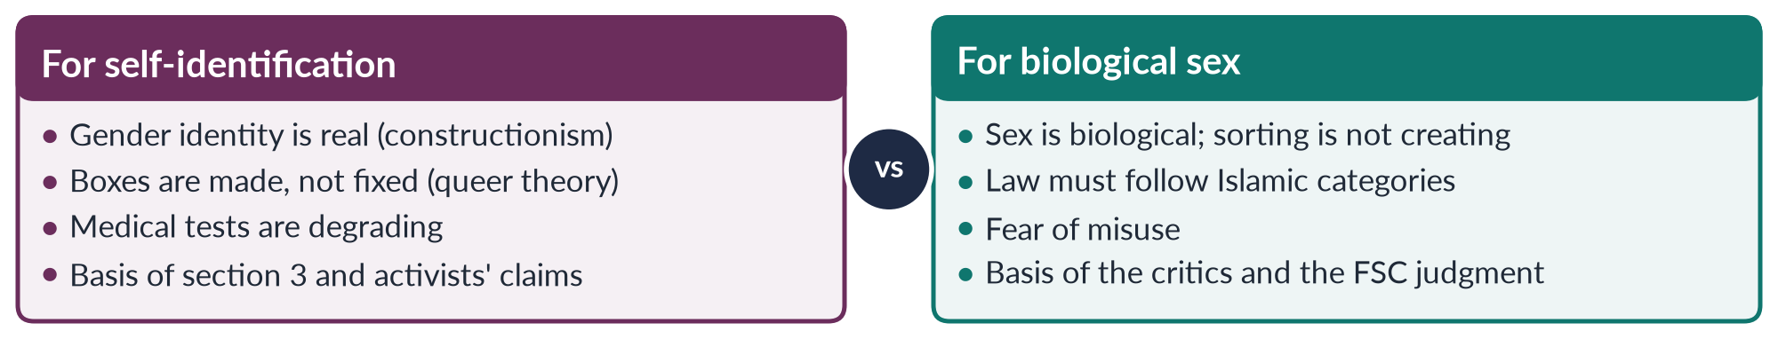
Figure 34 · The two sides of the debate and the theories behind them.
The debate in Pakistan's courts and parliament is therefore a local form of the academic argument: should legal gender follow the body, or the person's identity? Both sides accept that intersex variation exists and deserves protection.

10. Activism and the appeal

i) Activism
Transgender activists have used law and public life: petitioning the Supreme Court from 2009, standing as candidates in elections, running community organisations, and protesting against violence and against the 2023 judgment.

ii) The pending appeal
Appeals were filed before the Shariat Appellate Bench of the Supreme Court (the first by former senator Farhatullah Babar, July 2023); as of 2026 they were still pending. Under Article 203D, an FSC decision under appeal does not take effect until the appeal is decided.

11. A balanced view

i) Where there is agreement
Article 14 (dignity) and Article 25 (equality) require that transgender and intersex citizens be protected from violence and discrimination and have access to education, health, work and inheritance. The Supreme Court (2009), Parliament (2018) and the FSC (2023) all agree on this.

ii) Where there is dispute
Whether legal gender may follow self-perceived identity involves Article 227 (laws must conform to Islam). It should be settled by the courts and by agreement in parliament, informed by evidence, medical ethics and scholarship — not by false claims or street pressure.

12. Conclusion
Social constructionism and queer theory challenge the idea that sex and gender are fixed natural boxes; their critics insist on the biological reality of sex. Pakistan's transgender debate repeats this argument in law: the 2018 Act followed the constructionist and queer view by recognising self-perceived identity, while the Federal Shariat Court followed the biological view. Whatever the final judgment, the theories show why the debate is so hard — and the Constitution shows where agreement already exists: in the dignity, safety and equal citizenship of one of Pakistan's most vulnerable communities.

Why this answer scores
- All three demands have their own headings: critical examination, explanation, examples.
- The theories are presented and criticised, as "critically examine" requires.
- The legal record is precise: 1871, 2009, 2017, 2018 (sections 3 and 7), 2023, and the pending appeal.
- A comparison figure links each side to its theory.
- The balanced view anchored in the Constitution is exactly what a civil-service examiner rewards.

